Listening task
Do the listening task online. MODULE 10

Reading task
Do the reading task online. MODULE 10

Writing task (see other side)

Assessment
Listening | % | Reading |  | % |  | Writing | Assessment scale online  %
alle Teilbereiche sind gleichwertig
Schularbeitennote Einstufung  ¨ AHS  ¨ STANDARD |  |  | ____________%

Notenschlüssel
 | AHS | STANDARD
90 – 100% | Sehr gut | Sehr gut
80 – 89% | Gut | Sehr gut
70 – 79% | Befriedigend | Sehr gut
60 – 69% | Genügend | Gut
50 – 59% | Nicht genügend | Befriedigend
40 – 49% | Nicht genügend | Genügend
< 40% | Nicht genügend | Nicht genügend

Dein derzeitiger Notenstand im Fach Englisch ist: ………………………………………………………………………….
Details findest du in deinem Leistungsblatt und im Gradebook auf Eduvidual.

Most adventurous teacher contest
The city of Graz is looking for the most adventurous teacher in town. The class that has the most adventurous teacher will win an adventurous, fun day with that teacher – every activity is paid for.
Students have to enter their teachers in the competition.
Write a letter and explain why your English teacher is the most adventurous teacher in town.
Experiences | Details
Swim across Lake Wörthersee  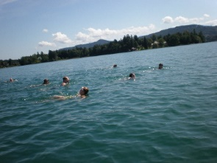 | group of friends  weather: warm, sunny  water warm  1,5 hours each way  great fun
climb in a cave  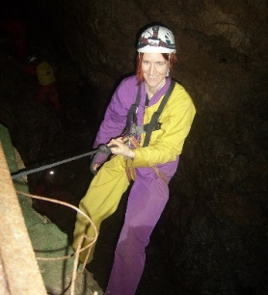 | Lurgrotte  wear special suits / helmet  headlamps  very dark  cold  1 km into cave
Cook and eat insects   | worms and grasshoppers  fry in a pan  bake in the oven
Start like this:

Dear team of the Most Adventurous Teacher Contest,
I would like to enter my teacher Mrs. Bergmann for the prize. I think she is a very adventurous person, and she has done lots of things that show it.
Then list for the jury what your teacher has done in her life. Use the pictures or what you remember from Ms Bergmann’s holiday presentation. Give 2-3 details for each of the cool things that Mrs. Bergmann has done.
………

Then tell the jury what your class would do on the day with your teacher, if you won the prize. Explain about at least 3 thing.
If we won the prize, we .….
End your letter like this:
I hope that I have convinced you that our teacher is a very adventurous person and that we should win the Most Adventurous Teacher prize.
Best regards,
… (name, class)

