http://learnenglishteens.britishcouncil.org/magazine/sport/skydiving-amazing-experience

Skydiving: an amazing experience!
5
by :
ChloeBlogger
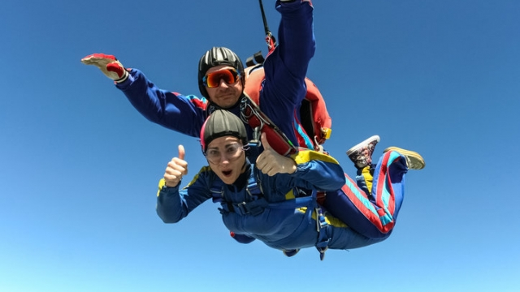
When I was 16 I wrote a bucket list. This was a list of things that I wanted to do in my lifetime. Some things were easy, some difficult and some near impossible. One of the things on my bucket list was to do a skydive.
Two years ago I spent three months travelling round South America. We visited so many places and it was a great experience. One of the most amazing things we saw was Iguassu Falls. The day after we visited the waterfalls we were relaxing in a hostel in Brazil, having breakfast. My friend then suddenly noticed an advert on the wall saying 'skydive over Iguassu Falls today!' We looked at each other and decided it was time to do something crazy. Today would be the day that we would jump out of a plane.
That afternoon we were picked up and taken to the Skydive Centre. We put on our harnesses and helmets and we were given some instructions. After signing a few papers we were on our way to the plane! There were 14 of us in a very small space as we took off into the air. This is when my heart started to beat very fast and I felt lots of adrenaline.
Suddenly we were 10,000 feet (3,000 metres) above the ground. Luckily, I was strapped to an instructor so I didn't have to worry about anything; I just had to enjoy myself. He asked me if I was ready to fall from the plane ... but before I had time to answer, I felt the wind rushing against my face as we fell to the ground at 200 km an hour! Everything below me looked so small and my breath was literally taken away.
After about 20 seconds of falling, the parachute opened and everything slowed down. We floated peacefully towards earth, leaving the clouds behind us.
This was definitely one of the scariest but most exhilarating experiences of my life. The sensation of falling from so high is amazing and the adrenaline rush is crazy. I would definitely do another skydive if I had the opportunity. I would also love to try other extreme sports such as bungee jumping. I think that everyone should do something that scares them once in a while!

Skydiving: an amazing experience!
original by : ChloeBlogger (simplified by LP)
Q1:
When I was 16 I wrote a bucket list. This was a list of things that I wanted to do in my lifetime. Some things were easy, and I did them in the first year. Some things were difficult and some near impossible. One of the things on my bucket list was to do a skydive.
Two years ago, I spent three months travelling round South America. We visited so many places and it was a great experience. One of the most amazing things we saw was Iguassu Falls. The day after we visited the waterfalls we were sitting in a small hotel in Brazil, having breakfast. My friend then suddenly saw a poster on the wall. It said: 'skydive over Iguassu Falls today!' We looked at each other and decided it was time to do something cool and crazy. Today would be the day that we would jump out of a plane.
Q1: True or False
F: Chloe Blogger has not done any of the things on her bucket list.
T: Chloe Blogger visited famous waterfalls in South America
T: She was travelling with a friend.
F: Chloe Blogger went to South America because she wanted to do skydiving.

Q2:
That afternoon we drove to the Skydive Centre. We put on helmets and the skydiving instructor gave us some safety tips. After filling in a few papers, we were on our way to the plane! There were 14 people on the airplane. It was very small. My heart started to beat very fast and I was very nervous.
Suddenly we were 10,000 feet (3,000 meters) above the ground. Luckily, I was strapped to my skydiving instructor, so I didn't have to worry about anything; I just had to enjoy myself. He asked me if I was ready to fall from the plane ... but before I had time to answer, I felt the wind rushing against my face as we fell to the ground at 200 km an hour! Everything below me looked so small and my breath was literally taken away.
After about 20 seconds of falling, the parachute opened, and everything slowed down. We floated peacefully towards earth, leaving the clouds behind us.

True or False
T: The skydiving teacher told Chloe what to do.
T: In the plane Chloe was a bit scared.
F: Chloe and her friend jumped out of the plane together.
F: When the plane was 10 000 meters up in the sky, Chloe said that she was ready to jump out of the plane.
F: Chloe opened the parachute herself.
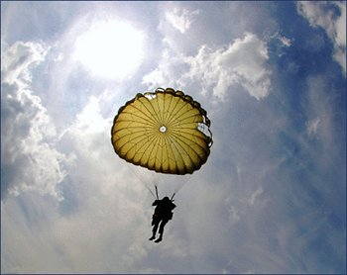
F: They landed on the ground after 20 seconds.
T: Falling down in the parachute was nice and slow.

Q3:
This was definitely one of the scariest but greatest and most amazing experiences of my life. The feeling of falling from so high is amazing and so cool. I would love to do another skydive if I had the chance and the money to do it. I would also love to try other extreme sports such as bungee jumping. I think that everyone should do something that scares them once in a while!

F: Chloe was so scared that she doesn’t want to go skydiving again.
T: If skydiving wasn’t so expensive, she would do it again.
F: Chloe is afraid of many things. She is easily scared.
T: She would like to try other scary things.

Q4:
What do you think of skydiving? Would you like to try it? Why? Why not?

