Put the verbs in the right form.
[Verse]
If I (be) a boy, even just for a day
I (roll) outta bed in the morning
And throw on what I (want) then go
Drink beer with the guys, and chase after girls
I (kick) it with who I wanted
And I (ever get) confronted for it.
Cause they (stick) up for me.
1. Put the lines in the right order
[Chorus] (x2)
If I were a boy
I’d listen to her
How it feels to love a girl
I think I could understand
I swear I’d be a better man.
’Cause he’s taken you for granted
When you lose the one you wanted
’Cause I know how it hurts
And everything you had got destroyed
[Verse]
If I were a boy , I would turn off my phone
Tell everyone it’s broken, so they’d think that I was sleepin’ alone
I’d put myself first, and make the rules as I go
‘Cause I know that she’d be faithful
Waitin’ for me to come home (to come home)
[Chorus]
[Verse 3]
It’s much too late for you to come back
Think it’s just a mistake
Think I’d forget you like that
If you thought I would look for you
You were wrong
Correct the mistakes
Choose the right solution.
[Chorus] (variation)
But you’re only/ just a boy
You don’t/ never understand
(Yeah/ No, you never/ don’t understand)
How you need / it feels to love a girl someday
You wish/ hope you were a better man
You don’t look at/ listen to her
You don’t care/ know how it hurts
One day/ Until you lose the one you wanted
‘Cause you’ve taken/ took her for granted
And everyone/ everything you have got destroyed
But you’re just a boy

VERSE ONE:
roll outta bed (= roll out of bed) =
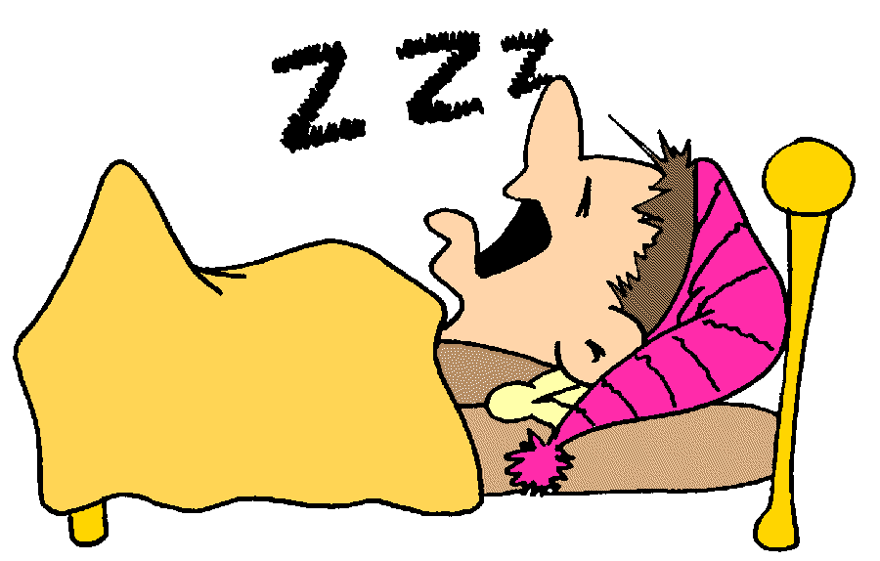  stay in bed | 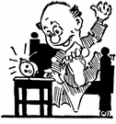  get up |   make the bed
throw on what I wanted =
  get dressed |   throw up | 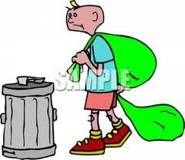  put the dustbin out
kick it with who I wanted
  hang out with (sb) | 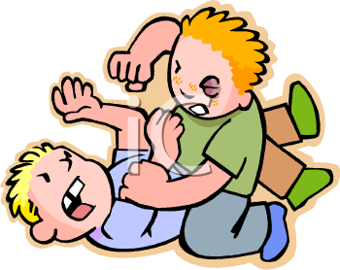beat up (sb) |   practise karate
stick up with me
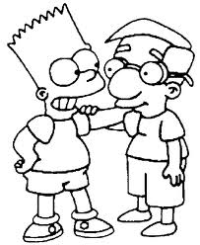  stay (like glue) | 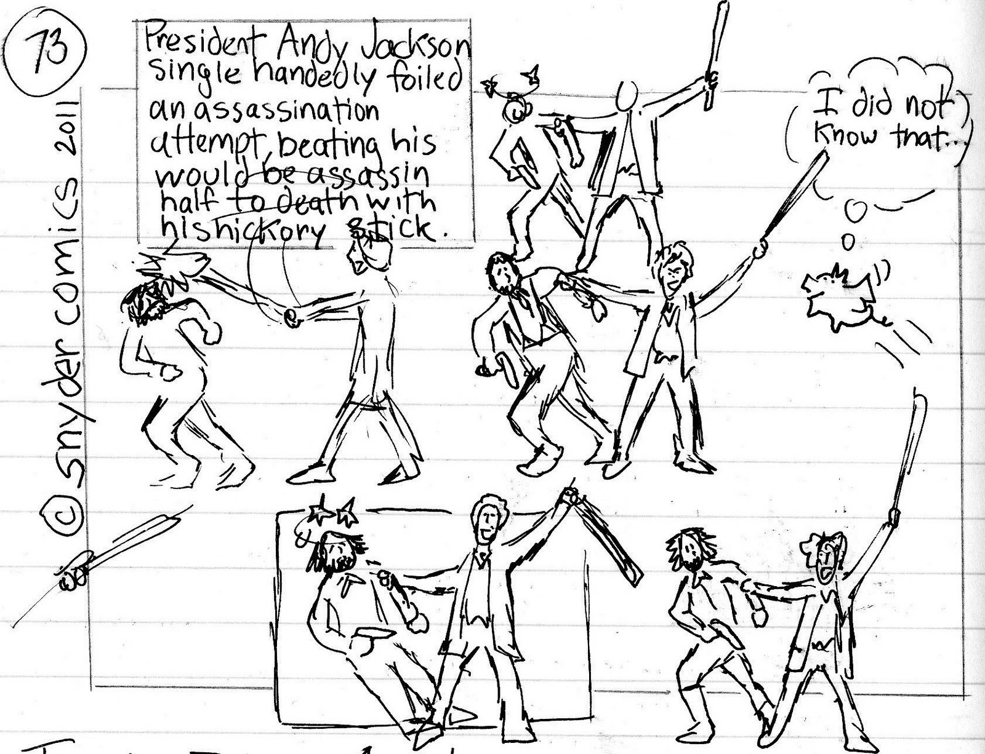  hit with a stick |   (lie and) protect
VERSE THREE: Find the English for:
être fidèle :
changer les règles :
rentrer à la maison :
penser à moi-même :
éteindre (un appareil) :
tout seul:

CHORUS (and variation) What is the French for ... ?
take a person for granted :
you don’t care :
how it feels :
destroyed : swear:
until: wish :

Beyoncé parle de ce qu’elle ferait si elle était un homme.
D’un côté elle évoque les comportements masculins qu’elle constate et qu’elle critique ( si elle était un homme, elle en profiterait pour …) : souligne ces éléments en rouge.
D’un autre côté elle parle des comportements masculins qu’elle souhaiterait de la part des hommes (si elle était un homme, elle rendrait sa femme heureuse en … ) : souligne ces éléments en vert.

adapted from ParaCris ’s work @islcollective.com

