If I was – Young Rebel Set
Listen to the song and fill in the missing words.
Then check with the key on Moodle.

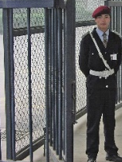



If I was a sailor I would sail you out to sea
Take you across the ocean, ask you to marry me
Oh if I was sailor I would sail you home to me
And if I was a soldier I would march to war for you
I'd face every bullet and cannonball that flew
Oh if I was a soldier I would wage a war for you
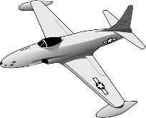

And if I was a jailer I would lock you away
Then I'd have the key to see you each and every day
Oh if I was a jailer I would still have you today
And was a rich man I'd buy you flowers every day
But I am a poor man so I'll pick them on the way
Oh if I was a rich man I would pay to make you to stay
I've wasted so much time
Writing songs and playing on my guitar
I've wasted so much love
Now I wish I'd never learnt to play a note
And if I had an aeroplane then I'd fly you away
Maybe we’d go to Rome or Paris for the day
Oh if I had an aeroplane then I'd whisk you away
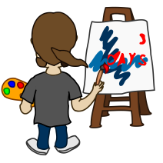
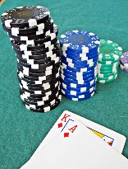
And if I was a betting man I'd bet you love me too
I'd bet everything I had for the chance to be with you
Oh if I was a betting man my odds are 9-2
I've wasted so much time
Writing songs and playing on my guitar
I've wasted so much love
Now I wish I'd never learnt to play a note
Yeah I wish I'd never learnt to play a note
Oh I wish I'd never learnt to play a note
I've wasted so much time
Writing songs and playing on my guitar
I've wasted so much love
Oh I wish I'd never learnt to play a note
And if I was a writer I would write the book on you
I'd tell them all the stories of the things we used to do
Oh if I was a writer I would write the book on you
And if I was a painter I'd paint portraits of you
Hang them in the galleries like all good painters do
Oh if I was a painter I'd paint portraits of you
I've wasted so much time
Writing songs and playing on my guitar
I've wasted so much love
Now I wish I'd never learnt to play a note
Yeah I wish I'd never learnt to play a note
Oh I wish I'd never learnt to play a note

