Find out where Mrs. Pö lived in Pittsburgh
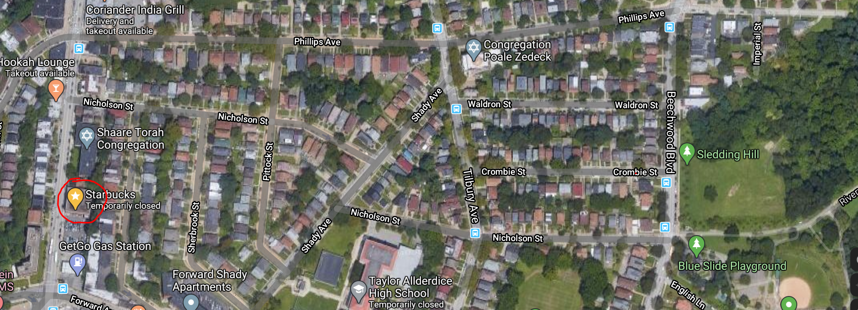
Let’s start at Starbucks Coffeeshop on 2345 Murray Avenue and walk to my house. It’s only a 12-15 minute walk.
When you get out of Starbucks, turn right. Walk past the Shaare Torah Congregation and turn into the first street on the right.
That’s a quiet street with homes and little front gardens. Follow this street to the end. At the end of the street turn left. Walk along the street. You will pass a number of small homes with nice, little front gardens.
At the end of the street, turn right. That’s a wider avenue. Cross the avenue and turn left at the second street.
You are almost there. What is the name of the street? ……………………………………………………………………………..
No open Google Maps and open the map of Pittsburgh.
https://www.google.com/maps/place/Starbucks/@40.4305692,-79.9242423,324m/am=t/data=!3m1!1e3!4m5!3m4!1s0x0:0x6787ea4776bfa9e9!8m2!3d40.4305692!4d-79.9231479
You can move on the map with your mouse (on your computer) – or you can move it with your fingers (on your tablet). Find my street.
Then turn on STREETVIEW.  
To start “walking” click into the street that you want to walk. Walk along the street and look around (turn the map with your mouse or fingers)
Walk to number 6348. It’s almost at the end of the street.
Look around and find number 6348. Take a screenshot of my house.
Then walk to the end of the street on Google maps or on Google earth. Turn right and walk into Frick park. Take a walk and take another picture.
That’s where I always took Anna to play. We went to sledding hill in the winter and to the blue slide in the summer. When I lived there, the blue slide was very different – much higher and much more dangerous.
Our neighbors on the left had a little boy called A.J. He liked to play baseball in the park. He was older than Anna, but he found she was a “cool baby” and sometimes came to play at our house.
Opposite our house, lived Leslie and Michael, with their baby Sebbie. We were good friends and our children played together a lot. Leslie and Michael used to plant tomatoes and strawberries in their garden. Now, someone else lives there and the bushes seem to be a bit overgrown.
The house next to Leslie and Michael’s is a bit bigger. It has three windows on the top floor and it has a garage. The family had two small children and we often spent time together. Now they have moved away and their house is for sale.
1: Question: What’s the name of my street in Pittsburgh?
2: Write a postcard or a WhatsApp message to Mrs. Pö. Tell her that you are in Pittsburgh and have just walked around on Squirrel Hill and found her house. Describe what you have seen and what it’s like there now.


You can write your message by hand and upload a photo, or you can write your message on your phone and upload a screenshot.
Have a good trip to Pittsburgh and enjoy walking around in my old neighborhood, Squirrel Hill.

