M11: one or ones --- this or these

Challenge 1
Look at the two dialogues below and highlight “one” and “ones”. What do you notice?
When do we use one and when do we use ones and this and these?
Shop assistant: Good morning. How can I help you?
Customer: I’m looking for a woolen sweater.
S: How about the red one in the corner over there?
C: I don’t like red… Do you have any grey ones?
S: Yes, over there. Come with me. Do you like this one?
C: Yes, this one is really nice.
S: What size do you wear?
C: Medium.
S: Ok, try this one
C: It’s too small. Do you have a larger one?
S: No, sorry. The large ones are sold out.

Shop assistant: Good afternoon. What can I do for you?
Customer: I’d like a pair of Converse.
S: What size do you wear?
C: I usually wear size 9. I’d like some golden ones.
S: Sorry, we don’t have any golden ones. But these silver ones are also quite fashionable, or these green ones. The green ones are very popular this year!
C: Can I try them on?
S: Sure.
C: They fit perfectly. How much are they?
S: 110 pounds.
C: That’s too expensive. I can’t afford that. What about the black ones?
S: They are on sale. They only cost 50 pounds right now.
C: Great, I’ll take the black ones!

My rule

We use THIS ONE for ….

We use THESE ONES for …..

M11: some or any

Challenge 2

What do your teachers have in their fridges? Read the texts and mark SOME and ANY in two different colours.

I’m a vegetarian, but Patrick eats meat. In our fridge, there are always some sausages. There is always some cheese, but we never have any milk. I usually have some oat milk in the fridge and we sometimes have some yogurt for Patrick.
There aren’t any eggs in our fridge. Sometimes, we have some tomatoes, and we usually have some carrots and some salad.

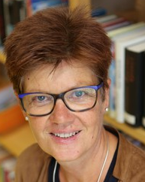
In my family we are all vegetarian. We don’t eat any meat or fish. Therefore, we never have any meat or sausages or fish in our fridge.
We always have some yogurt, because we eat yogurt with fruit for breakfast every day. We always have some milk in our fridge, and we love cheese. There is always some cheese in our fridge.
We eat lots of vegetables and salad, so there are usually some zucchini, some tomatoes and some carrots in our fridge.

Challenge 2
What’s in your teachers’ fridges? Draw the things in the correct fridge and label the picture!
Mrs Pö’s fridge:
Mrs Loitsch’s fridge:

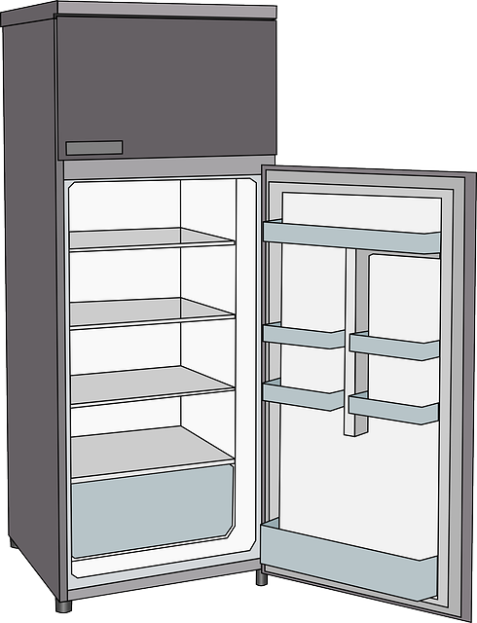

some carrots

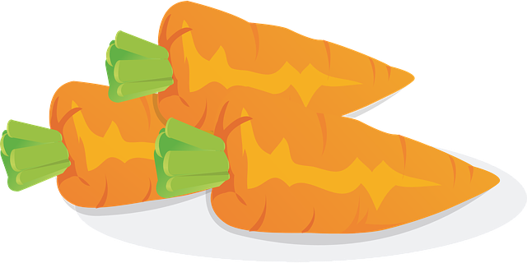

Challenge 3
What do your teachers not have in their fridge? Write sentences!
Ms Loitsch never has any milk in her fridge.
Mrs Pö never…
My rule

Challenge 4
Look at these questions. What is the difference? Why does the speaker use some or any?

Mrs. Pölzleitner, do you know some good English books that I could read? | Mr. Grasser, do you know any good English books that I could read?
Mrs. Bergmann, I know your family likes chicken. Do you have some good chicken recipies? | Mrs. Pölzleitner, I know you are vegetarian, but do you know any good chicken recipies?
Ms. Loitsch, I see you always put oat milk in your coffee. Could I try some, please? | Is there any oat milk in the teachers’ fridge at school?
Ms. Loitsch, can I have some colored paper for my Me-book, please? | Felix, do you happen to have any non-permanent markers that I could use?
 | 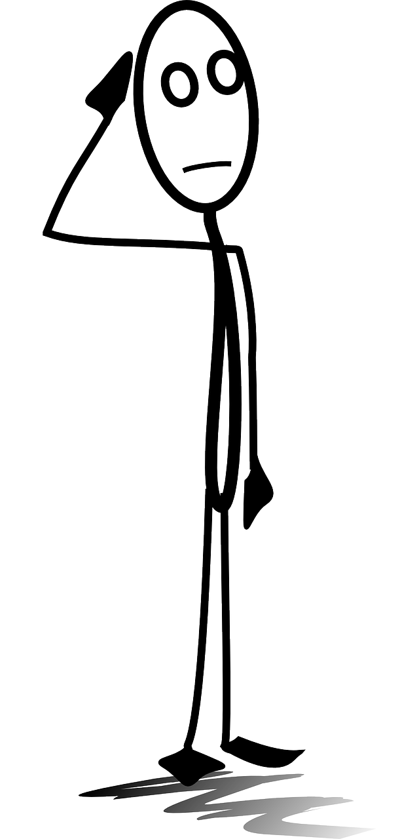

Challenge 5

Now it’s your turn! What do you never/sometimes/usually/always have in your fridge?

Draw the things that you have in your fridge! Then write 7 sentences. Use some and any.

M 11: much, many, a lot of, lots of

Challenge 6

Look at the examples. Guess how many there are.

many // a lot of | How many do you think there are? Guess !
In the teachers’ office there are many books and many folders. | I think there are 50 books and 20 folders.
How many brothers and sisters do you have?
There are too many kids in this room.
There were a lot of people at the concert.
I have a lot of friends
Valentina has many pets.
How many days are there till Christmas?
a lot of // much | What about these sentences?  Can you count these things?  How?
Bill Gates has got a lot of money.
In the holidays a spend a lot of time on the beach.
There is a lot of food in the fridge.
There is a lot of sand on the beach.
This winter we had a lot of snow in the mountains.

Sort the words into the two boxes:
dogs, apples, books, boys, children, time, minutes, money, euros, days, water, milk, butter, food, sand, snow, trees, air, love,
many | a lot of
My rule
We say many when ….

We say a lot of when …

Challenge 7

not many | not much // not a lot of
When I was little, I did not have many friends. | He doesn’t have a lot of hair. He is almost bald.  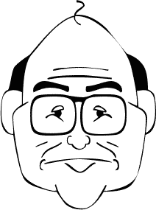  The old man doesn’t have much hair. He is almost bald.
Mrs. Pö has many books, but not many DVDs. | John doesn’t have a lot of money.  John doesn’t have much money.
Mr. Grasser does not have many English books. | We did not have much snow this winter.  We did not have a lot of snow this winter
There are not many Chinese children in Graz. | Hurry up, there is not much time left.
Mrs. Weinzettl does not know many famous soccer players, but she knows many famous singers. | There is not much food left in the fridge, we’ll have to go shopping.

My Rule
We say not many when….

We say not much or not a lot of when ….

Now it’s your turn

Write true and meaningful sentences about yourself, your family and friends.
Use much, many, a lot of, not much, not many,

many
many
a lot of
a lot of
not many
not many
not much
not much

