M11: some or any

Challenge 1

What do your teachers have in their fridges? Read the texts and mark SOME and ANY in two different colours.


I’m a vegetarian, but Patrick eats meat. In our fridge, there are always some sausages. There is always some cheese, but we never have any milk. I usually have some oat milk in the fridge and we sometimes have some yogurt for Patrick.
There aren’t any eggs in our fridge. Sometimes, we have some tomatoes, and we usually have some carrots and some salad.

In my family we are all vegetarian. We don’t eat any meat or fish. Therefore, we never have any meet or sausages or fish in our fridge.
We always have some yogurt, because we eat yogurt with fruit for breakfast every day. We always have some milk in our fridge, and we love cheese. There is always some cheese in our fridge.
We eat lots of vegetables and salad, so there are usually some zucchini, some tomatoes and some carrots in our fridge.

Challenge 2
What’s in your teachers’ fridges? Draw the things in the correct fridge and label the picture!
Mrs Pö’s fridge:
Mrs Loitsch’s fridge:

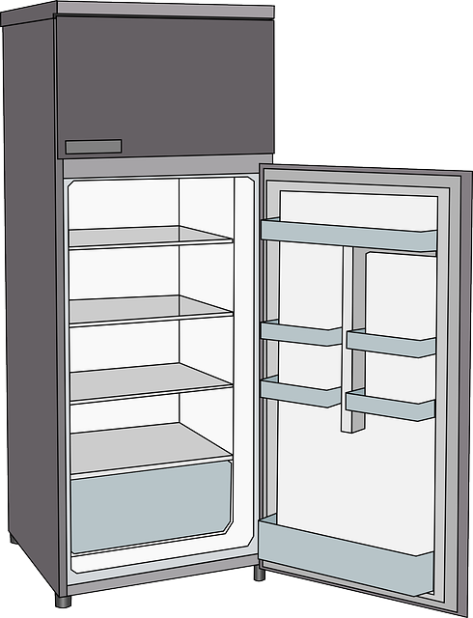

some carrots

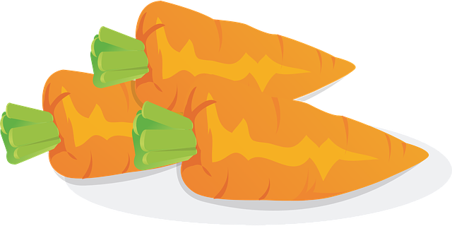

Challenge 2
What do your teachers not have in their fridge? Write sentences!
Ms Loitsch never has any milk in her fridge.
Mrs Pö never…

My rule

Challenge 3

Look at these questions. What is the difference?

Mrs. Pölzleitner, do you know some good English books that I could read?
Mr. Grasser, do you know any good English books that I could read?
Mrs Pölzleitner, I know you are vegetarian, but do you know any good chicken recipies?
Mrs. Bergmann, I know your family likes chicken. Do you have some good chicken recipies?
Ms Loitsch, I know you love oat milk. Do you have some so I could taste it?
Is there any oat milk in the teachers’ fridge at school?
Felix, do you happen to have any non-permanent markers that I could use?
Ms Loitsch, can I have some colored paper for my Me-book, please?

You want to cook, but you forgot to go shopping. Mrs Pö and Ms Loitsch live next door. Who would you ask the following questions? Write the name next to the question!

Do you have some sausages?  Do you have any sausages – wäre auch möglich | Ms Loitsch
Do you have some yogurt? | bei uns beiden geht beides
Do you have any yogurt?
Do you have some tomatoes? | auch hier, some or any ok
Do you have any oat milk? | any ist immer wahrscheinlicher, weil oat milk für die meisten Leute eher selten ist
Do you have some eggs? | some ist wahrscheinlich, da Haushalte meist Eier haben – nur wer euch wirklich gut kennt, würde any sage.

Challenge 4
Now it’s your turn! What do you never/sometimes/usually/always have in your fridge? Draw the things that you have in your fridge! Then write 7 sentences. Use some and any.

