 | 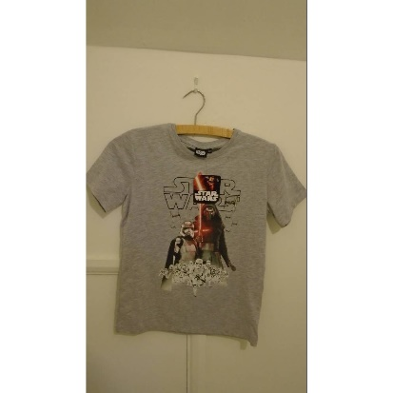 | 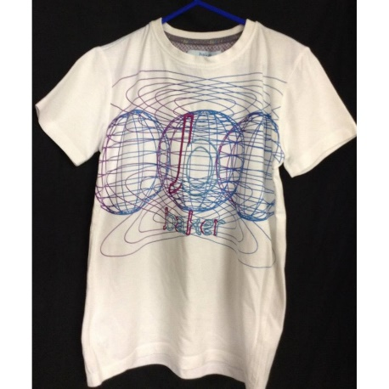 | 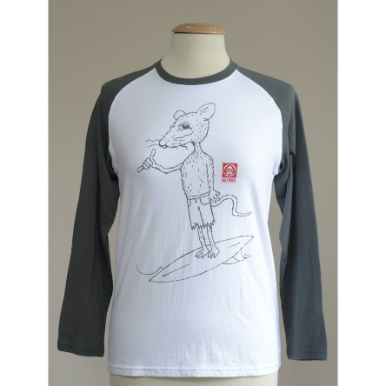
What brand is it? | Disney | Ted Baker | Saltrock
How much ist it? | 6 £ | 5.99£ | 14.99£
What is it made of? | cotton | cotton | cotton
Why do you like it? | Star Wars picture | Favourite colours | Long sleeves, funny picture, most comfortable
What condition is it in? | used | as new | new
A shirt I’d love to have

Some phrases you could use for a text:
I compared 3 products:
The product I liked best is the… because… // I would buy it because … // I prefer the … because…
I don’t like the … because it’s too ugly/childish/expensive/it looks cheap/…
The … is cheaper than … The … is more expensive than …. // The black one is more fashionable/cooler/more colourful/…
The … is made of …
The green one/the black one/the colourful one

