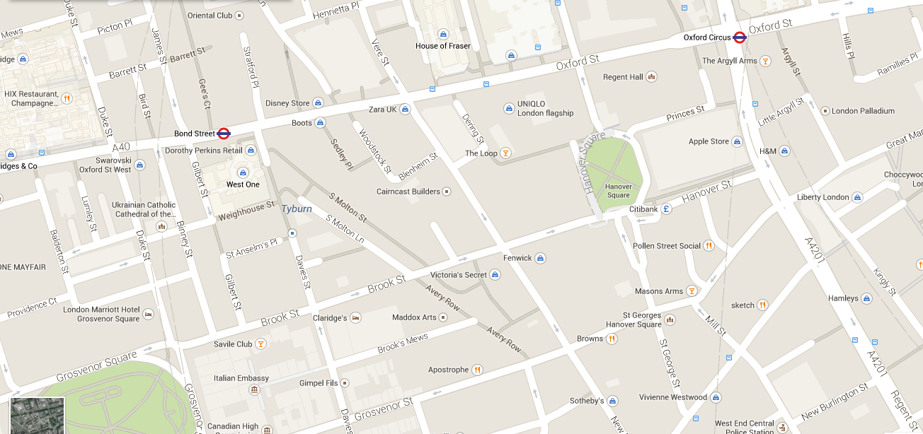
You are here
Homework: Write to mini dialogues. Ask for the way. Be polite!
You want to go to
1. Hamleys 2. The Citibank
Thank you very much.
You’re welcome.

Wo genau?
- It’s next to the …. It’s opposite the ….
- It’s between the …. and the …. It’s on your right/left.
Auf dem Weg..
- Walk past the ….
- There is …. on your right/left.

Welche Richtung?
- Go straight ahead
- Turn left (into…[street name])
- Turn right (into …[street name])
- Take the first/second/third right/left.

Excuse me, can you tell me the way to …….
Of, course. It’s not difficult.

You want to go to:
1 Hannover Square
2 sketch
3 The London Palladium
You are here
Homework: Write to mini dialogues. Ask for the way. Be polite!
You want to go to
1. H&M 2. The Italian Embassy
Thank you very much.
You’re welcome.

You want to go to:
1 Hamleys
2 London Marriot Hotel
3 Browns
Wo genau?
- It’s next to the …. It’s opposite the ….
- It’s between the …. and the …. It’s on your right/left.
Auf dem Weg..
- Walk past the ….
- There is …. on your right/left.

Welche Richtung?
- Go straight ahead
- Turn left (into…[street name])
- Turn right (into …[street name])
- Take the first/second/third right/left.

Excuse me, can you tell me the way to …….
Of, course. It’s not difficult.

