MODULE 2 Personal Time Planner

Week 1 |  | Week 2 |  | Week 3 |  | Week 4 |  | Week5
Date: _________ |  | Date: _________ |  | Date: _________ |  | Date: ____ |  | Date: ____
Date: _________ |  | Date: _________ |  | Date: _________ |  | Date: ____ |  | Date: ____
Date: _________ |  | Date: _________ |  | Date: _________ |  | Date: ____ |  | Date: ____
Week 6 |  | Week 7 |  | Week 8 |  | Week 9
Date: _________ |  | Date: _________ |  | Date: ____ |  | Date: ____
Date: _________ |  | Date: _________ |  | Date: ____ |  | Date: ____
Date: _________ |  | Date: _________ |  | Date: ____ |  | DATE: |  | 

normaler Zeitplan: (2 Jahre) Zeitplan für 3 Jahre:
Start: vor Mitte November Start: Ende November
Abschluss: Vor Weihnachten Abschluss: Anfang Februar
Be proactive in English, year 1

Life is what happens to me ☹ Life is what I make happen 😊😊
  Work in class | - Ich arbeite konzentriert und ruhig ohne meine MitschülerInnen zu stören.  - Ich arbeite selbständig.  - Ich wende B-B-B an und frage erst nach wenn nötig. (Brain-Book-Buddy)  - Ich arbeite flott und vertrödle keine Zeit. | 1  not yet | 2 | 3 | 4  very poor | 5  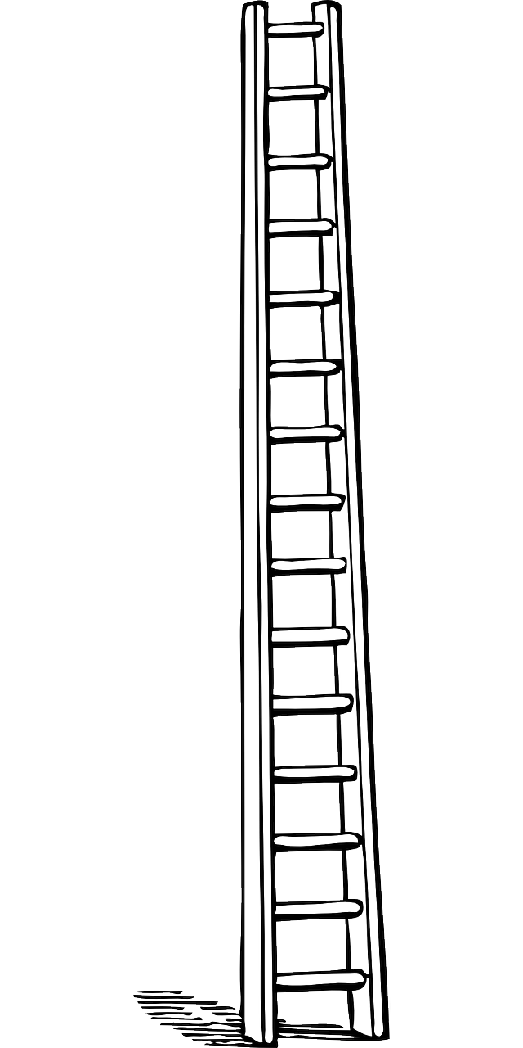  poor | 6  fair | 7  average | 8  good | 9  very good | 10  excellent
Work at home | - Ich arbeite regelmäßig mit meiner Vokabelbox und dem vocab-practice book. (Meine Vokabelbox geht nicht über.)  - Ich mache regelmäßig „stretch your memory“ in meinem vocab-practice book.
Time-management | - Ich nütze die Zeit in der Schule effektiv zum Lernen.  - Ich mache meine Module im Zeitplan. (Notfalls zuhause fertig gemacht)
My texts | - Meine Texte sind sorgfältig und so gut wie möglich geschrieben.  - Ich schreibe so viel wie möglich.  - Ich schreibe ordentlich und leserlich.  - Ich gebe meine Texte immer ab  - Ich mache nur wenige Fehler bei den Dingen, die wir schon gelernt haben.  - Ich korrigiere meine Fehler auf Vokabelkärtchen. |  |  |  | 
Speaking | - Ich versuche möglichst viel Englisch zu sprechen.  - Ich rede bei Gruppen- und Partnerarbeit und Spielen Englisch.
Listening | - Ich mache die Hörübungen im Modul so oft bis ich sie verstehe.  - Ich versuche so viel wie möglich zu verstehen, wenn jemand Englisch spricht.
Reading | - Ich lese die Englischen Arbeitsanweisungen und versuche sie zu verstehen.  - Ich lese Englische Texte (English Magazines) und versuche so viel wie möglich zu verstehen.
English Outside of School | - Ich finde Englische Worte und Sätze in meinem Alltag.  - Ich versuche Englische Lieder zu verstehen und schaue mir Englische Videos an.

Challenge1: Find the rule (Regel)…
LOOK at the VERBS (live, love, speak…)
M2
Task 1

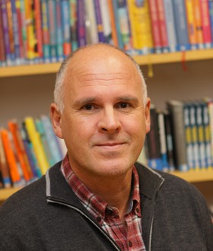
Hello, I am Mr Grasser.
I live in a white house in Dobl. I am a Maths teacher. I love sitting in my garden and reading books. I speak German and English. I have two children – a daughter and a son and a granddaughter. I love my grandchild.
I like travelling in my camper 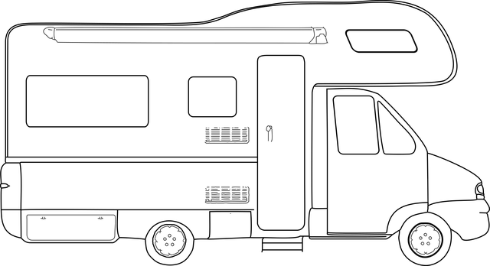. I go to school by car – I have an electric car.

This is Mr Grasser.
He lives in a white house in Dobl. He is a Maths teacher. He loves sitting in his garden and reading books. He speaks German and English. He has two children – a daughter and a son and a granddaughter. He loves his grandchild.
He likes travelling in his camper . He goes to school by car –he has an electric car.

What do you notice?

Challenge: Read the texts and find a rule!
Tell it to a teacher.

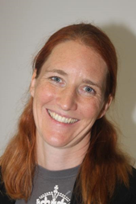

This is Mrs. Bergmann.
She lives in a yellow house in Graz. She has a big family. She loves her family. She speaks German, English and a little bit French. She is an English teacher and she loves reading English books and watching English TV series. She also likes sports. In summer she goes swimming and jogging, and she rides her bike to school every day. She also likes dancing a lot.

Hello, I am Mrs. Bergmann.
I live in a yellow house in Graz. I have a big family. I love my family! I speak German, English and a little bit French. I am an English teacher and I love reading English books and watching English TV series. I also like sports. In summer I go swimming and jogging, and I ride my bike to school every day. I also like dancing a lot.

Challenge part 2: Use the rule (go to your personal grammar book)

Task 2: Finding out about my friends
M2
Task 2

- What is the question? Read Mrs. Pölzleitner’s answers and write the fitting question (passende Frage) into column 1.
- What about you? Write your answers.
- ENGLISH ONLY: Now interview a classmate. Remember: We speak ENGLISH only!
- Practice your interview. Then record it on flipgrid.
What are your favorite foods?
What’s your email address?
What’s your name?
What are your favorite hobbies?
What languages do you speak?
Do you have any brothers and sisters?
Where do you live?
Where do you come from?
Do you have any pets?
What’s your phone number?

What’s the question? | Mrs. Pölzleitner’s answers | Your answers
 | My name is Elisabeth Pölzleitner
 | I live in Graz, St. Peter.
 | I come from Austria, from Bruck an der Mur.
 | Yes, I have one sister. She is called Maria.
 | Yes, I have a cat and four ducks.
 | I really like reading, skiing and learning languages.
 | I speak German, English, French, Greek and Italian.
 | I like all fruits and vegetables. I do not eat meat. One of my favorite foods is Indian curry.
 | My e-mail address is elisabeth.poelzleitner@phst.at
 | My phone number at school is 0316 80671222


Help card
Hobbies: I like playing tennis, playing the piano, watching TV, playing computer games, painting, dancing, singing, skiing, reading, …
Family: I do not have any brothers and sisters. I am an only child. I have … brother(s) and … sister(s). They are called Max, Moritz and Anna.
Pets: I have a dog, a hamster, some fish, a guinea pig, a horse, a budgie, three white mice (one mouse), a rat, a turtle, …

My countries and languages – Put this page into your ME Book
Choose two colors. Colour1: Color the countries where you have already been and label them.
Colour2: Colour the countries that you would like to visit.
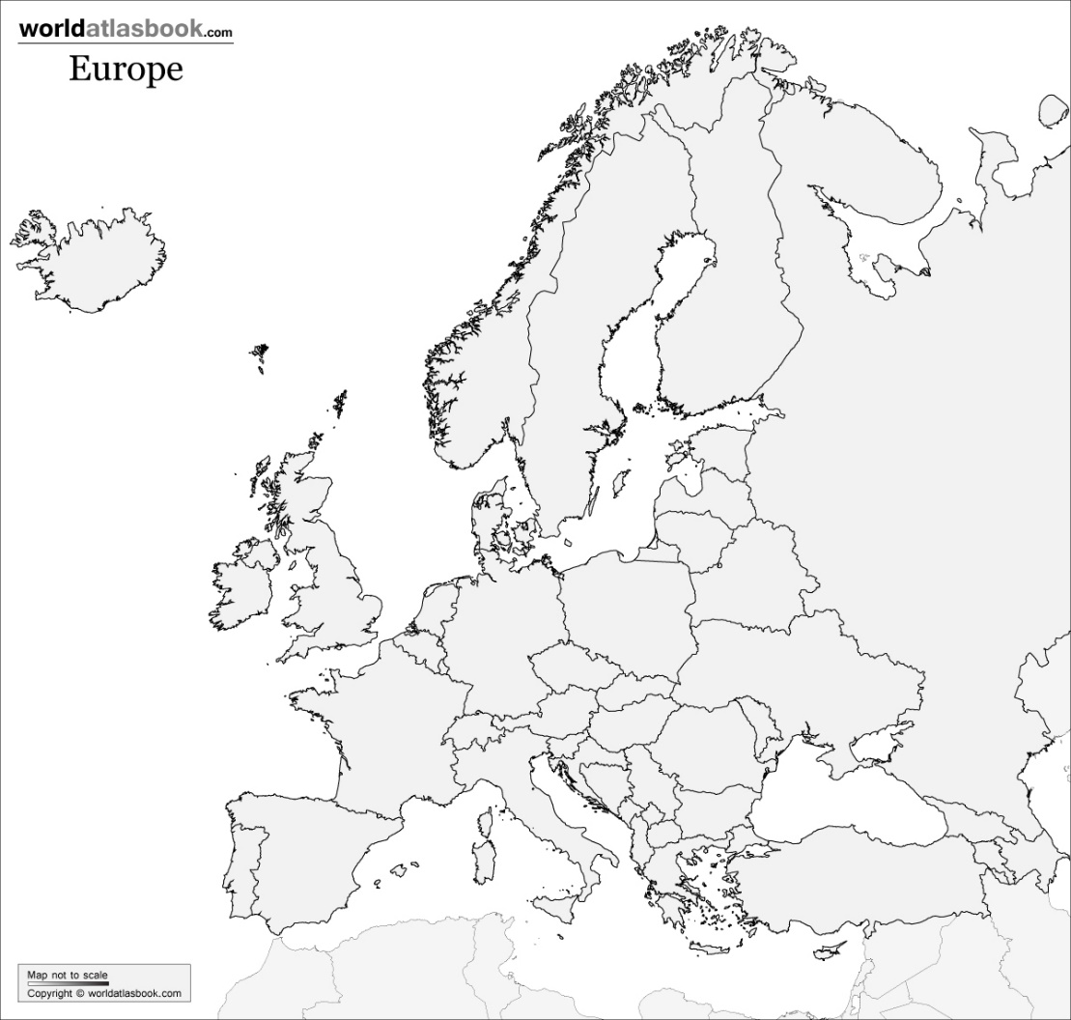
My Language Portrait
What languages do you speak?
Where are they in your body?

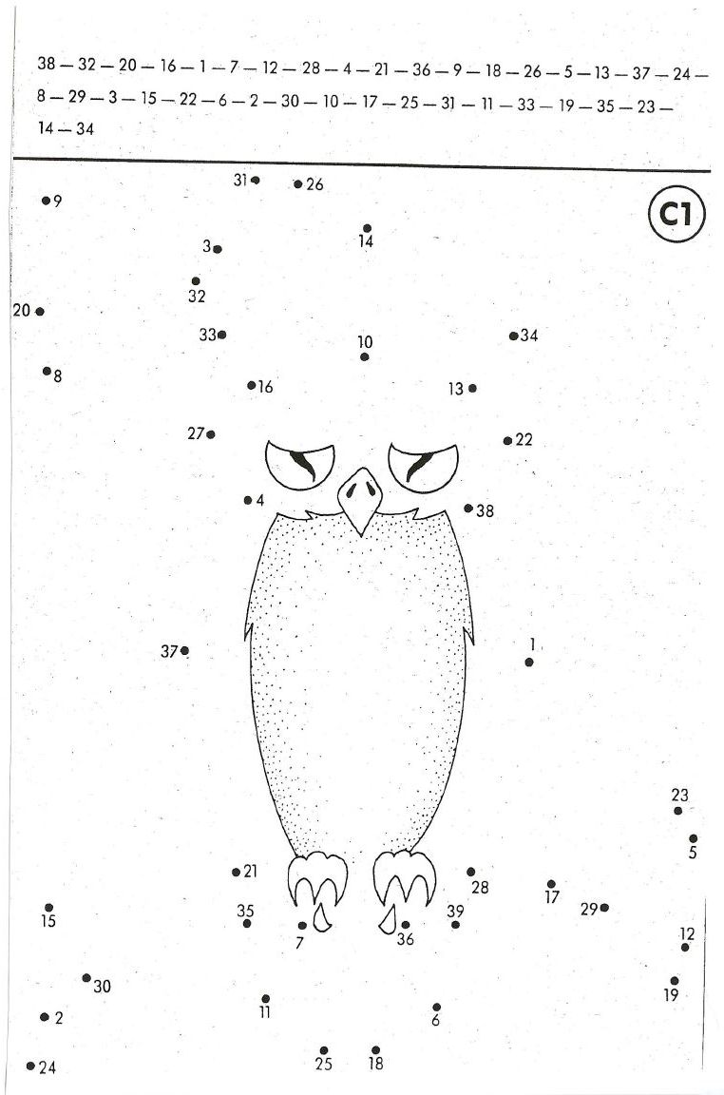
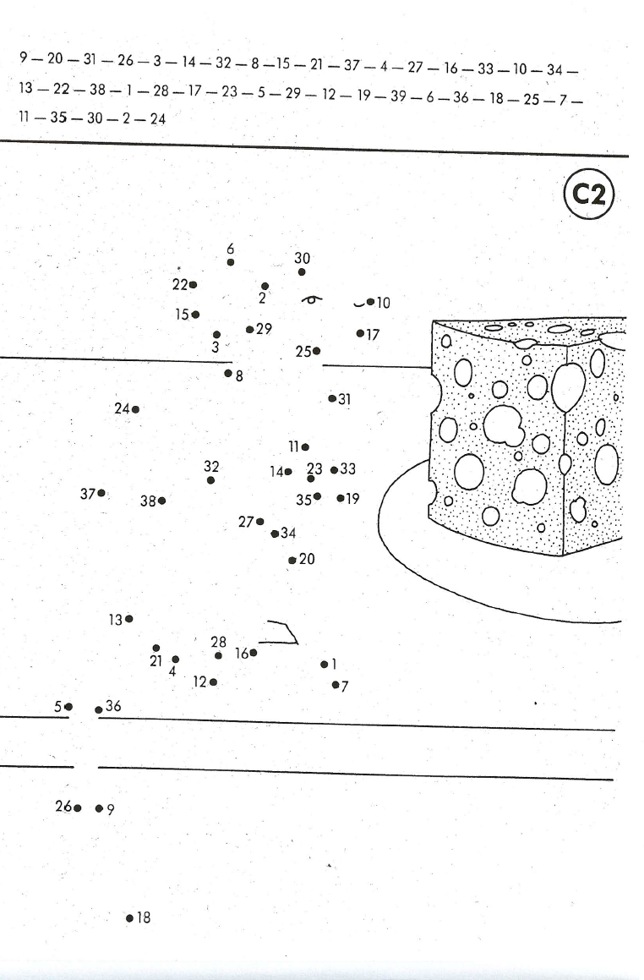
M2
Task 3

Numbers drawing A

Numbers drawing B

