M2: I speak --- She speaks – I live ---He lives

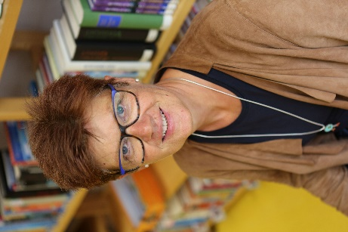
This is Mrs. Pölzleitner.
She lives in a blue house in Graz. She is an English teacher. She loves reading books and learning languages. She speaks English, German, French, Italian and Greek. She also likes sports. In winter she goes skiing and in summer she goes jogging. She rides her bike to school every day. Her favorite food is Indian curry. She is vegetarian, so she does not eat meat.
Hello, I am Mrs. Pölzleitner.
I live in a blue house in Graz. I am an English teacher. I love reading books and learning languages. I speak English, German, French, Italian and Greek. I also like sports. In winter I go skiing and in summer I go jogging. I ride my bike to school every day. My favorite food is Indian curry. I am vegetarian, so I do not eat meat.



This is Mrs. delCueto.
She lives in a small white house in Graz. She has a big family. She loves riding her bike and watching animals. She has three guinea-pigs. She also likes gardening. In summer she goes swimming in her little pool and she reads lots of books.
Hello, I am Mrs. delCueto.
I live in a small white house in Graz. I have a big family. I love riding my bike and watching animals. I have three guinea-pigs. I also like gardening. In summer I go swimming in our little pool and read lots of books.


My rule:

Ich verwende das S (lives, loves, likes, has, goes) wenn ich über eine andere Person berichte.

