M2: Ordinal Numbers: first, second, third…
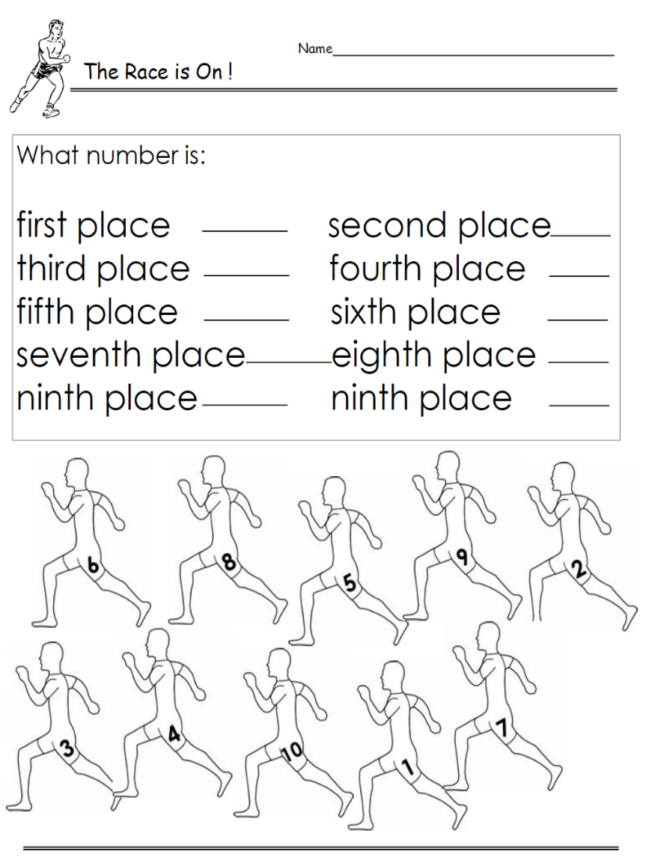
first 1st
second 2nd
third 3rd
fourth 4th
fifth 5th
sixth 6th
seventh 7th
eighth 8th
ninth 9th
tenth 10th
eleventh 11th
…
twenty-first 21st
twenty-second 22nd
thirty-third 33rd
forty-fourth 44th
…

Who wins the race? Write sentences about all the runners:
Example:
Number 3 is in first place.
Number 6 is in second place.

www.worksheetplace.com


Now it’s your turn:

Number 3 is in first place.
Number 6 is in second place.
Number 4 is in third place.
Number 8 is in fourth place.
Number 10 is in fifth place.
Number 5 is in sixth place.
Number 1 is in seventh place.
Number 9 is in eighth place.
Number 7 is in ninth place.
Number 2 is in tenth place.

