Challenge1: Find the rule (Regel)…
M2
Task 1


Hello, I am Mr Grasser.
I live in a white house in Dobl. I am a Maths teacher. I love sitting in my garden and reading books. I speak German and English. I have two children – a daughter and a son and a granddaughter. I love my grandchild.
I like travelling in my camper 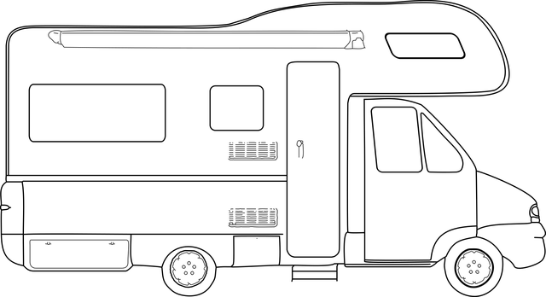. I go to school by car – I have an electric car.

This is Mr Grasser.
He lives in a white house in Dobl. He is a Maths teacher. He loves sitting in his garden and reading books. He speaks German and English. He has two children – a daughter and a son and a granddaughter. He loves his grandchild.
He likes travelling in his camper . He goes to school by car –he has an electric car.

What do you notice?

Challenge: Read the texts and find a rule!
Tell it to a teacher.

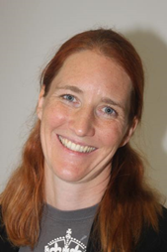

This is Mrs. Bergmann.
She lives in a yellow house in Graz. She has a big family. She loves her family. She speaks German, English and a little bit French. She is an English teacher and she loves reading English books and watching English TV series. She also likes sports. In summer she goes swimming and jogging, and she rides her bike to school every day. She also likes dancing a lot.

Hello, I am Mrs. Bergmann.
I live in a yellow house in Graz. I have a big family – I love my family! I speak German, English and a little bit French. I am an English teacher and I love reading English books and watching English TV series. I also like sports. In summer I go swimming and jogging, and I ride my bike to school every day. I also like dancing a lot.

