Stretch your Memory
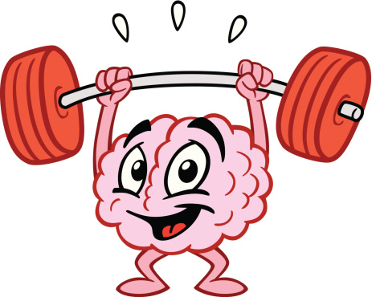
This Photo by Unknown Author is licensed under CC BY-SA
- Pick a card.
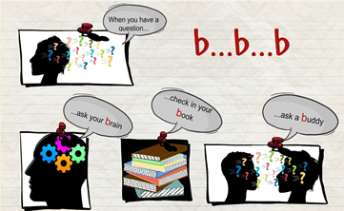
- Read the text carefully. If you do not understand a word
- guess its meaning (rate was es bedeuten könnte)
- use your book or your vocabulary list
- ask your teacher
- Put the card on the blackboard with a magnet.
- Now you are ready to “stretch your memory”. Merke dir soviel du kannst und gehe langsam zu deinem Platz und schreibe es auf ein Blatt. Gehe solange hin und her bis du den ganzen Text geschrieben hast. Vergleiche am Ende und verbessere deine Fehler. Schreibe alle Sätze in denen du Fehler gemacht hast auf Vokabelkarten.

Stretch your memory:
Our classroom:  Our classroom is nice and big. We have very large windows with colorful curtains.  Our walls are white and we have a big green blackboard.  Our desks are gray and our chairs are brown.  On the teacher’s desk there is a computer and we have a projector.  The floor of our classroom is yellow.  On the back wall there are two big, grey cupboards and we have brown shelves for our books and folders.  I really like our classroom. | My best friend:  My best friend is called Mark. He is eleven years old and he is really cool. He likes playing soccer and he likes singing a lot.  Mark has a large family. He has three brothers and two sisters. They are all very nice.  Mark’s dog is very big. It is black and brown.  I really like my friend Mark. | My friend Sally  My friend Sally is very nice, but sometimes she is a bit silly. Sally likes singing and dancing. She also likes to go to school. Her favorite subjects are English and German. Sally doesn’t like maths.  Sally is an only child. She doesn’t have any brothers and sisters, but she has lots of friends. | Mr. Miller  Mr. Miller is an English teacher. He really likes school. Mr. Miller comes from America. He speaks English and a bit of German.  Mr. Miller likes his students, but he doesn’t like noise. He likes voice level 0 and voice level 1.

