Challenge1: Find the rule (Regel)…
M2
Task 1

This is Mrs. Pölzleitner.
She lives in a blue house in Graz. She is an English teacher. She loves reading books and learning languages. She speaks English, German, French, Italian and Greek. She also likes sports. In winter she goes skiing and in summer she goes jogging. She rides her bike to school every day. Her favorite food is Indian curry. She is vegetarian, so she does not eat meat.
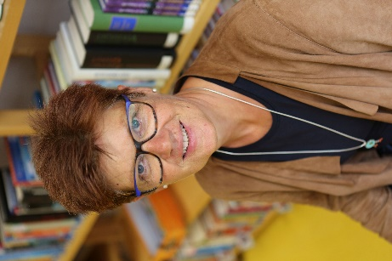

Hello, I am Mrs. Pölzleitner.
I live in a blue house in Graz. I am an English teacher. I love reading books and learning languages. I speak English, German, French, Italian and Greek. I also like sports. In winter I go skiing and in summer I go jogging. I ride my bike to school every day. My favorite food is Indian curry. I am vegetarian, so I do not eat meat.

What do you notice?

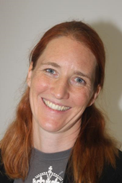

Challenge: Read the texts and find a rule!
This is Mrs. Bergmann.
She lives in a yellow house in Graz. She has a big family. She loves reading books and watching English TV series. She also likes sports. In summer she goes swimming and jogging, and she rides her bike to school every day. She also likes dancing a lot.
Hello, I am Mrs. Bergmann.
I live in a yellow house in Graz. I have a big family. I love reading books and watching English TV series. I also like sports. In summer I go swimming and jogging, and I ride my bike to school every day. I also like dancing a lot.

Challenge part 2: Use the rule:

Now it's your turn
Step 1: Draw a large speech bubble and write a similar text about yourself. Hand it in to your teacher.
Step2: Correct your speech bubble and put it on the pin board.
Step 3: Find a speech bubble from a classmate on the pin board or get one from your teacher. Then draw a box and write about your classmate. Hand your text in to your teacher. (Don’t forget to write YOUR NAME on the sheet.)
Get the blue sheet for your LR book from your teacher and put your speech bubble and your text box into your LR book.

Task 2: Finding out about my friends
M2
Task 2

- What is the question? Read Mrs. Pölzleitner’s answers and write the fitting question (passende Frage) into column 1.
- What about you? Write your answers.
- ENGLISH ONLY: Now interview a classmate. Remember: We speak ENGLISH only!
- Practice your interview. Then record it on fliprid.
What are your favorite foods?
What’s your email address?
What’s your name?
What are your favorite hobbies?
What languages do you speak?
Do you have any brothers and sisters?
Where do you live?
Where do you come from?
Do you have any pets?
What’s your phone number?

What’s the question? | Mrs. Pölzleitner’s answers | Your answers
 | My name is Elisabeth Pölzleitner
 | I live in Graz, St. Peter.
 | I come from Austria, from Bruck an der Mur.
 | Yes, I have one sister. She is called Maria.
 | Yes, I have a cat and four ducks.
 | I really like reading, skiing and learning languages.
 | I speak German, English, French, Greek and Italian.
 | I like all fruits and vegetables. I do not eat meat. One of my favorite foods is Indian curry.
 | My e-mail address is elisabeth.poelzleitner@phst.at
 | My phone number at school is 0316 80671222


Help card
Hobbies: I like playing tennis, playing the piano, watching TV, playing computer games, painting, dancing, singing, skiing, reading, …
Family: I do not have any brothers and sisters. I am an only child. I have … brother(s) and … sister(s). They are called Max, Moritz and Anna.
Pets: I have a dog, a hamster, some fish, a guinea pig, a horse, a budgie, three white mice (one mouse), a rat, a turtle, …

My countries and languages – for your ME Book
Choose two colors. Colour1: Color the countries where you have already been and label them.
Colour2: Colour the countries that you would like to visit.
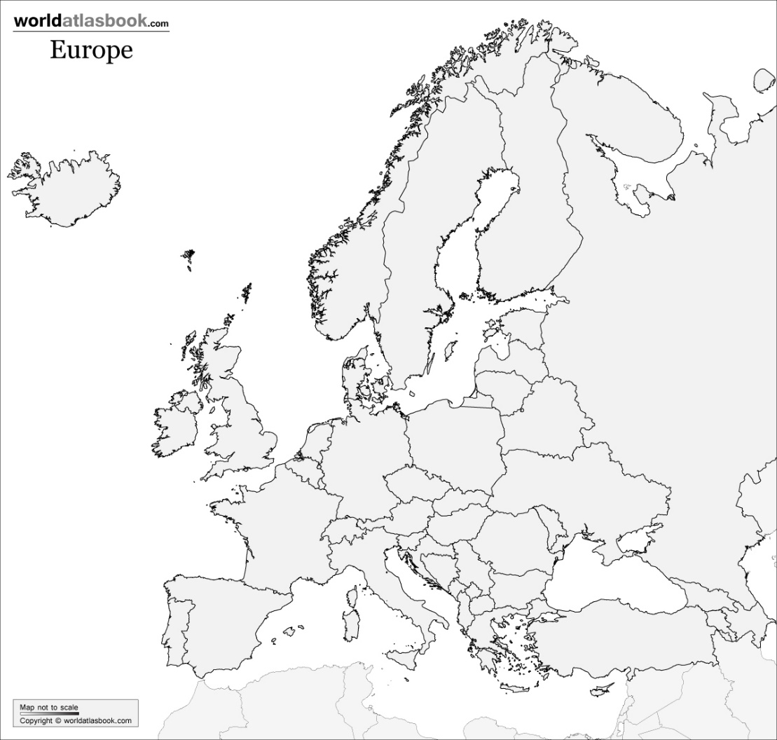
My Language Portrait
What languages do you speak?
Where are they in your body?

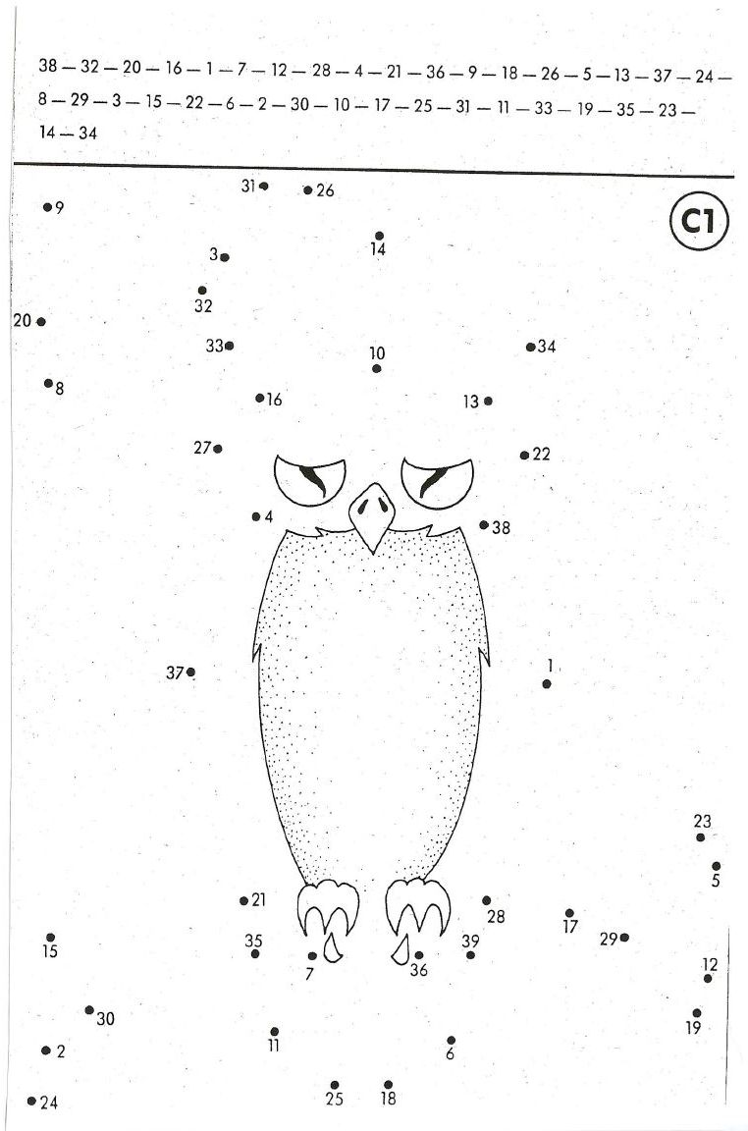
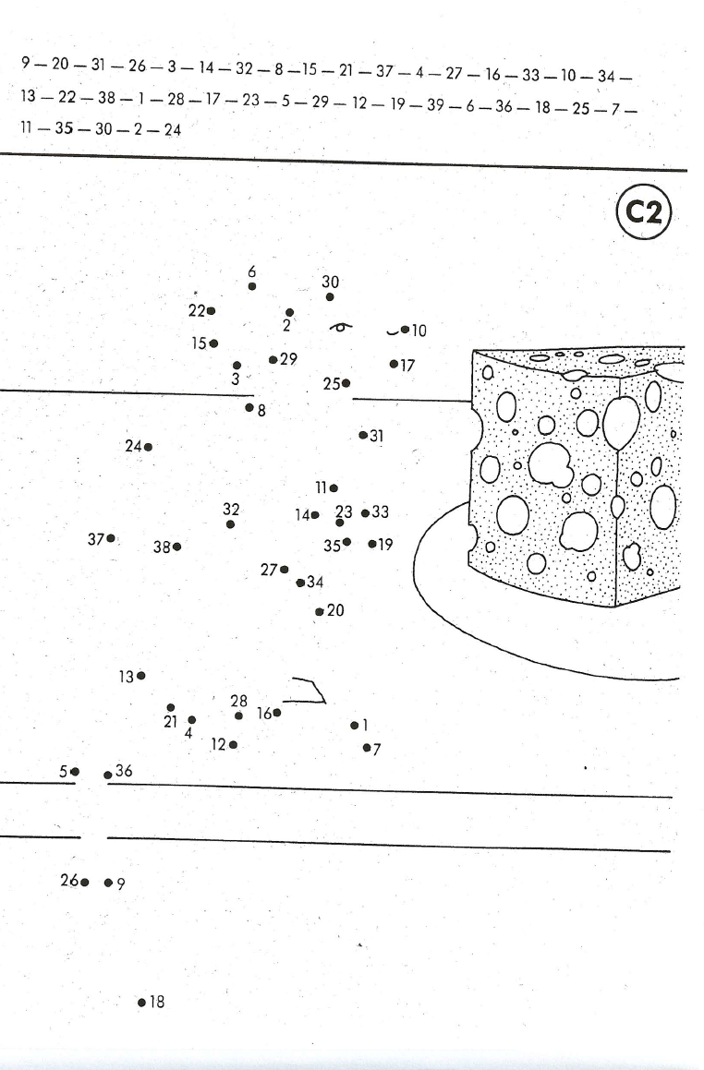
M2
Task 3

Numbers drawing A

Numbers drawing B

For your LR Book: do these tasks, then ask your teacher for the blue sheets for your LR book.

a or an
an apple  an orange  an onion  an ice-cream  an ugly duck  an nteresting book | a boy  a girl  a chair  a dog  a unicorn  a unicycle

Wenn ich am Beginn eines Wortes ein a e i o u HÖRE oder SPRECHE, verwende ich an.
Ich sage a unicorn, a unicycle weil…………………………………………………………………………………..

Now it’s your turn: Zeichne auf einem Blatt zwei große Kreise. Schreibe in den einen Kreis möglichst viele Wörter vor denen wir ein a sagen. Im anderen Kreis sammelst du Wörter vor denen wir an sagen.
an
a

Get the blue sheet for your LR book from your teacher. Write your answers again very nicely and put them into your LR book.

BIG LETTERS – small letters

In English we use big letters for
- I
- names (Paula, Peter),
- countries (England, Austria)
- cities (Vienna, Graz, London)
- languages (German, Croatian, English)
- and at the beginning of sentences.

In the English lessons we speak English. Elisabeth and Selina are talking about London and England but I am reading a book about America.

Now it’s your turn: Write 3 sentences and mark the BIG LETTTERS.
Schreibe deine Beispiele auf die gegenüberliegende Seite.

For your LR Book

am – is – are
I am a student at PraxisNMS.  I am ten years old.  I am not in class 4b. (I’m not…)  Draw yourself here:   | How old are you?    You are a very nice person. You are not horrible.  is licensed under CC BY-SA  You are my best friend.  Mary and Peter are good friends.  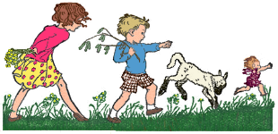  They are very happy.    We are also happy.  We are not sad.  (We aren’t sad.) | Anton is not in my class.  He is in NMS Kepler.  He is funny.    Sally is a student in England.  She is very nice.

Now it’s your turn: Write 10 sentences with am-is-are .
Write true sentences about yourself, your friends, your classmates and teachers and your family members or pets.
Schreibe immer wahre, sinnvolle Sätze.
Show your sentences to your teacher. Then write the correct sentences on the blue sheet and put it into your LR book.

For your LR Book - NUMBERS
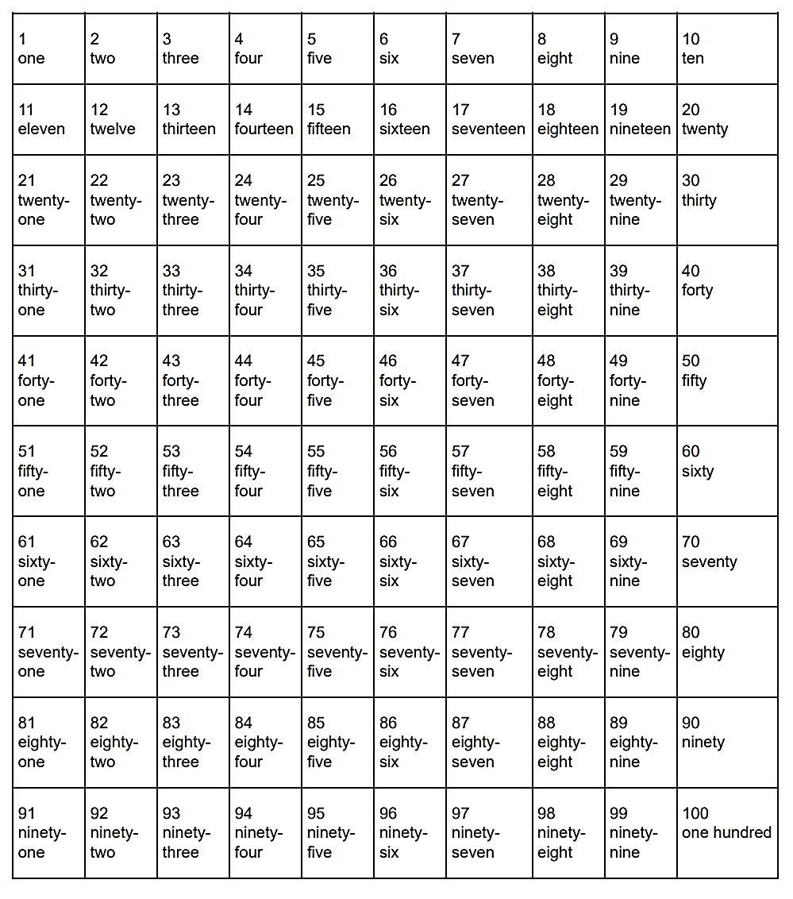
Now it’s your turn:
task 1: Write page numbers into your ME-book. Write numbers and words: 1 -one, 2 – two 3—three…..
task 2: Choose one number in each row and tell us what it means for you. Write your answers on a sheet of paper.
Example:
- Twenty-five: My daughter is twenty-five years old.
- seventy-four: I live in Scheigergasse seventy-four.
Show your answers to your teacher. Correct them and put the numbers sheets into your LR book.

Ordinal Numbers: first, second, third…
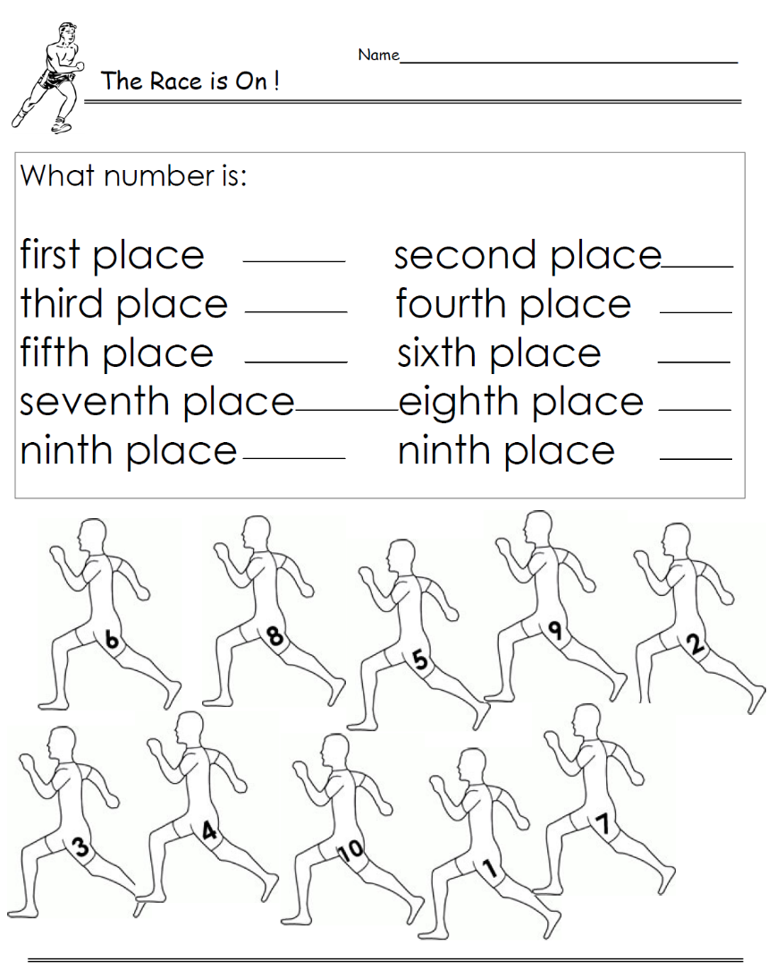
first 1st
second 2nd
third 3rd
fourth 4th
fifth 5th
sixth 6th
seventh 7th
eighth 8th
ninth 9th
tenth 10th
eleventh 11th
…
twenty-first 21st
twenty-second 22nd
thirty-third 33rd
forty-fourth 44th
…
www.worksheetplace.com

Now it’s your turn:
GIVING THE DATE
British:
1st October 2018
2nd November 2018
American:
December 3rd, 2018
January 4th, 2019
February 5th, 2019
When is your birthday?
It’s on ______________________________
What is today’s date?
It’s the _______________________________
On what floor is your English teachers’ office?
It’s on the ____________________________
On what day is Christmas?
It’s o_ _______________________________
When does Ramadan start this year?
It’s _ _ _____________________________

Sh
Show this sheet to your teacher. Then copy your answers on the blue LR book sheet and put it into your LR book folder.

Days of the week and months
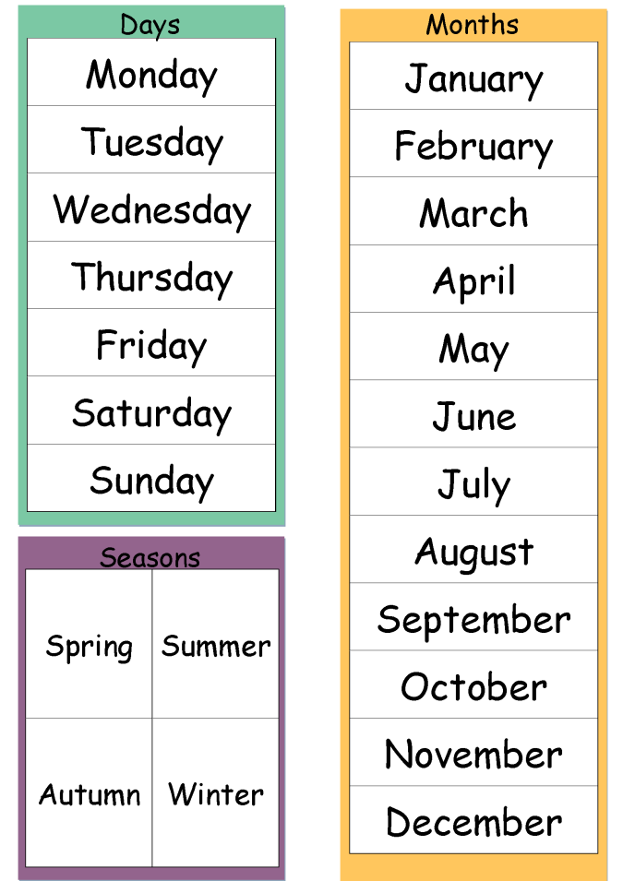
Write your answers on an extra sheet and put it into your LR book, next to the blue LR book sheet for this topic.
What is your favorite season?
What is your favorite month? Tell us why?

In which months do you go swimming?
In which months do you wear short sleeves?
What is your favorite day 😊 of the week? Tell us why.
What is your least favorite ☹ day of the week? Tell us why.

