Sea Battle
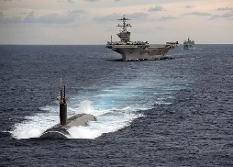  Draw 4 battleships like in the example. Then take turns asking for the numbers.  Words you need:  - missed (daneben),  - hit (angeschossen),  - sunk (versenkt)  Remember:  We speak ENGLISH ONLY!!!
  0 | 1 | 2 | 3 | 4 | 5 | 6 | 7 | 8 | 9
  1
  2
  3
  4
  5
  6
  7
  8
  9

A | B
  0 | 1 | 2 | 3 | 4 | 5 | 6 | 7 | 8 | 9
  1
  2
  3
  4
  5
  6
  7
  8
  9
  0 | 1 | 2 | 3 | 4 | 5 | 6 | 7 | 8 | 9
  1
  2
  3
  4
  5
  6
  7
  8
  9
missed --- hit--- sunk missed hit sunk

A | B
  0 | 1 | 2 | 3 | 4 | 5 | 6 | 7 | 8 | 9
  1
  2
  3
  4
  5
  6
  7
  8
  9
  0 | 1 | 2 | 3 | 4 | 5 | 6 | 7 | 8 | 9
  1
  2
  3
  4
  5
  6
  7
  8
  9
missed hit …..sunk missed hit sunk

