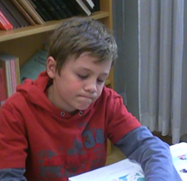  Write about Xaver | Name | Xaver
 | Places | Vienna | Father: Paris  
 | Languages |  | in school: Sp…  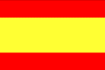
 | Hobbies | 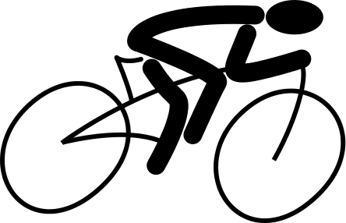 | 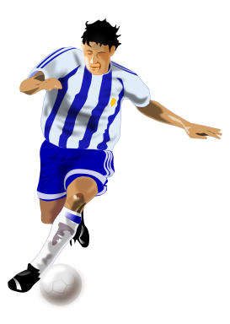
 |  |  | 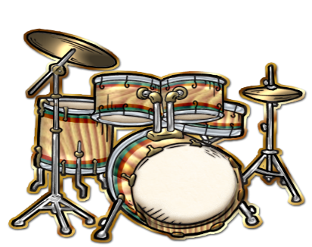  drums
 |  | 
Your ideas
What else can you say about Xaver?

Write about Martina.  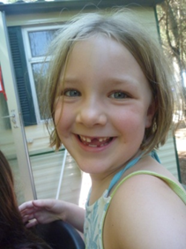 | Name | Martina
 | Places | Graz | Mother: Athens in Gr.  
 | Languages |  | in school  
 | Hobbies | 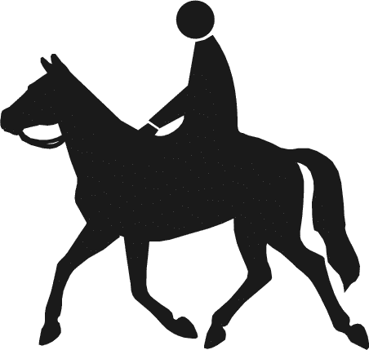 | 
 |  | 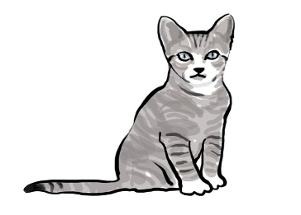 | 
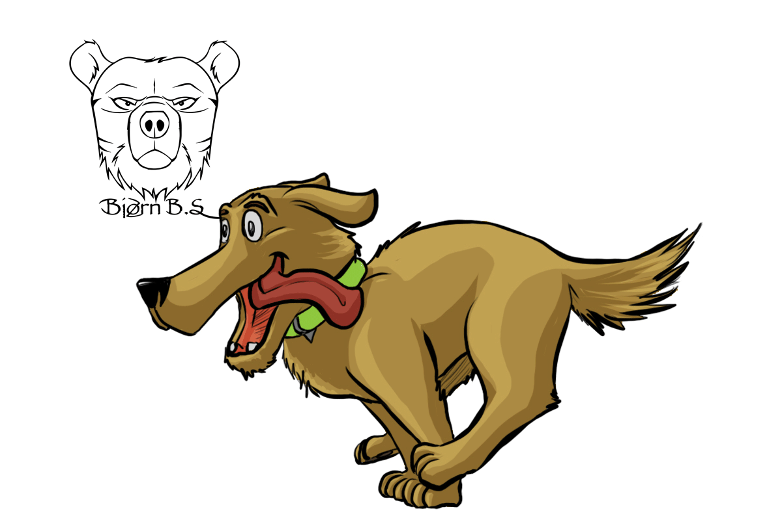
This Photo by Unknown Author is licensed under CC BY-NC-ND
Your ideas…
What else can you say about Martina?

Write about Angela.  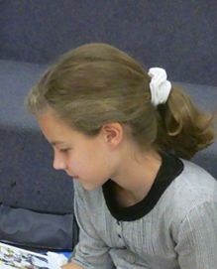 | Name | Angela
 | Places |  | Mother: Croatia  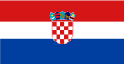
 | Languages | 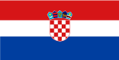 | in school:  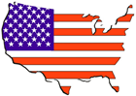
 | Hobbies | 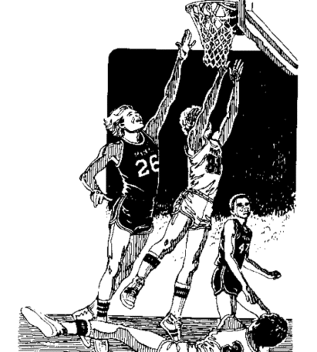
 |  |   This Photo by Unknown Author is licensed under CC BY-SA | 
 |  | 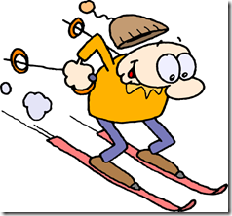
Your ideas…
What else can you say about Anglea?

Write about Tom.   | Name | Tom
 | Places | New York | Mother: Rome  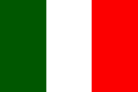
 | Languages | 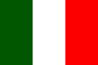 | in school: G  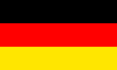
 | Hobbies
 |  |  | 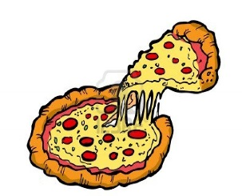  This Photo by Unknown Author is licensed under CC BY-NC-ND
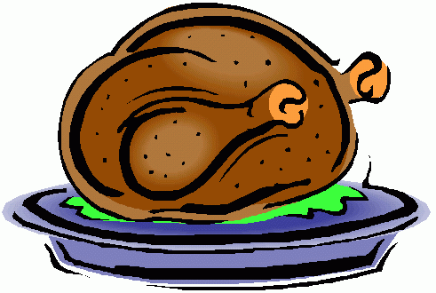
This Photo by Unknown Author is licensed under CC BY-NC-ND
Your ideas…
What else can you say about Tom?

Write about Emily.   | Name | Emily
 | Places | San Francisco | Mother: Egypt  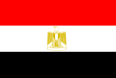
 | Languages | . 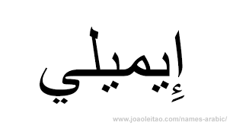 | in school  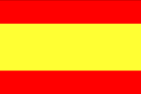
 | Hobbies | 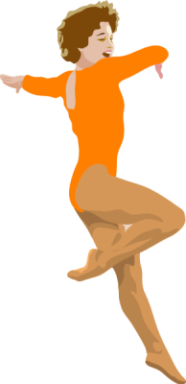
 |  |  | 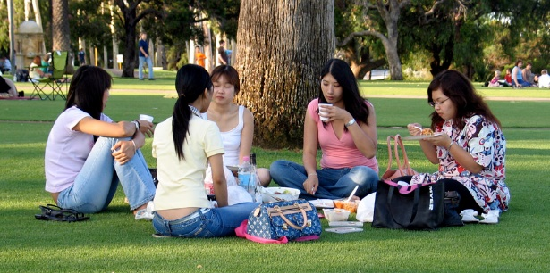
 |  | 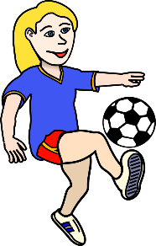
Your ideas…
What else can you say about Emily?

