
MODULE 3 Personal Time Planner

Week 1 |  | Week 2 |  | Week 3 |  | Week 4
Date: _________ |  | Date: _________ |  | Date: _________ |  | Date: ____
Date: _________ |  | Date: _________ |  | Date: _________ |  | Date: ____
Date: _________ |  | Date: _________ |  | Date: _________ |  | Date: ____
Week 5 |  | Week 6 |  | Week 7 |  | Week 8
Date: _________ |  | Date: _________ |  | Date: ____ |  | Date: ____
Date: _________ |  | Date: _________ |  | Date: ____ |  | Date: ____
Date: _________ |  | Date: _________ |  | Date: ____ |  | Date: ____
normaler Zeitplan (2 Jahre) Zeitplan für 3 Jahre:
Start: Weihnachten Start: Semesterende
Abschluss: Semesterende Abschluss: Anfang April

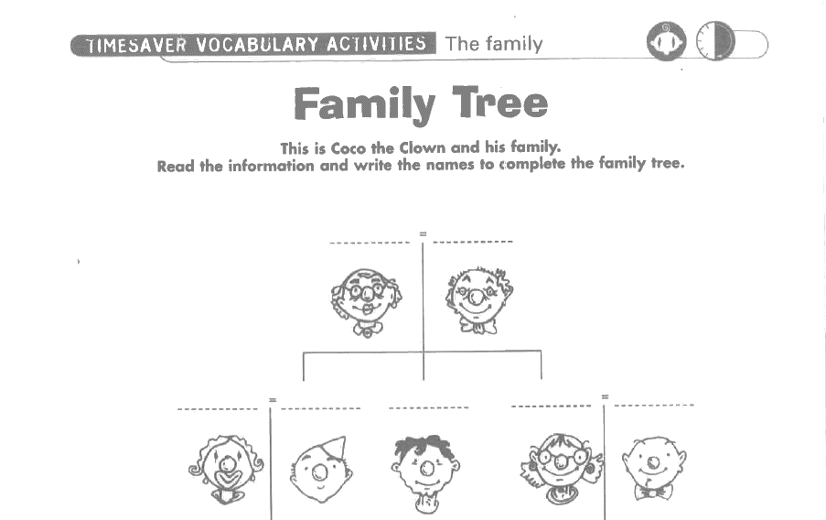
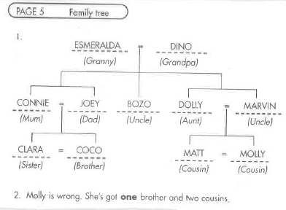
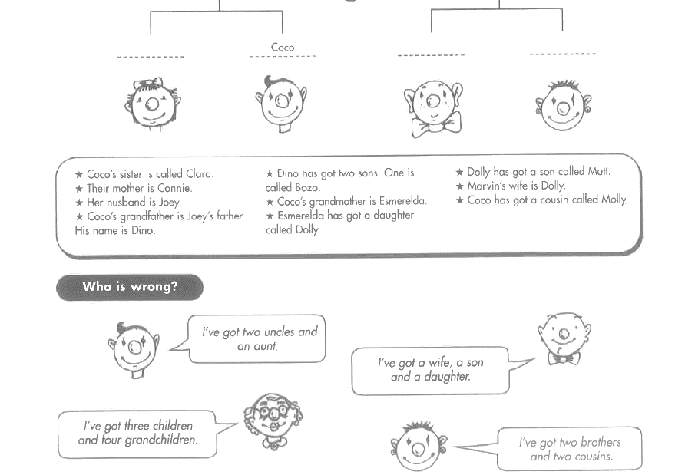
I have two uncles and an aunt.
I have a wife, a son and a daughter.
I have three children and four grandchildren
I have two brothers and two cousins
Module 3: Family
TASK
3A
KEY:
Talking about families: Dialogue chart:
TASK
3B
Prepare a dialogue and act it out
B: _______________ .
A: What’s his name?
No, I don’t.
Do you have a brother?
A: Do you have a pet?
No, I don’t.
B: She likes …….
What about you? Do you have a brother or sister?
Do you have a sister?
A: Does he live at your house?
B: Yes. I have a brother.

A: What does she do in her freetime?
B: She speaks ….

A: What languages does she speak?
B: Yes, she does. /No she doesn’t
A: Does she live at your house?
B: ______________ .
A: What is her name?
Yes. I have a sister.
B: Yes, he does. / No he doesn’t.
A: What languages does he speak?
A: What does he do in his freetime?
B: He likes …….
What about you? Do you have a brother or sister?
B: He speaks ….

B: No, I don’t have a pet.
But what about you? Do you have a pet?
A: What color is it?
B: Yes, they are sweet.
But what about you? Do you have a pet?
A: I like ________, too.
B: It’s ___________.
B: Yes. I have a ____________.

