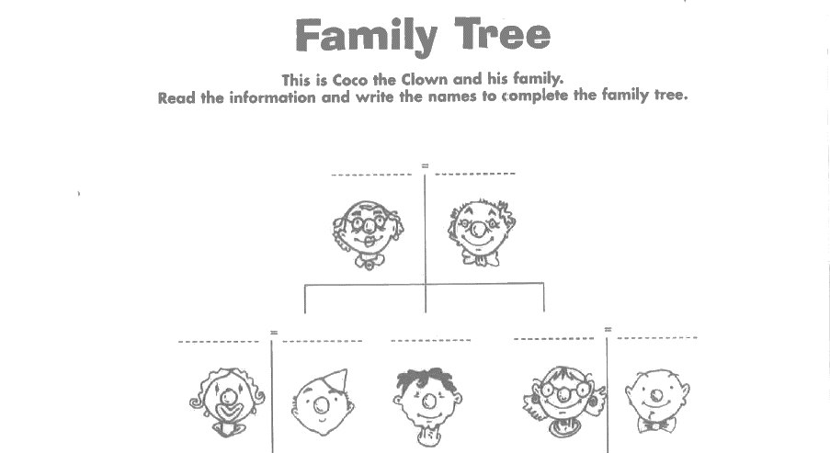
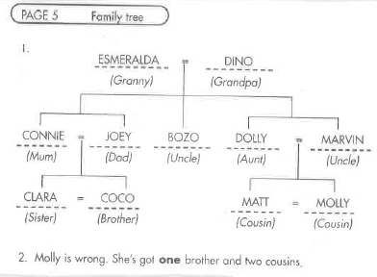
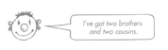
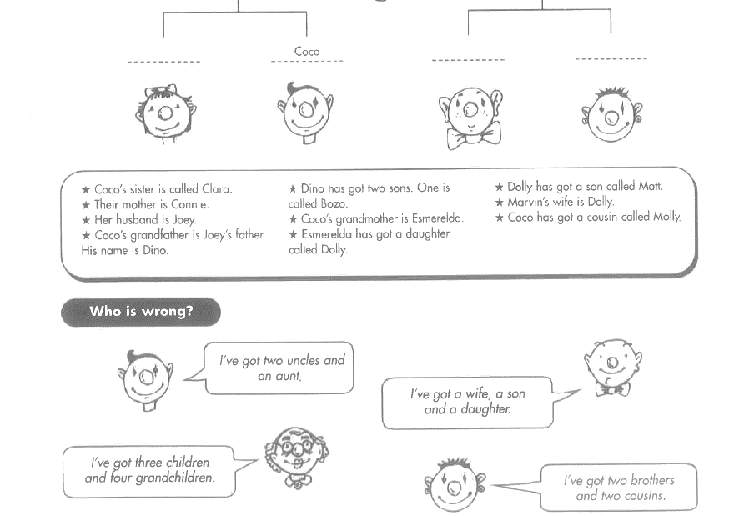
Module 3: Family
I have two brothers and two cousins
I have three children and four grandchildren
I have a wife, a son and a daughter.
I have two uncles and an aunt.
TASK
3A
KEY:
Talking about families: Dialogue chart:
TASK
3B
Prepare a dialogue and act it out
B: _______________ .
A: What’s his name?
No, I don’t.
Do you have a brother?
A: Do you have a pet?
No, I don’t.
B: She likes …….
What about you? Do you have a brother or sister?
Do you have a sister?
A: Does he live at your house?
B: Yes. I have a brother.

A: What does she do in her freetime?
B: She speaks ….

A: What languages does she speak?
B: Yes, she does. /No she doesn’t
A: Does she live at your house?
B: ______________ .
A: What is her name?
Yes. I have a sister.
B: Yes, he does. / No he doesn’t.
A: What languages does he speak?
A: What does he do in his freetime?
B: He likes …….
What about you? Do you have a brother or sister?
B: He speaks ….

B: No, I don’t have a pet.
But what about you? Do you have a pet?
A: What color is it?
B: Yes, they are sweet.
But what about you? Do you have a pet?
A: I like ________, too.
B: It’s ___________.
B: Yes. I have a ____________.
Challenge: Find the rule
TASK
3C

Peter’s brother is called Thomas.
Andrea’s sister is very funny.
My mom’s favorite food is ……………………
My dad’s mom is my grandmother.
My aunt’s dog is really big.

’s
What does it mean?

Ich schreibe ein …‘s um….

Now it’s your turn:
Write 5 similar (ähnliche) sentences on the opposite page.
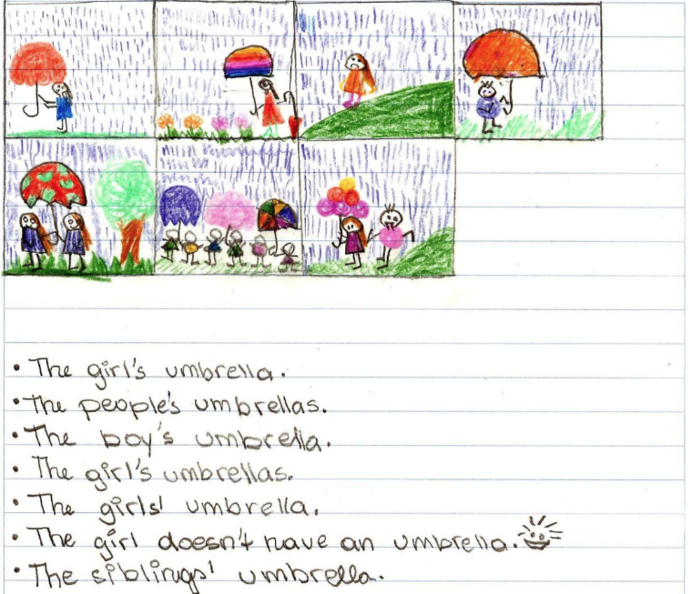
Remember: Always write TRUE sentences that make sense for you.

Besitz: for pros
My parents’ bedroom is very big.
My friends’ houses are beautiful.
The girls’ umbrellas are colorful.
s‘s

Match the pictures and the sentences

Now it’s your turn: Make your own matching game. Write 5 sentences with … .‘s or s’ and draw a picture for each on. Show them to your teacher.
Then ask a friend to match your sentences and your pictures.
Show your answers to your teacher. Then write your answers on the blue sheet in your LR book.

Personal Pronouns
TASK
3D
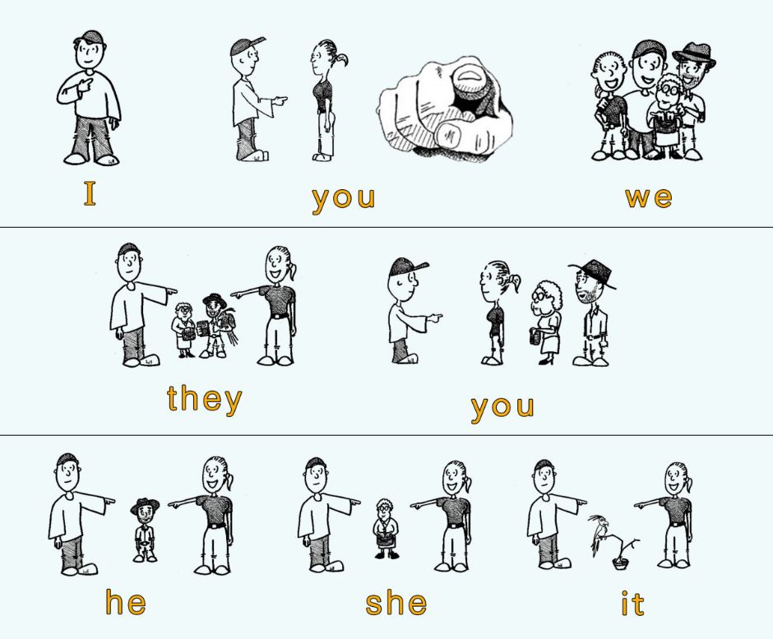
https://benjweinberg.com/2017/11/24/english-corner-personal-pronouns/

Now it’s your turn: Do this exercise online (Focus on Form)
Then complete the text here:

Dear Amy,
……………… am in a new school. ……………. is called PraxisNMS. In my class there are ………… children. ………………….. are all very nice. …………. have many new teachers, ……………….. are very nice too. Only one of the teachers is very strict. …………….. is strict but fair. …………………… have four English teachers. …………………… speak only English with us.
Our class has a cool classroom, ………….. is the best classroom of the whole school.
Do …………………… also like your school? Tell me about it in your next letter.
Yours,
xy

Wem gehören diese Dinge? Possessive Pronouns
TASK
3E

Is this your dog, Thomas?
Yes, these are our children.
These are their pets. They are really cute.



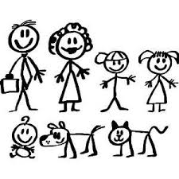
Yes, this is her cat.
Is this Susan’s cat?
Are these your children?
Yes, this is his dog.
Yes, it is my dog.

More examples:
Thomas has a sister. His sister is called Mary.
Mrs. Pölzleitner goes to school by bike. Her bike is black and blue.
Mrs. Bergmann has three children. Her children are called Martina, Julia and Matthias.
We have a very nice classroom. Our classroom is the best.
Some children from my old school go to a “Gymnasium”. Their school is not as cool as ours.

Now write TRUE sentences about yourself and your friends and family.
Use: my, your, his, her, our, their
Show your sentences to your teacher. Then write them on the blue page in your LR book.

Questions
TASK
3F

Look at the questions on this page.
Then write your own questions.

Questions, questions, questions
https://pixabay.com/de/fragezeichen-hinweis-duplikat-2110767/
Do you like bananas?
Does he like bananas?
Where do you come from?
Where does she come from?
When do they get up?
When does your father get up?
Why do you go to school by bike?
Why does Mr. Grasser go to school by car?
What do you do after school?
What does he do after school?

How do your classmates study vocabulary?
How does your best friend get to school?

What do you notice? (Was fällt dir auf?)
- Man kann für Fragen Fragewörter (z.B. ___________________________________________) verwenden, aber man muss nicht.
- Man bildet Fragen häufig mit __________ oder ___________.
Does verwendet man bei ________________________________________________________
- Das verb (z.B. ________________________________________________) verändert sich nicht.
Now it’s your turn: Make a questionnaire (Fragebogen)
- Write a lot of questions to interview guests and student-teachers.
- Put your questionnaire into your LR-Book on the opposite page.
- When we have guests in class, talk to them and ask them lots of questions.


Negation in English
TASK
3G

Look at the examples.

I don’t speak Spanish. I only speak English and German.
My mother doesn’t speak German. She speaks Croatian and English.
My brother doesn’t like dogs. He likes cats.
My dog doesn’t like sitting at home. It likes running in the park.
We don’t eat meat. We eat a lot of vegetables.
You don’t know the new biology teacher. You know the new English teacher.
They don’t live in Graz. They live in Gratkorn.

What do you notice? (Was fällt dir auf?)
- In der Verneinung verwendet man ___________ oder _____________ vor dem Verb (z.B. speak, like, eat)
- Doesn’t (= does not) verwendet man bei ____________________________________________________
- Das verb (z.B. ________________________________________________________) verändert sich nicht.
Now it’s your turn: Write your own examples:
I …
My best friend …
My teacher …
My cat/dog …
My parents …
My friends ….
We ….

Show your examples to your teacher. Then write them again on a blue sheet and put it into your LR book.

