MODULE 4 Personal Time Planner
Week 1 |  | Week 2 |  | Week 3 |  | Week 4 |  | Week5
Date: ________ |  | Date: ________ |  | Date: ________ |  | Date: ____ |  | Date: ___
Date: ________ |  | Date: ________ |  | Date: ________ |  | Date: ____ |  | Date: ____
Date: ________ |  | Date: ________ |  | Date: ________ |  | Date: ____ |  | Date: ____
Week 6 |  | Week 7 |  | Week 8 |  | Week 9
Date: ________ |  | Date: ________ |  | Date: ____ |  | Date: ____
Date: ________ |  | Date: ________ |  | Date: ____ |  | Date: ____
 |  |  |  |  |  |  |  | 
Date: ________ |  | Date: ________ |  | Date: ____

normaler Zeitplan (2 Jahre) Zeitplan für 3 Jahre:
Start: Beginn 2. Semester Start: Anfang April
Abschluss: Anfang April Abschluss: Ende Juni

 | 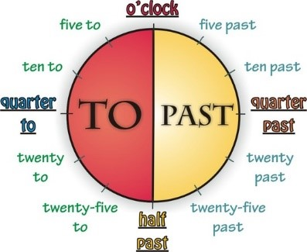
  Telling the time:
  Handout for Module 4
  It’s one o’clock.
  It’s twelve o’clock.
  It’s midnight.
  It’s five (minutes) past three.
  It’s ten past four.
  It’s quarter past five.
  It’s half past six.
  It’s quarter to seven.
  It’s ten to seven.
  It’s five to twelve.
Analogue | Digital | you say: | Hints | Timetables, TV, etc.
 | 6:00 | „It's 6 o’clock."
 | 6:05 | „It's 5 past 6.“ | past | It's six o five.
 | 6:15 | „It's quarter  past 6.“ | past | It's six fifteen.
 | 6:30 | „It's half past 6.“ | past | It's six thirty.
 | 6:35 | „It's 25 to 7.“ | to | It's six thirty-five.
 | 6:45 | „It's quarter to seven.“ | to | It's six forty-five.
 | 6:55 | „It's 5 to 7.“ | to | It's six fifty-five.
 | 7:00 | „It's 7o’clock."

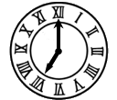
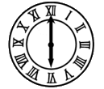



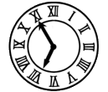
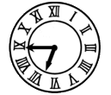
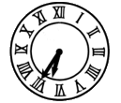
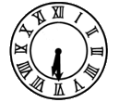
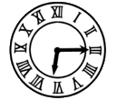
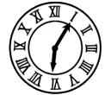
TASK
4A

Time Bingo

Draw in nine different times. Only draw five-minute steps.
Then listen to your teacher and tick off the times that your teacher has announced.
Bingo: If you have ticked off three clocks in a row, shout out “BINGO”. You are the winner!

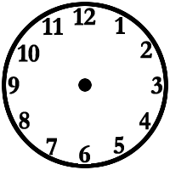

TASK
4B
4. miss the bus
16. have / take a shower
5. wash the hands
6. brush the teeth
7. play in the park
8. get up
9. read a book
10. arrive home
11. have dinner
12. go to bed
13. make the bed
14. watch TV
15. wake up
18. go to the toilet/bathroom
21. leave school
19. wash the face
20. listen to music
3. ride the bike
2. wait for the bus
1. /have lunch
22. have breakfast
23. study / do the homework
17. catch/take the bus
25. walk to school
24. comb the hair
26. get dressed
DAILY ACTIVITIES
Match the actions with the pictures.

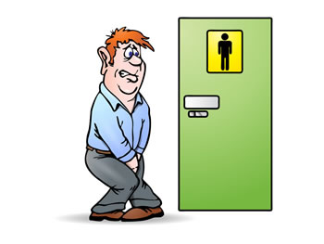
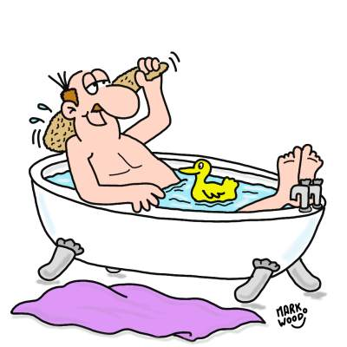
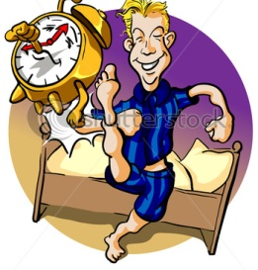
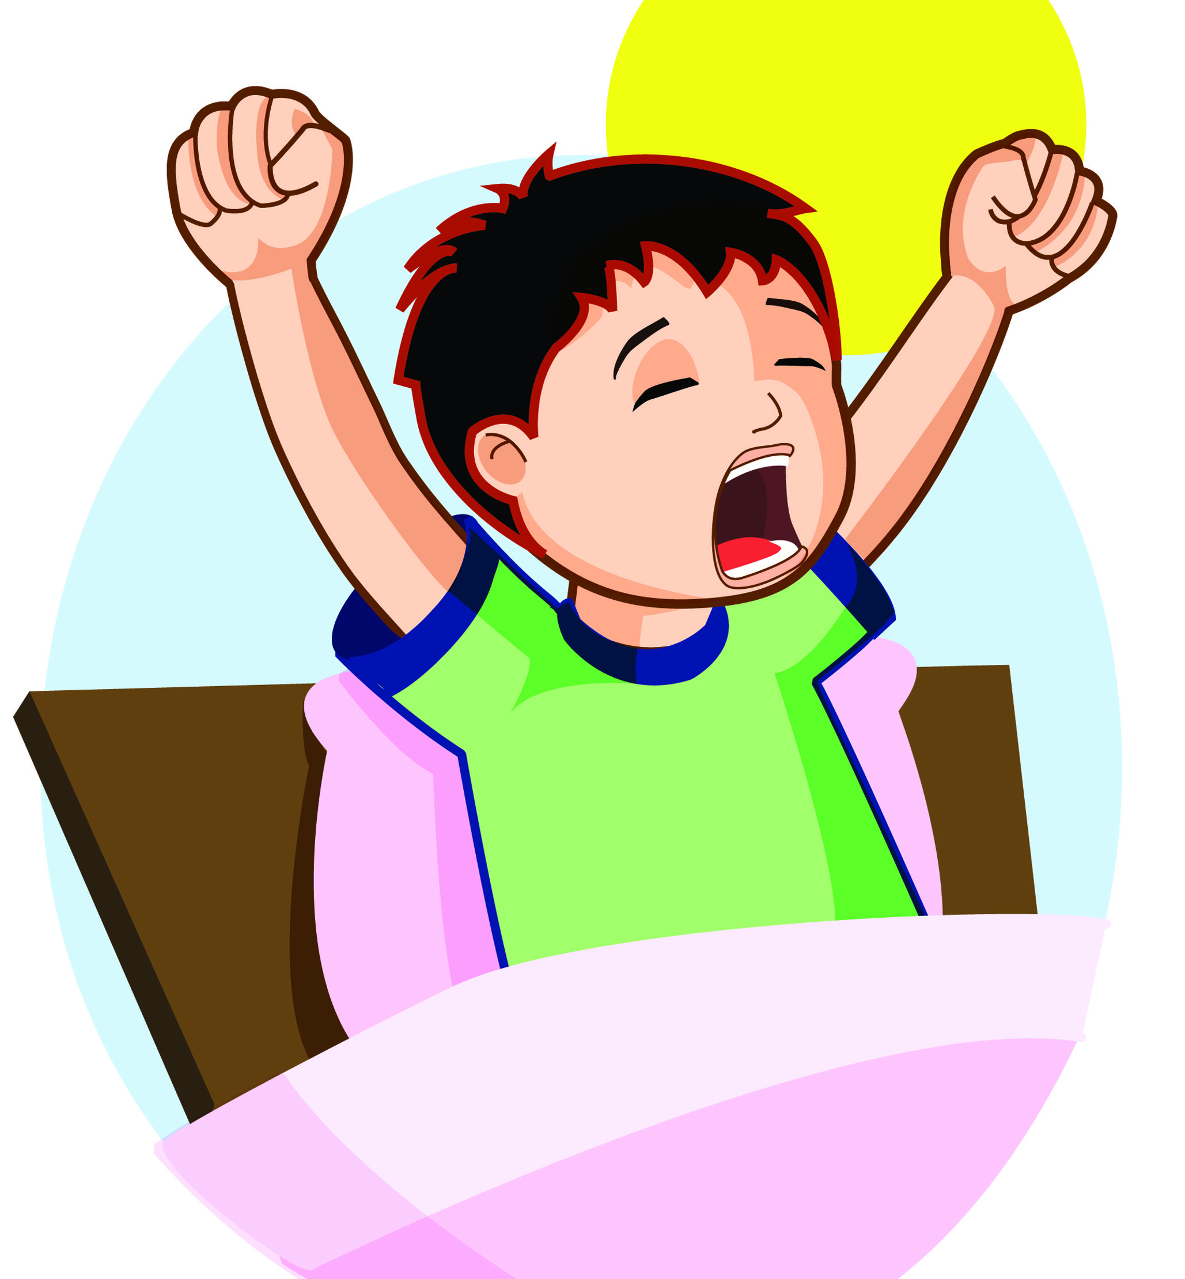

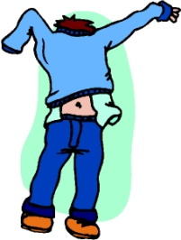
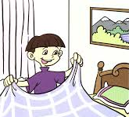
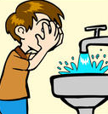
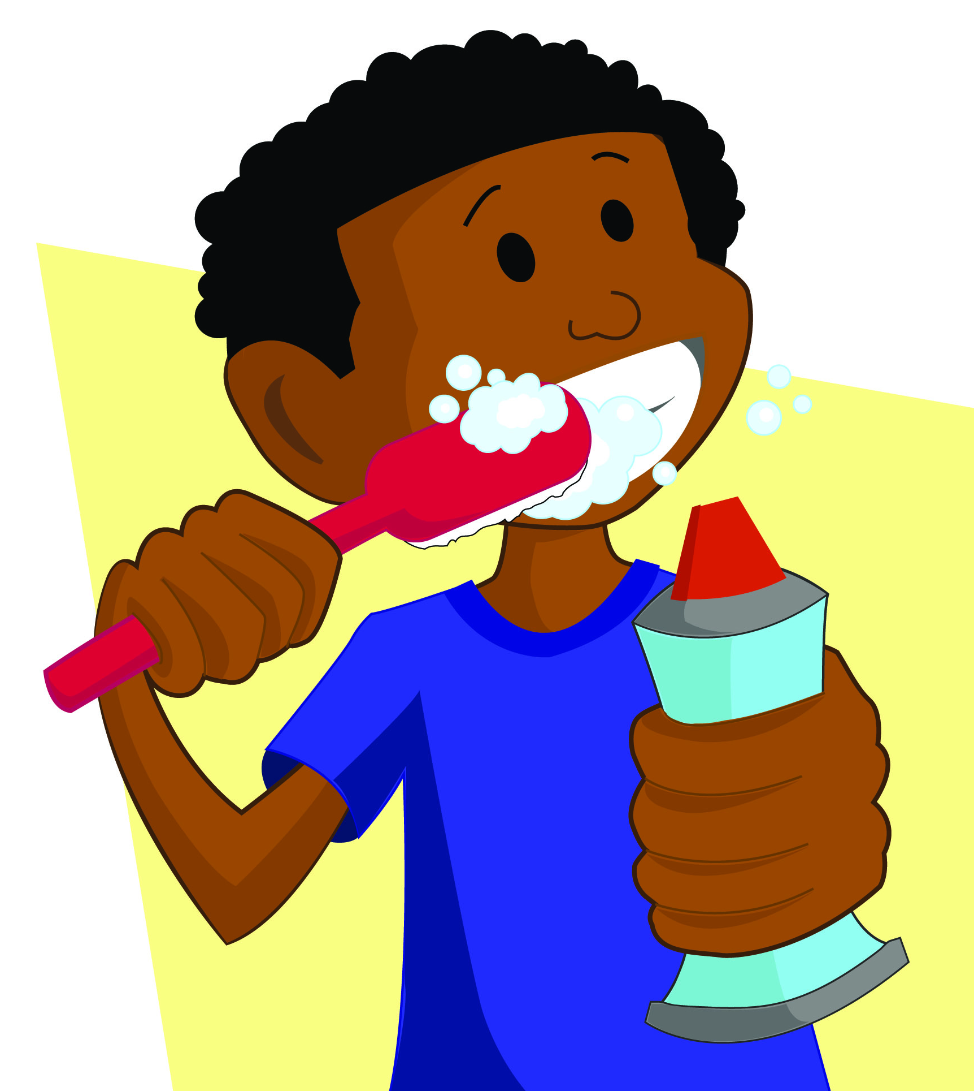

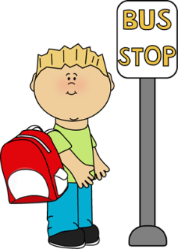
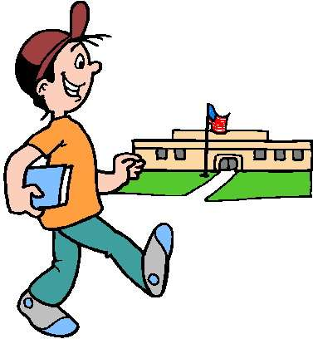

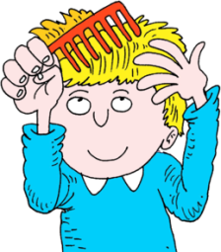

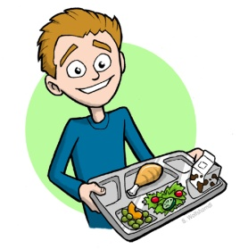
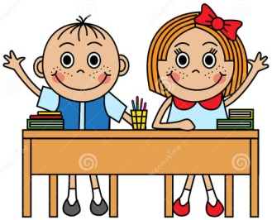
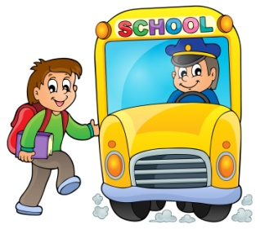
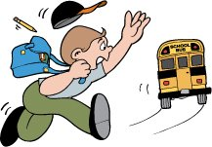

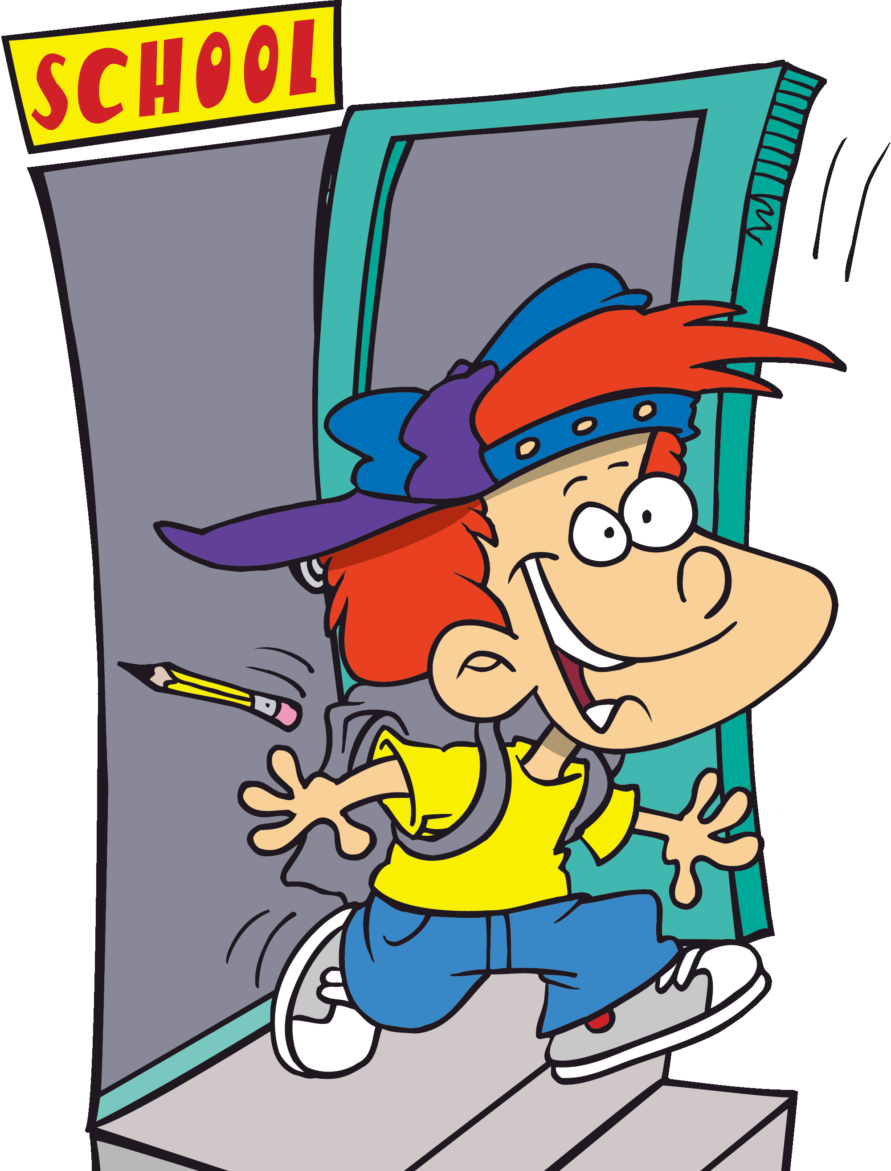
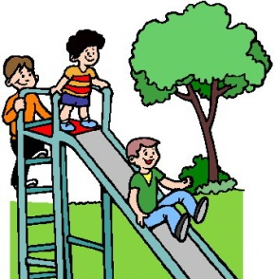
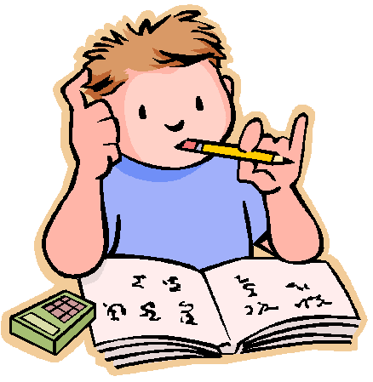
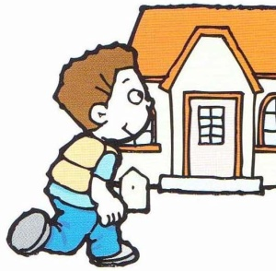

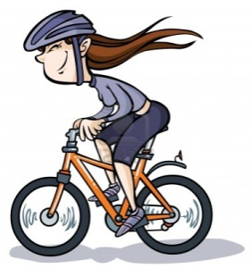
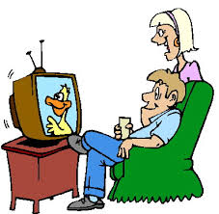
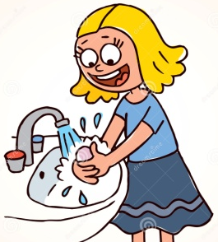
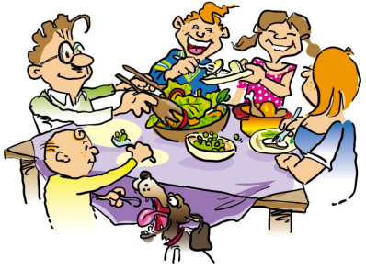

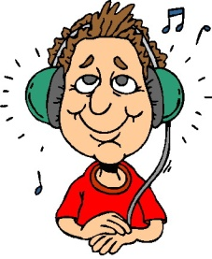
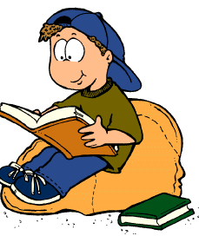

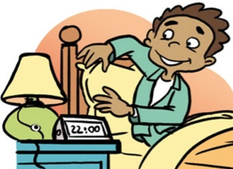

Mary’s Daily Routines: An Interview
28. have / take a bath
27. have classes
https://en.islcollective.com/resources/printables/worksheets_doc_docx/daily_activities/present-simple-tense/84197
TASK
4C

Hi Mary, let’s talk about your daily routines.  At what time do you normally get up on school-days? | Find the correct answers for the questions. Use the online WS.  Then answer the questions for yourself. Write the dialog on a sheet of paper.  Practice the dialog with a friend and act it out for your teacher.
 | After dinner, I read a book, or a watch TV and I talk with my family. Sometimes we play some card games or board games.
What is the first thing you do in the morning?
 | We usually have dinner at seven. That’s when my dad comes home from work.
What do you do next?
 | After school, I go home, or I go to a friend’s house to play. We always have some homework, so I do my homework, then I play until dinnertime.
What do you do after breakfast?
 | First, I take a shower and then I get dressed.
How do you go to school?
 | I am usually at school from nine o’clock until four o’clock. We have 5 lessons in the morning, then we have lunch in the school cafeteria, and then we have 3 lessons in the afternoon.
How long are you in school?
 | I normally get up at 8 o’clock, because school starts at 9.
What do you do after school?
 | Yes, I go to hip-hop lessons every Wednesday after school and I play the piano. My piano lesson is every Friday at five o’clock.
At what time do you have dinner?
 | I take the bus.
What do you do in the evening?
 | After breakfast I put the dishes in the dishwasher. Then I take my schoolbag, I put on my coat and shoes and I go to school.
At what time do you go to bed?
 | When I am dressed, I have breakfast with my family. I usually eat a bowl of cereal with milk I drink a cup of tea.
Do you have any hobbies, or do you do any sports?
 | I usually go to bed around nine thirty.
That’s quite a full week, Mary.
Yes, but I don’t mind; I like all the things that I do.

TASK
4D

Talking about daily routines: A
Use these verbs:
do, play, have, leave, have, get, have, get, have, watch, go
Find a partner who has got sheet B.

Ask your partner:
What time does Mary get up?
What time does Mary ……:::.?

What time do you get up?
What time do you………….?

Ask your partner: | Mary | You | Your partner
______ up | 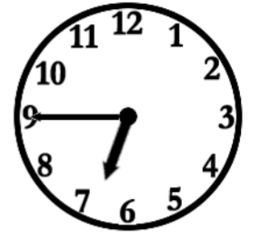 | 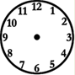
______ a shower
______ dressed | 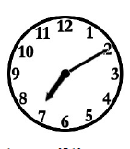
______ breakfast
______ for school | 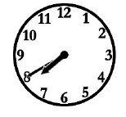
______ lunch
______ homework | 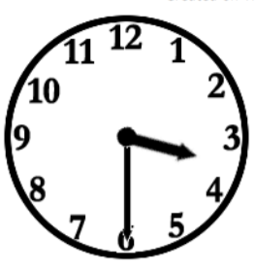
______ with friends
______ dinner | 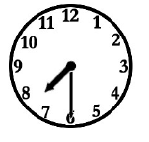
_______ TV
_______ to bed. | 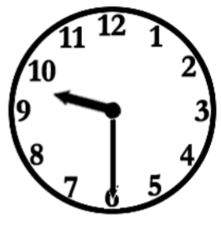

Talking about daily routines: B
TASK
4D
Use these verbs:
do, play, have, leave, have, get, have, get, have, watch, go
Find a partner who has got sheet A.

Ask your partner:
What time does Mary get up?
What time does Mary ……:::.?

What time do you get up?
What time do you………….?
 | Mary | You | Your partner
______ up
______ a shower | 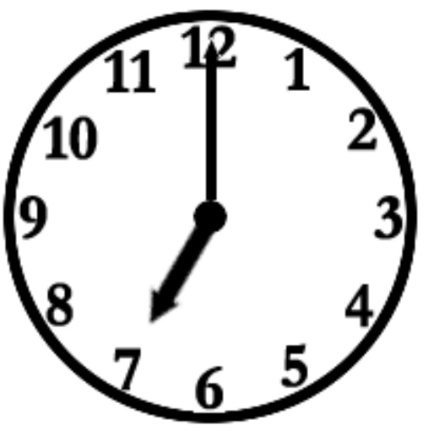
______ dressed
______ breakfast | 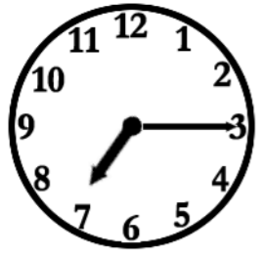
______ for school
______ lunch | 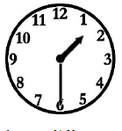
______ homework
______ with friends | 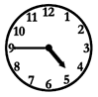
______ dinner
_______ TV | 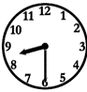
_______ to bed.

TASK 4E
Copyright License: This file is licensed by TeacherHenning under the iSLCollective Copyright License Upload date: 2016-09-23 11:10:18
https://en.islcollective.com/resources/printables/worksheets_doc_docx/months_seasons_weather_clothes_and_activities/months/91033
What month is it? | What season is it? |  | How is the weather? | What do you wear? | What can you do?
1 – J __________ |  | It is ________.  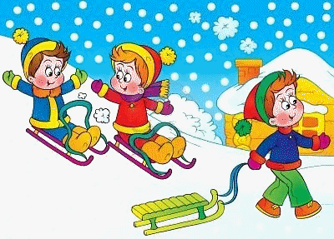 | It is ________ and ________.     | I wear ________________  an____________________.   | I can _________________  and ____________________.  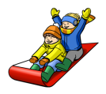
2 – F__________
3 – M__________ |  | It is ________.  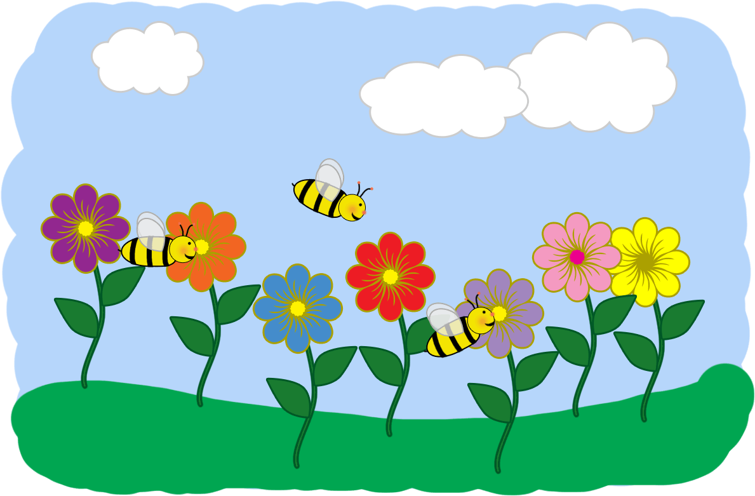 | It is ________ and ________.   | I wear ________________  and I take _________with me..   | I can _________________  and ____________________.  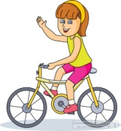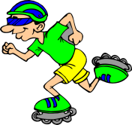
4 – A__________
5 – M__________
6 – J__________ |  | It is ________.   | It is ________ and ________.   | I wear ________________  and _________________.   | I can _________________  and ____________________.  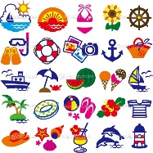
7 – J__________
8 – A__________
9 – S__________ | It is ________.   |  | It is ________ and ________.  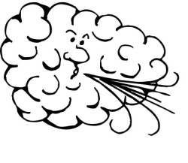 | I wear ________________  and ____________________   | I can _________________  and ____________________.  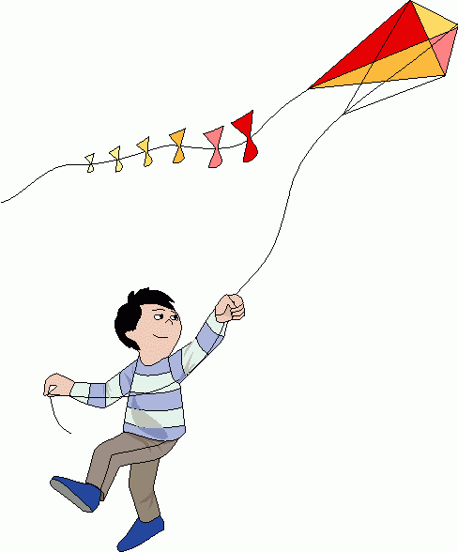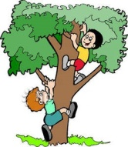
10 – O__________
11 – N__________
12 – D__________ | It is ______________. |  | It is ________ and ________. | I wear _______ and _______. | I can ________ and _______.
April, August, December, February, January, July,  June, March, May,  November, October, September | summer, winter  spring, autumn |  | hot, cold, cool, warm  rainy, sunny, windy, snowy | a hat, an umbrella, sunglasses  a shirt, a jacket, a coat, a raincoat  shorts, pants, a dress, a skirt  shoes, boots, flip flops, ice skates | fly a kite, go swimming,  ride a bike, build a snowman  go roller skating, climb a tree,  ride a sled, eat ice cream

What we do and what we don’t do
1. Highlight the things that are true for you. Cross out what’s wrong for you. | 2. Now interview a friend. Find out what he or she does every day. | Your friend’s answers | 3. Report what your friend does every day…  TASK 4F
I have / don’t have breakfast every morning. | Do you have breakfast every morning? |  | x has breakfast every morning. y doesn’t have breakfast ….
I get dressed / don’t get dressed before breakfast. | Do you get dressed….? |  | x (usually) gets dressed before …  y doesn’t get dressed before…
I pack /don’t pack my schoolbag after breakfast. | Do you pack your…. |  | x (always) packs his/her ….  y doesn’t pack his/her….
I go / don’t go to school by bus. | Do you…. |  | x goes to school by…
I go / don’t go to school by bike. |  |  | y doesn’t go to school by….
I meet /don’t meet my friends on the way to school. |  |  | x sometimes meets friends on..  y doesn’t meet friends….
I have / don’t have lunch at school every day. |  |  | x always has lunch at school  y often has lunch at school
I go / don’t go home right after school. |  |  | x usually goes home …  y does not go home …
I play / don’t play with my friends before dinner. |  |  | x usually plays ….  y does not play ….
I have / don’t have dinner with my family. |  |  | x usually has….  y doesn’t have…
I watch / don’t watch TV before/ after dinner. |  |  | x always watches ….  y never watches….  z does not watch….
I study / don’t study vocabulary before/ after dinner. |  |  | x always studies ….  y doesn’t study….
I take /don’t take a shower in the evening. |  |  | x usually takes….  y doesn’t take …
I read / don’t read a book in the evening. |  |  | x sometimes reads…  y doesn’t read….

3. Now write a text about your friend. Look at the examples:
Max has breakfast every morning. He doesn’t get dressed before breakfast, but he gets dressed after breakfast. Then Max packs his schoolbag. He doesn’t go to school by bike, but he goes to school by bus….
Use these words to make your text more professional: but, then, normally, sometimes, always
Be careful:
have – has  doesn’t have | do – does  doesn’t | watch – watches  doesn’t watch | go – goes  doesn’t go

TASK
4G
Questionnaire: How often do you...?
How often do you .......?
Step 1 : Complete the questions with the correct words – check with the key!
Step 2 : Use the questions to interview a friend.
Step 3 : Write about your friend.

1. How often do you ……………….…… to the cinema?
a. go
b. see
c. visit
d. watch
4. How often do you ……….…… your teeth?
a. cleaned
b. brush
c. polish
d. whitening

3. How often do you …………….…… eggs for breakfast?’
a. cooks
b. eaten
c. have
d. swallow

2. How often do you …………..…… shopping?
a. buy
b. do
c. go
d. go to

a. bored
b. boring

5. How often do you ………… a horse?
a. drive
b. eat
c. ride
d. sail

8. How often do you ……………… volleyball?
a. do
b. go
c. play
d. practise

7. How often do you ………… your bicycle?
a. cycle
b. play
c. practice
d. ride

6. How often do you ………… the Internet?
a. connect
b. play
c. surf
d. watch

11. How often do you ……….…… before 6 AM?
a. get up
b. stay up
c. stand up
d. woke up
d. hasn’t it?

12. How often do you ……………… vocabulary?
a. speak
b. practice
c. play
d. walk
10. How often do you ……………… your email?
a. check
b. log on
c. reply
d. send
9. How often do you …………………… by bus?
a. drive
b. go
c. move
d. travel

13. How often do you ……………….. online games?
a. log on
b. play
c. surf
d. sign up

16. How often do you ………………..… your grandparents?
a. meeting
b. saw
c. visit
d. wrote a letter

15. How often do you …………..…… fast food?
a. go
b. eat
c. pay
d. eating

14 How often do you ……………… a computer?
a. check
b. play
c. surf
d. use

20. How often do you ………………..…… your parents?
a. argue with
b. disagree for
c. fight on
d. go under

17. How often do you ………… up your room?
a. go
b. visit
c. like
d. tidy
Every day.
Four times a month.
adapted from: http://www.eslprintables.com/grammar_worksheets/questions/how_often_/Grammar_Meets_Conversation_Ho_487876/#thetop
Never.
Twice a year.
Three times a week.
Twice a week.
Once a day.
Once day / week
Twice a week / month
Three times year

always – usually, normally – often – sometimes – not often – rarely – hardly ever – never
100% 80% 60% 40% 20% 10% 5% 0%

