2nd test, Flexi year 1
Name:
Writing: Mike’s daily routines
Tell us everything about Mike’s daily routines.
Use as many new words as possible and add details!
(First, then, after that, in the morning, but, because,…)

Write the text on a sheet of paper in your spiral block.
6:10 a.m. 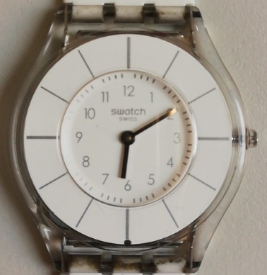 |  | 6:15 a.m.  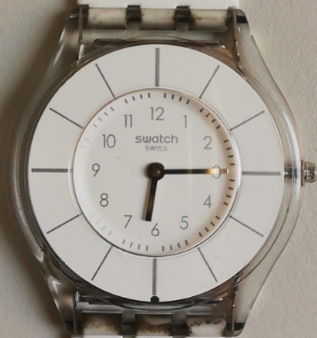 | 
6:30 a.m.  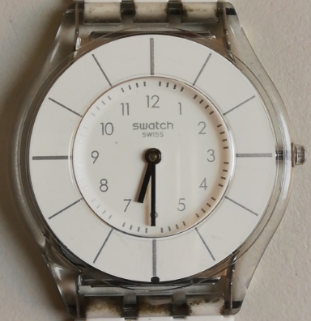 |  | 7:05 a.m.  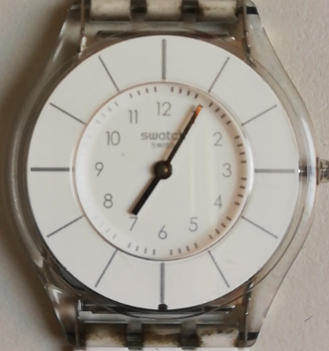 | 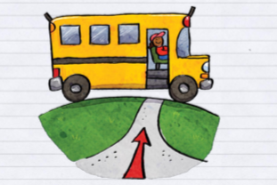 | 7:30 a.m.  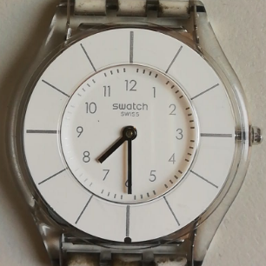 | 
7:40 a.m.  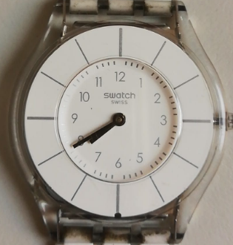 |  | 9:20 a.m.  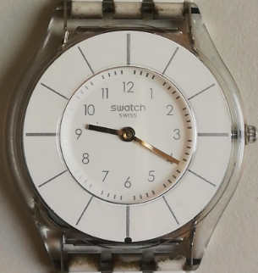 | 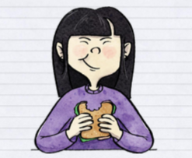 | 11:20 a.m.  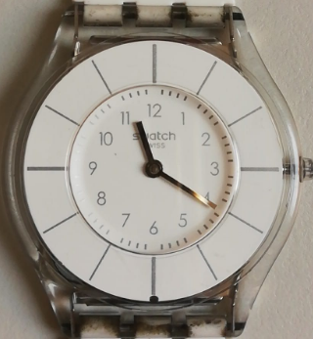 | 
1:10 p.m.  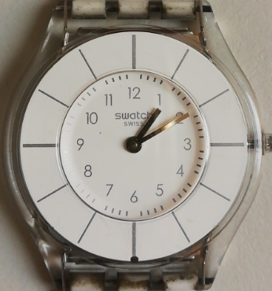 | School ends | 2:00 – 3:00  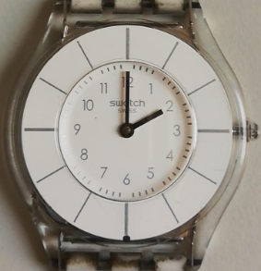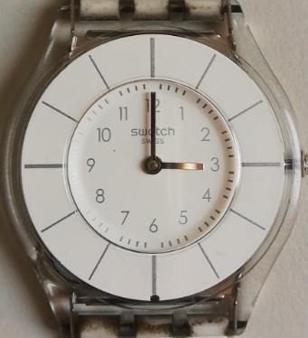 | What does Mike usually do between 2 and 3 o’clock? | 3:25 p.m.  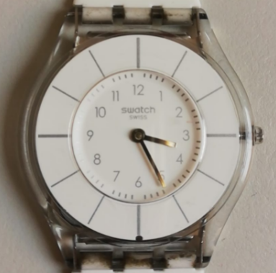 | 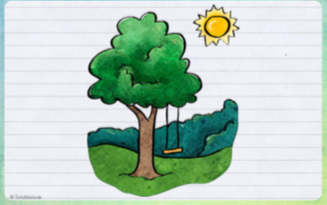
5:00  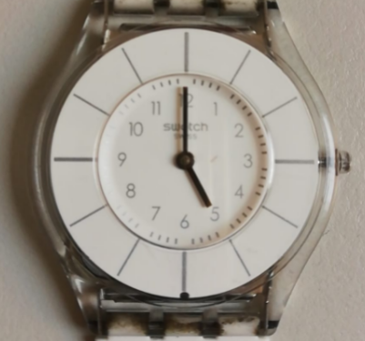– 6:00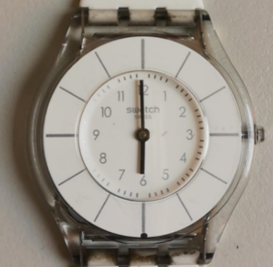 | What does Mike usually do between 5 and 6 o’clock? | 6:50 p.m. 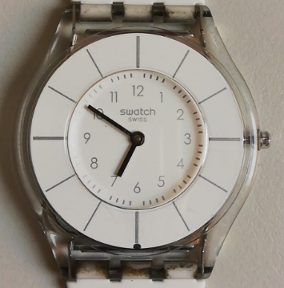 |  | 8:45 p.m.  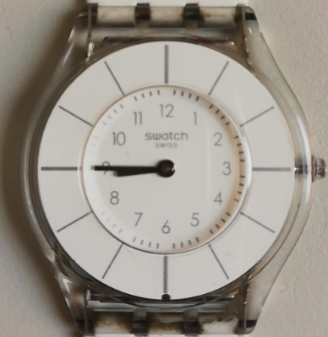 | 

Reading: do the listening task online
https://www.eduvidual.at/mod/quiz/view.php?id=571454

Writing Scale: Year 1
Notenschlüssel

Sehr gut: AA – AB
Gut: BB, AC
Befriedigend: BC, CC, AD
Genügend: BD, CD, DD, AE, BE
Nicht genügend:
BC, CE, BD, ED, EE

Task achievement and organization
not yet | very poor | poor | average | good |  | excellent
Range of Vocabulary and Structures
not yet | very poor | poor | average | good |  | excellent
Accuracy
not yet | very poor | poor | average | good |  | excellent
Overall writing performance:
Reading:

GESAMTNOTE:

