In this course you will... (In diesem Kurs wirst du...)
...learn to (...lernen)
- talk about your daily routines (über Tagesabläufe sprechen)
- ask people about their daily routines and freetime activites (Leute über Tagesabläufe und Freizeitaktivitäten befragen)
- talk about school routines (incl. school subjects, timetable) (Über typische Schultage sprechen, inkl. Schulfächer und Stundenplan)
- read and tell the time (die Uhrzeit zu lesen und zu sagen)

Language Focus
- Ask questions (Do / Does + question words (e.g. when, what time, why, where, what...)
- Use adverbs of frequency (sometimes, usually, always, never, often) + present simple
- Give the time
- Use sentence connectors (e.g. then, after that, after, later, before)
- Vocab: freetime activites, school subjects, weekdays, seasons

FoF - questions
Find the questions -- wie? Gapfill?? oder ganz frei und 2 oder 3 punkte pro Frage??

When _______ you _______ up?
I get up at quarter past six.
________ __________ your mother _____________up?
My mother gets up at six o’clock.
_________ _________ you _______after breakfast?
After breakfast I take a shower and get dressed. Then I go to school
________your sister ___________to school?
No, my sister does not go to school. She goes to kindergarden.
_______________________________________?
I get home at five o’clock. Then I practice vocabulary for ten minutes.
_______________________________________?
I practice vocabulary every day.
_______________________________________?
Yes, I usually watch TV after dinner.
_______________________________________?
I go to bed at nine o’clock.
_______________________________________?
My sister goes to bed at eight o’clock.
________________________________________?

FoF – adverbs – Abgabe (achtung – höhere Punktezahl vergeben, sonst zählt review zu viel – 3 P pro Satz?)
Write 5 sentences about your daily routines
Use: sometimes, usually, always, never, often

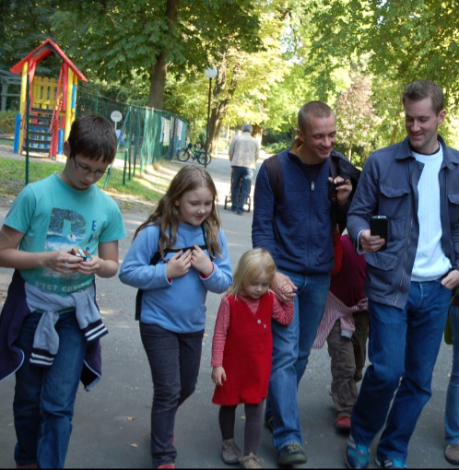
FoF revision
personal pronouns, third person s, prepositions of place

Free gapfill
This is a picture of my family. You can see me – I’m the girl on the left with the blue pullover and the backbag. I am between my brother Matthias (with his rubik’s cube) and my little cousin Hannah – she is the one in the red dress. Next to Hannah you can see my uncles Georg and Ulrich. My little cousin Felix is behind my uncles. You can see his red pullover and his red shoes but you can not see his face.
Ulrich is my favourite uncle. He lives in Berlin. Ulrich always gets up at six o’clock. He loves/likes cars and he has a cool red car. After work he often does sports – he goes climbing or mountain biking. In the evening he usually watches TV or reads a book.
Georg, Hannah and Felix live in Vienna. They have three rabbits that live in their big garden. Felix has/has got a white rabbit. He loves his rabbit. Hannah has/has got a brown rabbit. She loves her rabbit, too. The third rabbit is Georg’s rabbit. It is black.
Felix and Hannah love playing in the garden. They usually get up at six o’clock and play in the garden before school. Hannah and Felix go to primary school. In the afternoon they usually play in the garden again. In the evening they sometimes watch TV or read a book.

Complete the text with the correct times
Phillip usually gets up at
He always has breakfast at

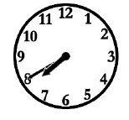
He leaves for school at
His school ends at
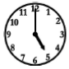
Philipp usually has tea at

