Challenge
Look at these examples. What’s the difference?
A: Here we are talking about………………………………………………………………
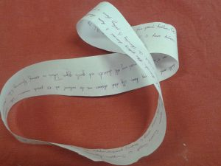 | I usually get up at half past six. Then I take a shower and I get dressed. At seven o’clock I have breakfast with my family. We eat bread, butter and jam and we drink hot chocolate. Then I go to school by bus. I arrive at school at half past seven. I go to my locker to change my shoes and to hang up my coat or jacket. School starts at quarter to eight….

B: Here we are describing what……………………………………………………………
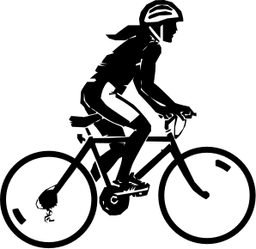  The girl is riding her bike. |   The girl is dancing. | 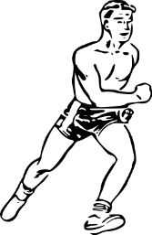  The boy is running.
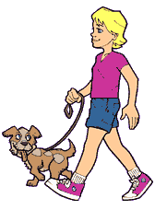  The boy is walking his dog. |   The person is swimming. | 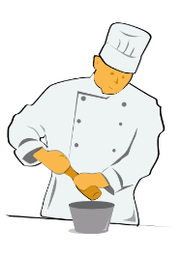  The cook is cooking.
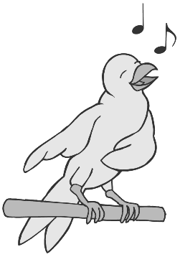  The bird is singing | 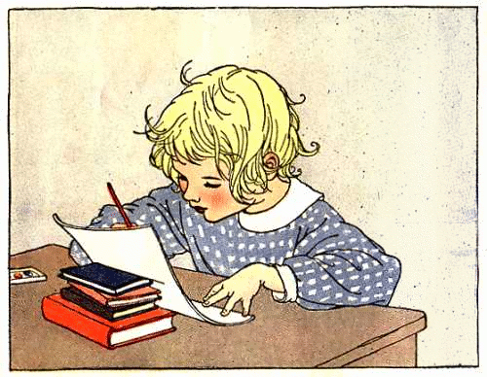  The child is doing homework. | 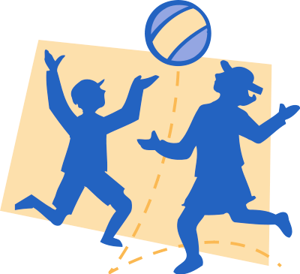  The children are playing with a ball.
Glue this page into your LR book. Cut off the edges to make it a bit smaller. Then look around the classroom and write 10 true sentences. What are your classmates doing right now? Show your sentences to your teacher, then copy them them into your LR book.

