 | 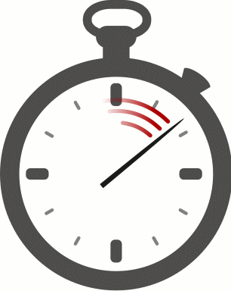  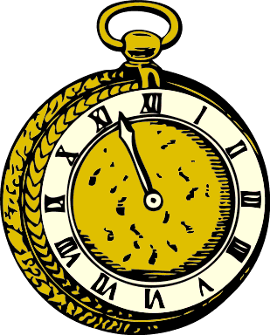
  Telling the time:
  It’s one o’clock.
  It’s twelve o’clock.
  It’s midnight.
  It’s five (minutes) past three.
  It’s ten past four.
  It’s quarter past five.
  It’s half past six.
  It’s quarter to seven.
  It’s ten to seven.
  It’s five to twelve.

Time Bingo
Draw in nine different times. Only draw five minute steps.
Then listen to your teacher and tick off the times that your teacher has announced.
Bingo: If you have ticked off three clocks in a row, shout out “BINGO”. You are the winner!
