1. eat/have lunch
2. wait for the bus
3. ride the bike
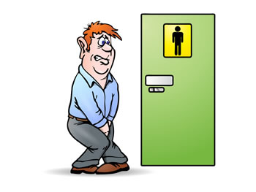
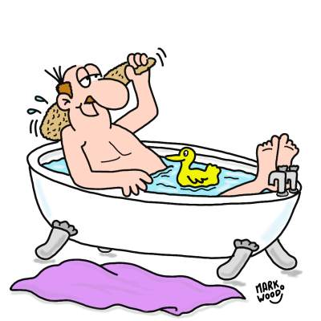
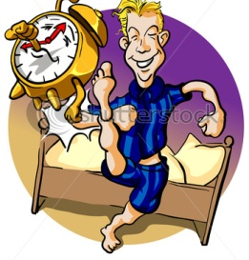
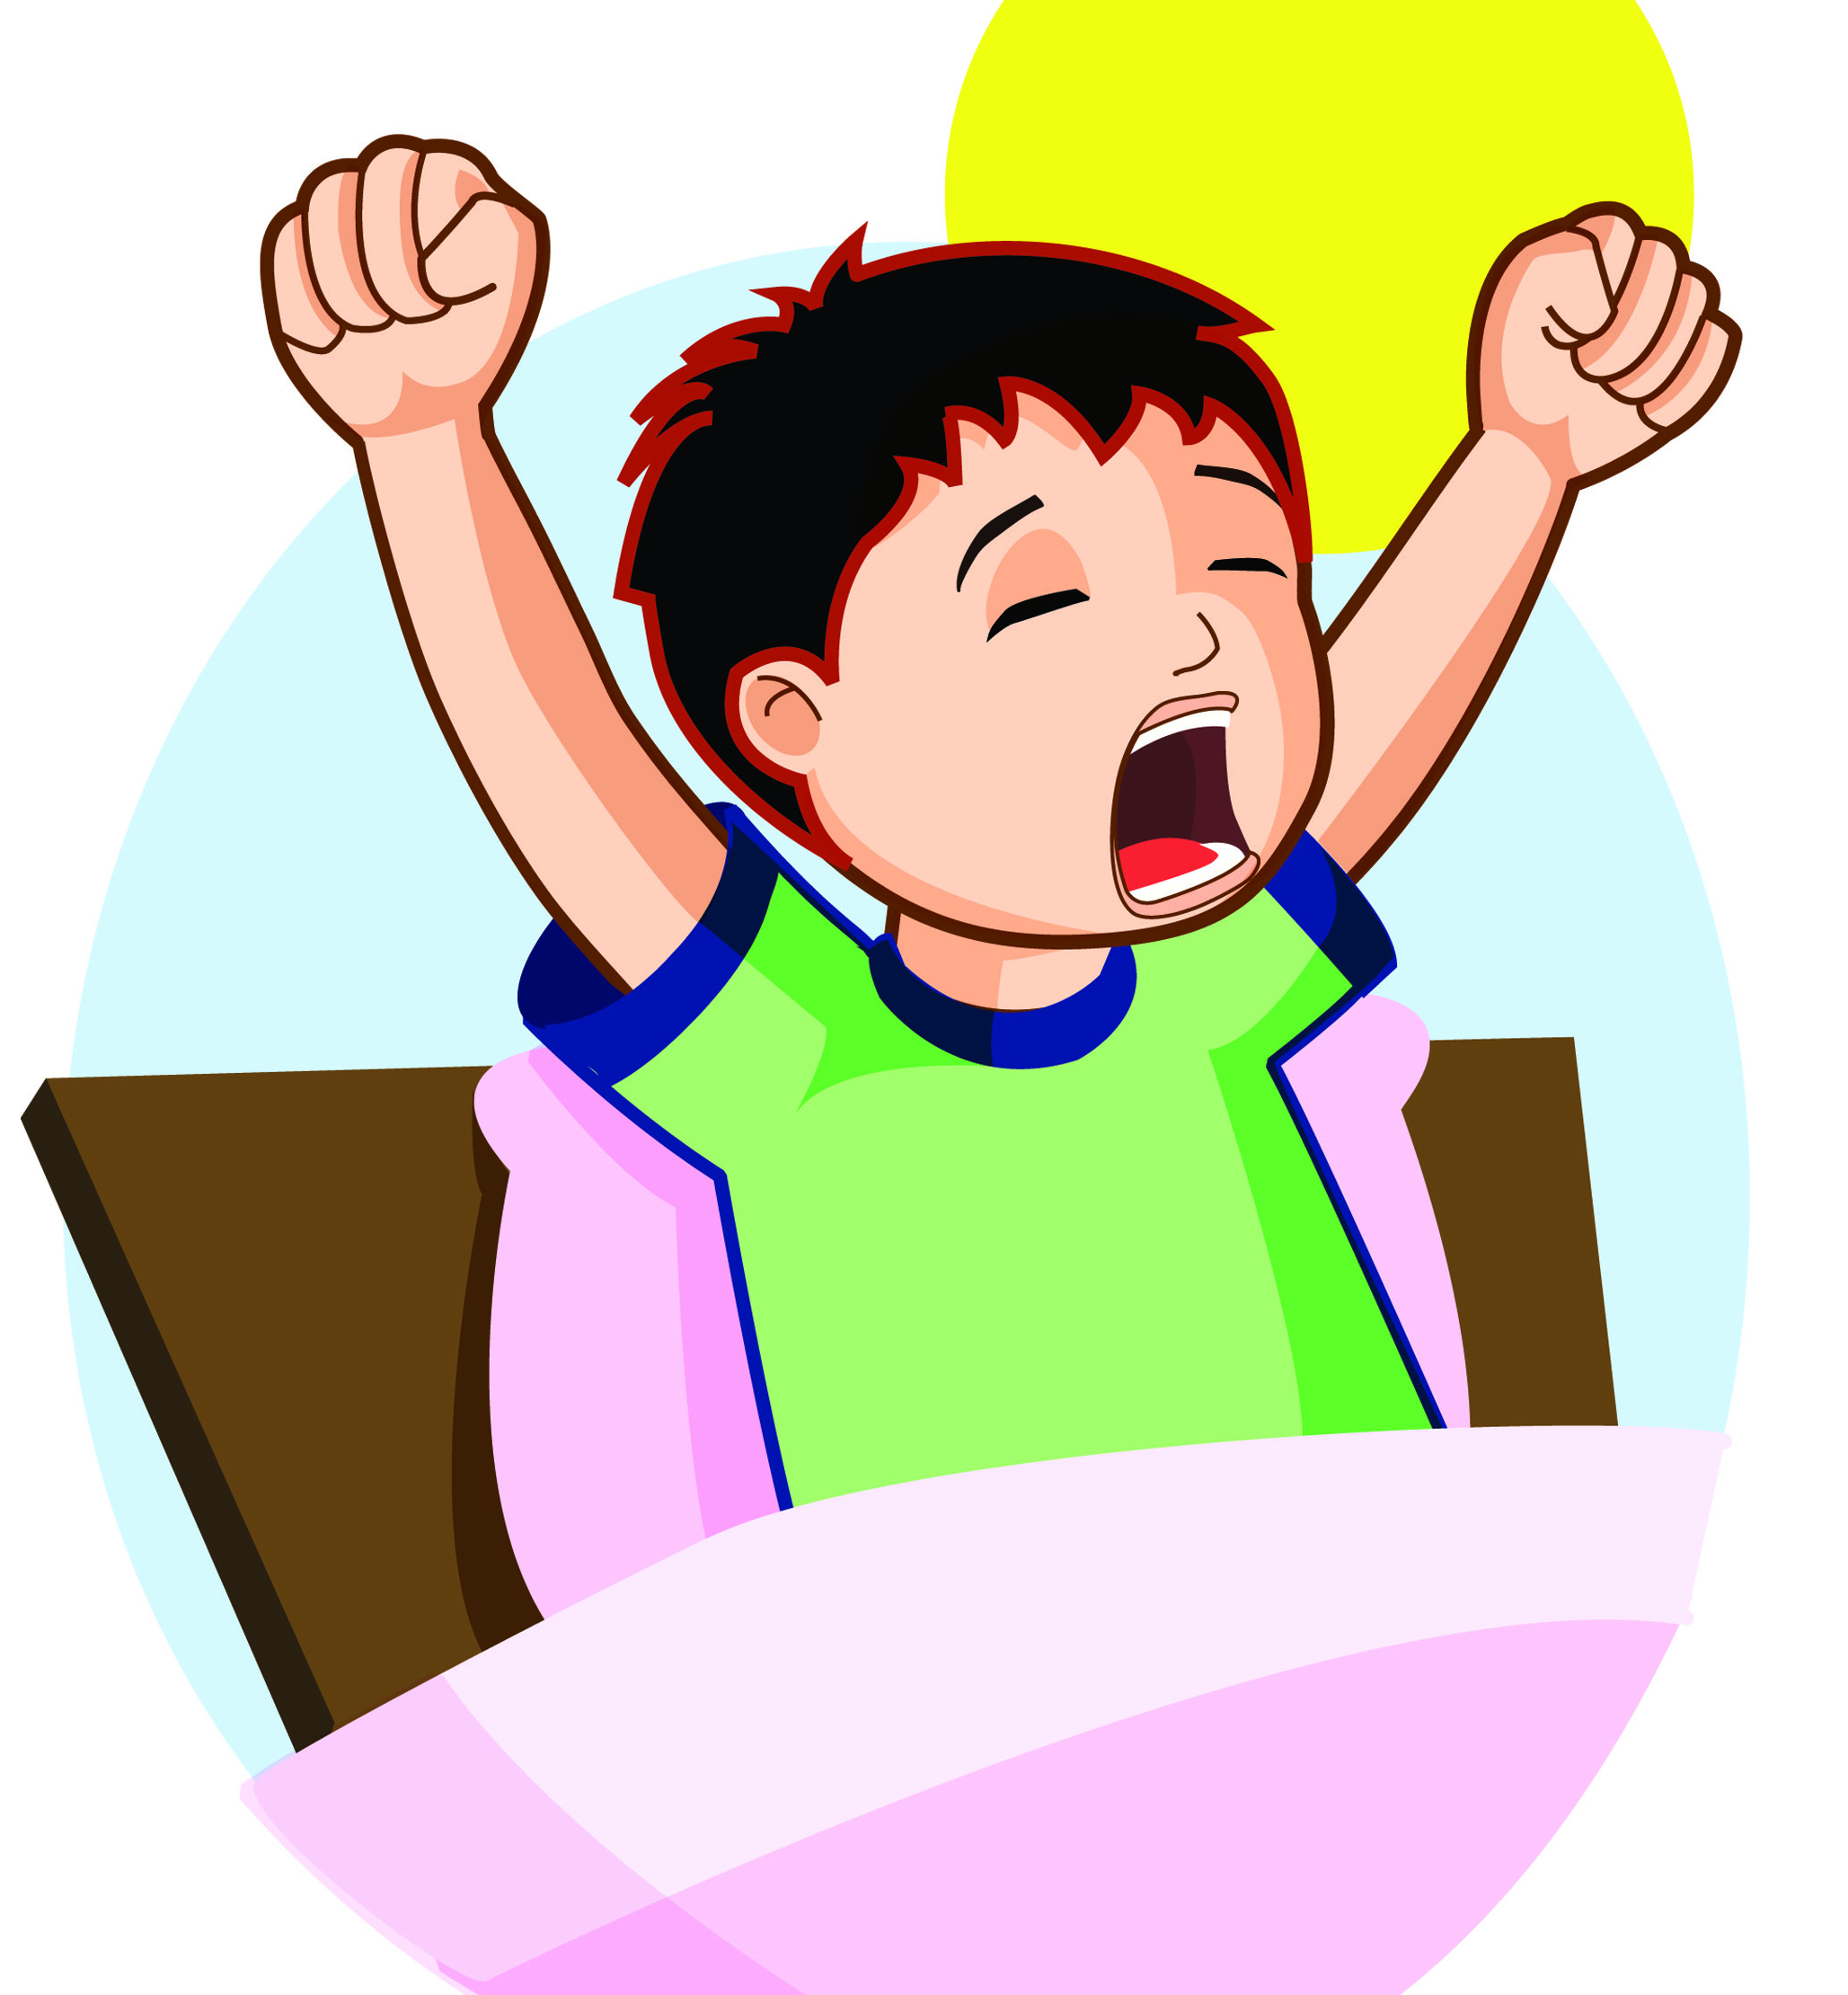

4. miss the bus
5. wash the hands
6. brush the teeth
7. play in the park
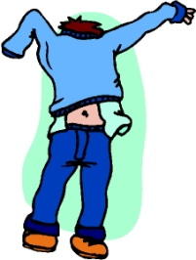
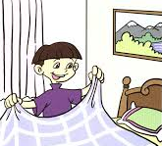
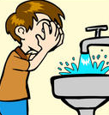
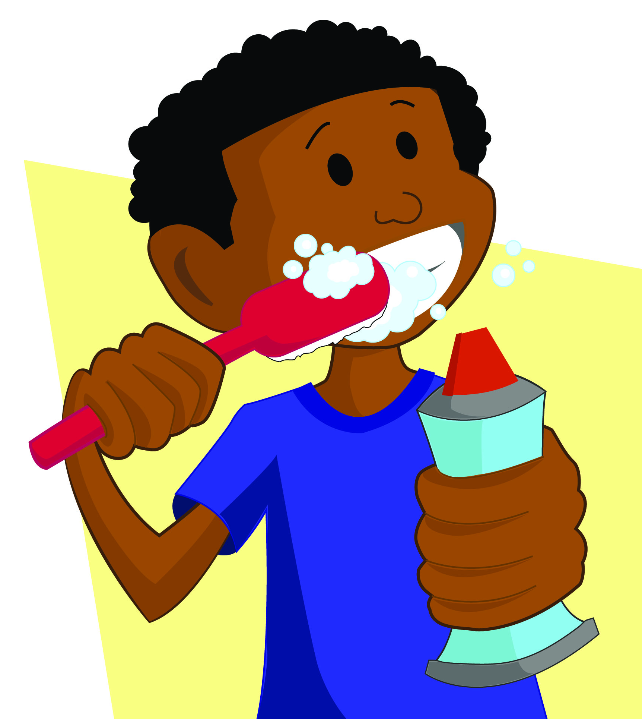
8. get up
9. read a book
10. arrive home
11. have dinner
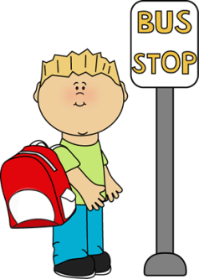
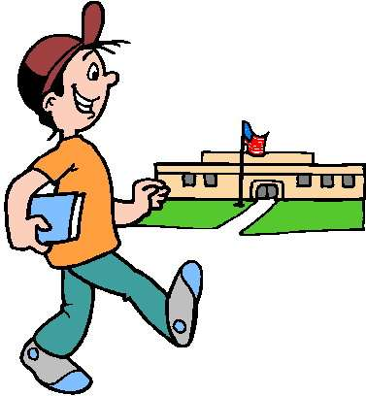
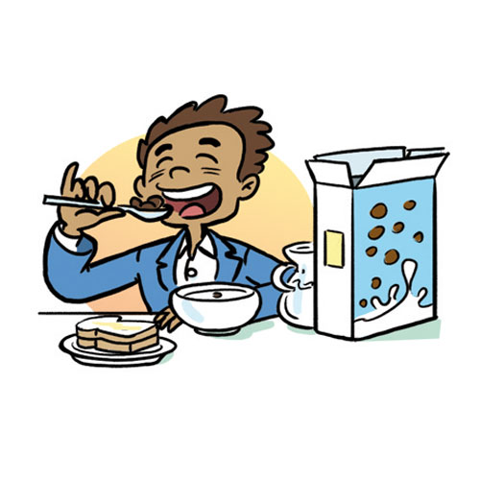
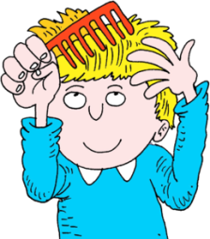
12. go to bed
13. make the bed
14. watch TV
15. wake up
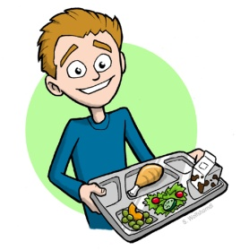
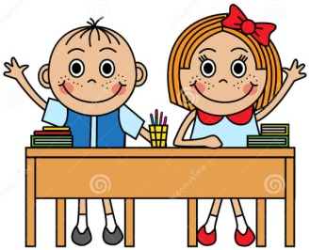
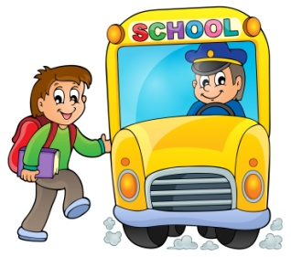
16. have / take a shower
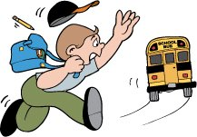
17. catch/take the bus
18. go to the toilet/bathroom
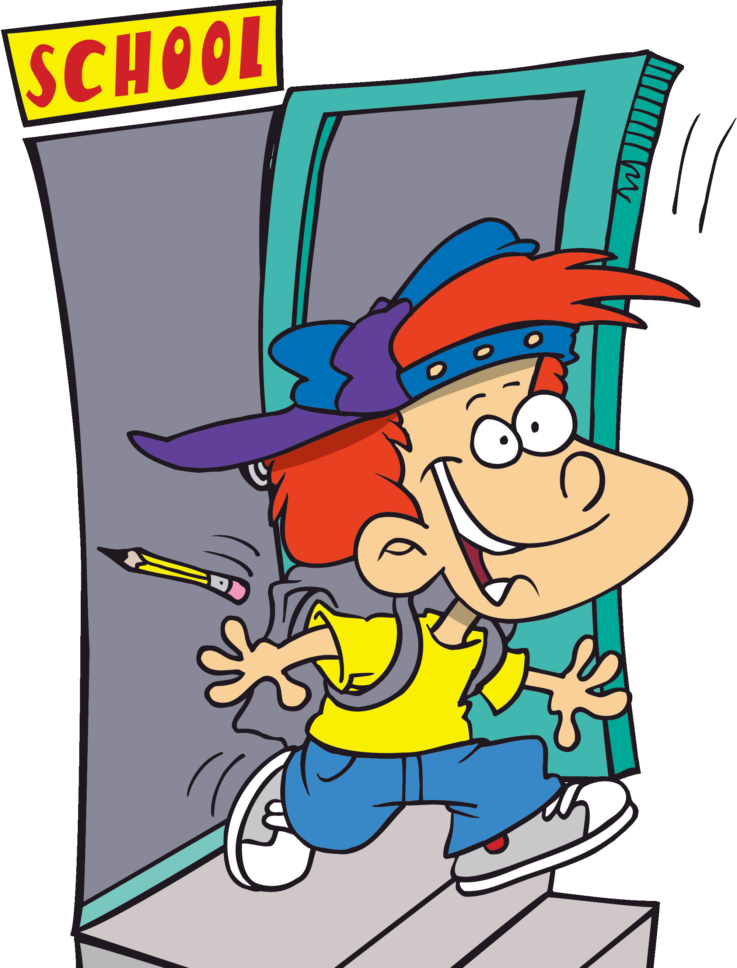
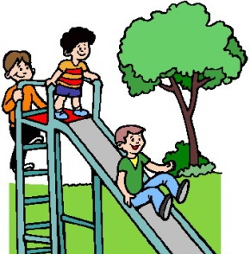
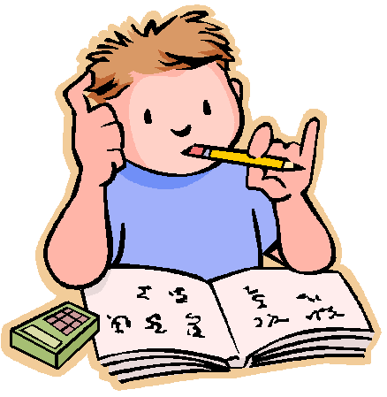
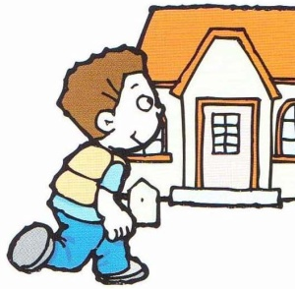
19. wash the face

20. listen to music
21. leave school
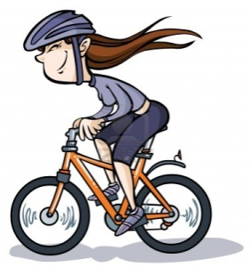
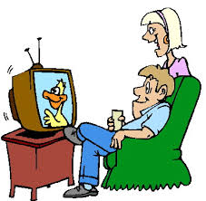
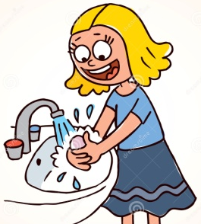
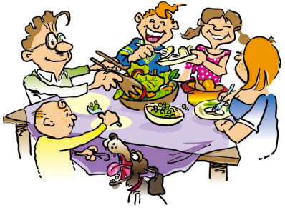
22. have breakfast
23. study / do the homework
24. comb the hair
25. walk to school
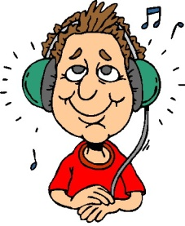
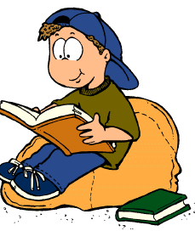

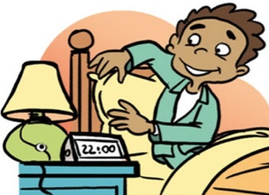
26. get dressed
27. have classes
28. have / take a bath
https://en.islcollective.com/resources/printables/worksheets_doc_docx/daily_activities/present-simple-tense/84197
1. eat/have lunch
2. wait for the bus
3. ride the bike
4. miss the bus
5. wash the hands
6. brush the teeth
7. play in the park
8. get up
9. read a book
10. arrive home
11. have dinner
12. go to bed
13. make the bed
14. watch TV
15. wake up
16. have / take a shower
17. catch/take the bus
18. go to the toilet/bathroom
19. wash the face

20. listen to music
21. leave school
22. have breakfast
23. study / do the homework
24. comb the hair
25. walk to school
26. get dressed
27. have classes
28. have / take a bath

1. eat/have lunch
2. wait for the bus
3. ride the bike
4. miss the bus
15
8
28
18
5. wash the hands
6. brush the teeth
7. play in the park
8. get up
6
19
13
26
9. read a book
10. arrive home
11. have dinner
12. go to bed
24
22
25
2
13. make the bed
14. watch TV
15. wake up
16. have / take a shower
17
4
27
1
17. catch/take the bus
18. go to the toilet/bathroom
21
10
23
7
19. wash the face

20. listen to music
21. leave school
22. have breakfast
3
14
5
11
23. study / do the homework
24. comb the hair
25. walk to school
9
20
16
12
26. get dressed
27. have classes
28. have / take a bath

