Talking about daily routines: KEY
Use these verbs:
do, play, have, leave, have, get, have, get, have, watch, go
Ask your partner:
What time does Mary get up?
What time does Mary ……:::.?

What time do you get up?
What time do you………….?
 | Mary | You | Your partner
______ up | 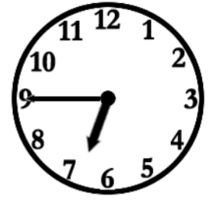 | 
______ a shower | 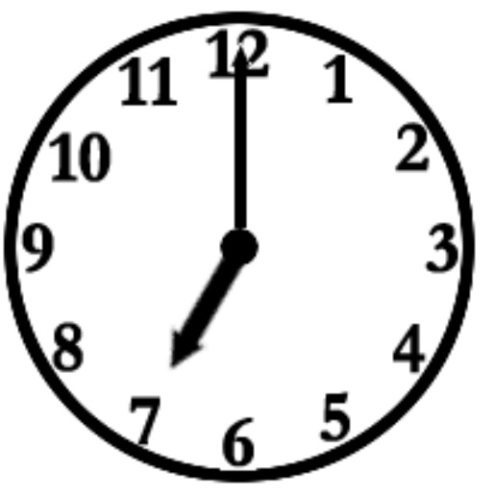
______ dressed | 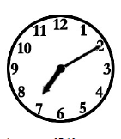
______ breakfast | 
______ for school | 
______ lunch | 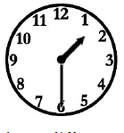
______ homework | 
______ with friends | 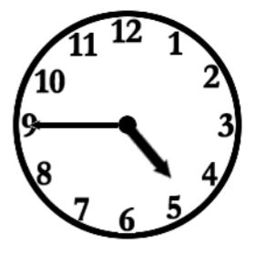
______ dinner | 
_______ TV | 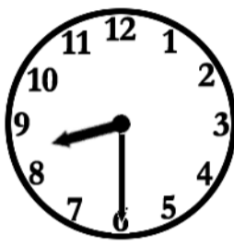
_______ to bed. | 

Talking about daily routines: A
Find a partner who has got sheet B.

Ask your partner:
What time does Mary get up?
What time does Mary ……:::.?

What time do you get up?
What time do you………….?

Use these verbs:
do, play, have, leave, have, get, have, get, have, watch, go
Ask your partner: | Mary | You | Your partner
______ up
______ a shower
______ dressed
______ breakfast
______ for school
______ lunch
______ homework
______ with friends
______ dinner
_______ TV
_______ to bed.

Talking about daily routines: B
Find a partner who has got sheet A.

Ask your partner:
What time does Mary get up?
What time does Mary ……:::.?

What time do you get up?
What time do you………….?
Use these verbs:
do, play, have, leave, have, get, have, get, have, watch, go
 | Mary | You | Your partner
______ up
______ a shower
______ dressed
______ breakfast
______ for school
______ lunch
______ homework
______ with friends
______ dinner
_______ TV
_______ to bed.

