Talking about daily routines: KEY
 | Mary | You | Your partner
What time does Mary get up?  What time do you get up? | 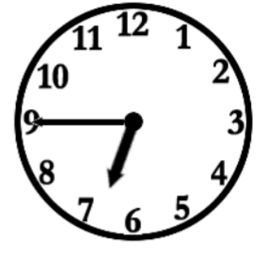 | 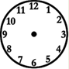
What time does Mary have a shower?  What time do you have a shower? | 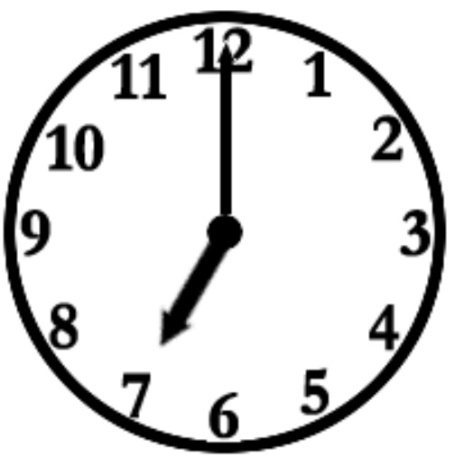
What time does Mary get dressed?  What time do you get dressed? | 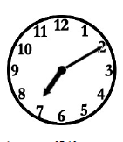
What time does Mary have breakfast?  What time do you have breakfast? | 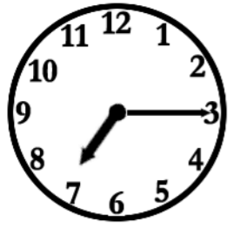
What time does Mary leave for school? What time do you leave for school? | 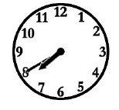
What time does Mary have lunch?  What time do you have lunch? | 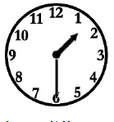
What time does Mary do homework?  What time do you do homework? | 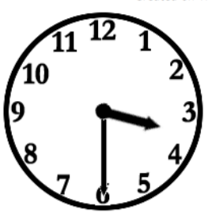
What time does Mary play with friends? What time do you play with friends? | 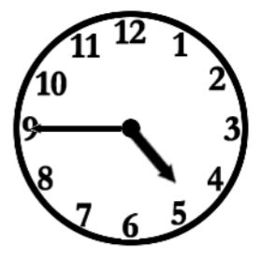
What time does Mary have dinner?  What time do you have dinner? | 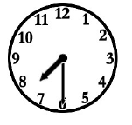
What time does Mary watch TV?  What time do you watch TV? | 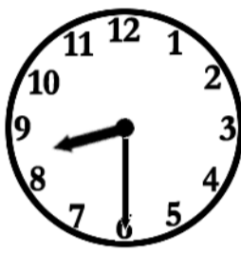
What time does Mary go to bed?  What time do you got to bed? | 