What month is it? | What season is it? | How is the weather? | What do you wear? | What can you do?
1 – January | It is winter.  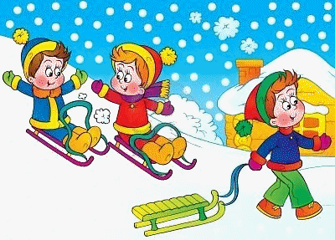 | It is cold and snowy.  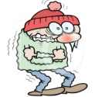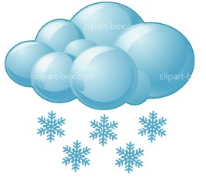 | I wear a pullover, a coat, a scarf, a hat and gloves.  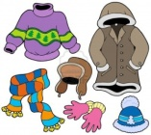 | I can build a snowman  and ride a sled.  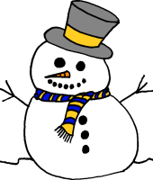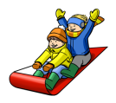
2 – February
3 – March | It is spring.  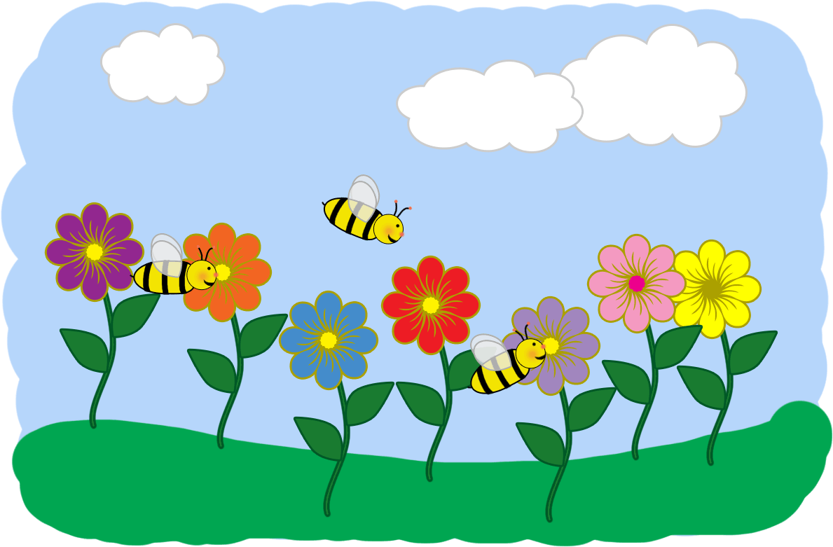 | It is warm and rainy.  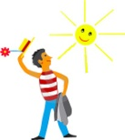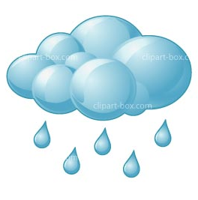 | I wear a raincoat, boots, socks, a jacket, socks and I take an umbrella with me.  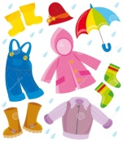 | I can ride my bike  and go roller skating.  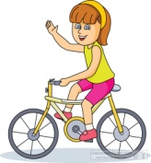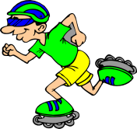
4 – April
5 – May
6 – June | It is summer.  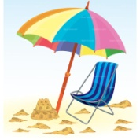 | It is hot and sunny.  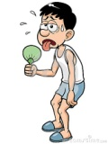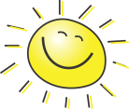 | I wear a skirt, a dress or shorts and a t-shirt. I wear flip-flops and sunglasses.  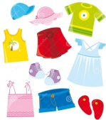 | I can go swimming  and eat ice cream.  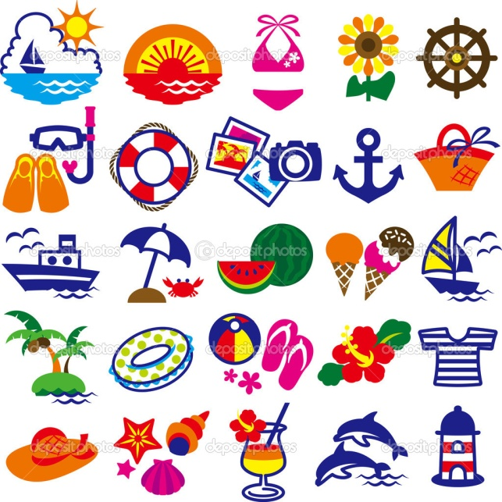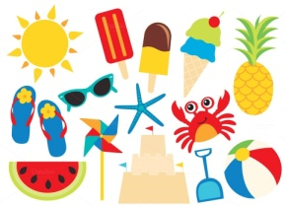
7 – July
8 – August
9 – September | It is autumn.   | It is cool and windy.  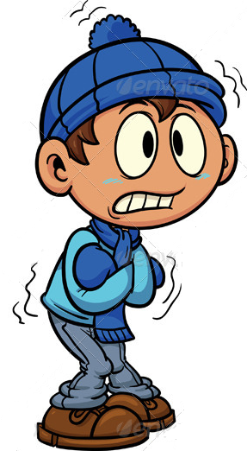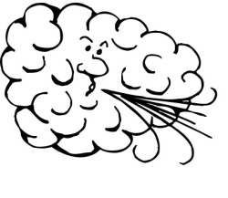 | I wear pants and a shirt. I wear boots, a hat and a coat | I can fly a kite  and climb a tree.  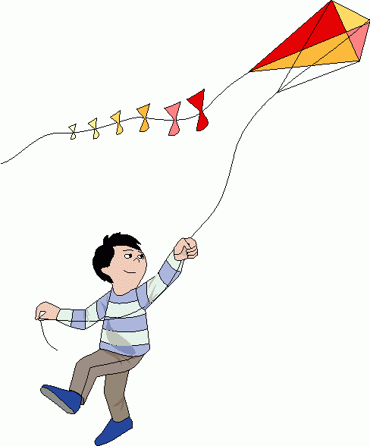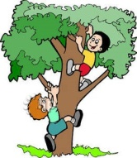
10 – Ocotober
11 – November
12 – December | It is winter. | It is cold and snowy. | I wear a coat and boots. Sometimes I wear ice-skates. | I can go skiing and ice-skating.
Copyright License: This file is licensed by TeacherHenning under the iSLCollective Copyright License Upload date: 2016-09-23 11:10:18
https://en.islcollective.com/resources/printables/worksheets_doc_docx/months_seasons_weather_clothes_and_activities/months/91033

