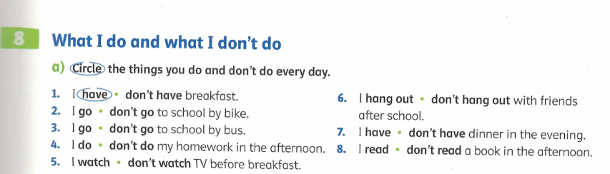
Interview a classmate. What does he or she do every day?
Ask them:
- Do you go to school by bike?
- Do you do your homework in the afternoon?
- Do you…

Now write true sentences about your classmates.
Ask: DO you go to school by bike?

What they do:

What they don’t do:

