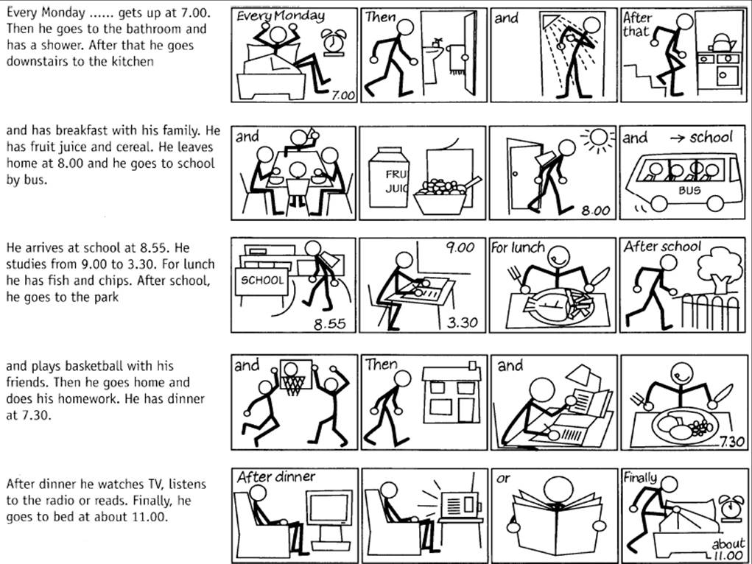
ANSWER THE FOLLOWING QUESTIONS ACCORDING TO THE PICTURES.

1. What time does he get up?________________________________________________________________________. 2. Does he have a shower in the morning?______________________________________________________________. 3. What does he have for breakfast?___________________________________________________________________. 4. How does he go to school?_________________________________________________________________________. 5. Does he eat soup and steak for lunch?________________________________________________________________. 6. Where does he go after school?_____________________________________________________________________. 7. Does he play soccer with his brother?_________________________________________________________________. 8. When does he have dinner?________________________________________________________________________. 9. What does he do after dinner?______________________________________________________________________. 10. What time does he go to bed?_____________________________________________________________________.

WRITE ABOUT YOUR DAILY ACTIVITIES.
___________________________________________________________________________________________________
___________________________________________________________________________________________________
___________________________________________________________________________________________________
___________________________________________________________________________________________________
___________________________________________________________________________________________________
___________________________________________________________________________________________________

