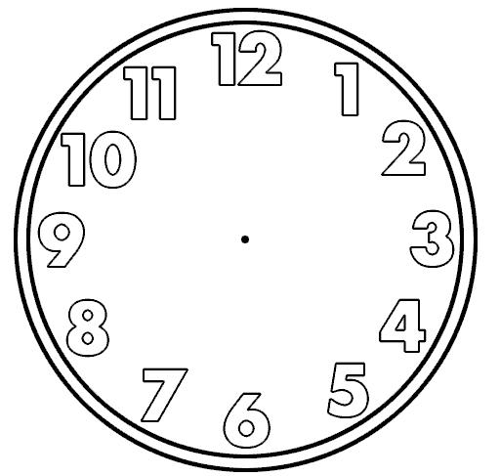have dinner
go to bed
play
do my homework
prepare my bag
put on my coat
go to school
have lunch
get dressed
comb my hair
dry myself

have a shower

brush my teeth
get up
have breakfast
wake up

