Partner Dictation: Time
Student A: Dictate these times to your partner. He/she has to draw them into the clock-faces.
1  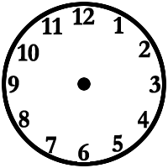 | 2 | 1. It’s half past six.  2. It’s a quarter to eight.  3. It’s ten past five.  4. It’s twenty to ten.  5. It’s five to seven.  Now add your own:  6.  7.  8.
3 | 4
5 | 6
7 | 8

Partner Dictation: Time
Student B: Dictate these times to your partner. He/she has to draw them into the clock-faces.
1 | 2 | 1. It’s five to eleven.  2. It’s a quarter past one.  3. It’s twenty past four.  4. It’s quarter to nine.  5. It’s half past eight.  Now add your own:  6.  7.  8.
3 | 4
5 | 6
7 | 8

