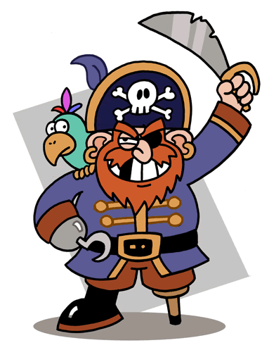
Answers and Replies
What’s your name? | 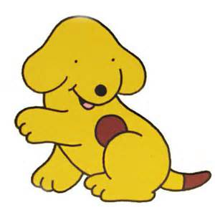  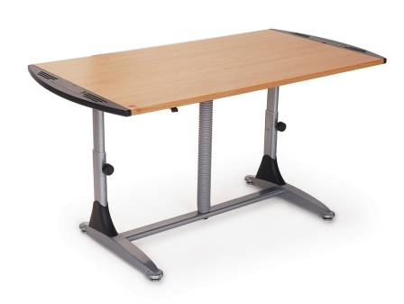
How old are you?
Good morning.
Are you scared?
How are you?
Which class are you in?
Where is your ring binder?
What colour is your hair?
Has your friend got a dog?
Have you got a cat?
Have you got long hair?
What has the pirate in your picture got?
What is there in your school bag?
Where is the dog in your picture?
Good bye.

Answers and Replies
Are you happy? | 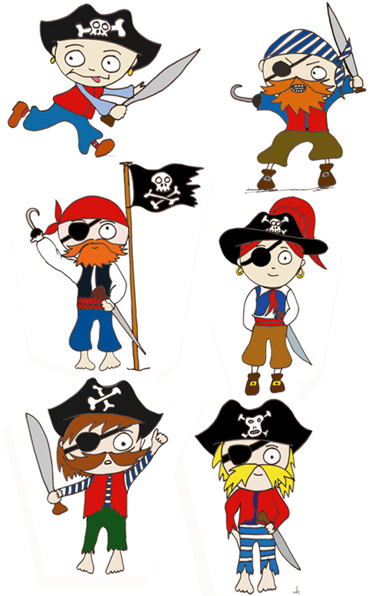
Which class are you in?
Good morning.
Has your friend got a cat?
Have you got a hamster?
Have you got brown eyes?
How are you?
How old are you?
What colour is your pencil case?
What has the pirate in your picture got?
What is there in your school bag?
What’s your name?
Where is the dog in your picture?
Where is your English book?
Good bye.

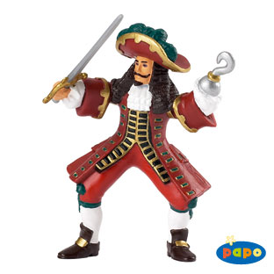
Answers and Replies
What’s your name?
Where is your pen?
Good morning.
Are you sad?
How are you?
What has the pirate in your picture got?
How old are you?
What colour is your pen?
Where is the dog in your picture?
Has your friend got a dog?
Have you got a goldfish?
Have you got long hair?
Which school are you in?
What is there in your school bag?
Good bye.

Answers and Replies
What colour is your ring binder?
What has the pirate in your picture got?
What is there in your school bag?
What’s your name?
Where is the dog in your picture?
Where is your pencil?
Which school are you in?
How old are you?
Are you hungry?
How are you?
Good morning.
Has your friend got a cat?
Have you got blue eyes?
Have you got a hamster?
Good bye.

Answers and Replies
Which class are you in? | 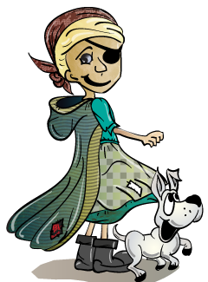
Where is your glue stick?
What colour is your grammar book?
Has your friend got a dog?
Have you got a mouse?
Have you got blonde hair?
What has the pirate in your picture got?
What is there in your school bag?
Where is the dog in your picture?
Are you busy?
What’s your name?
How old are you?
Good morning.
How are you?
Good bye.

Answers and Replies
What colour are your eyes?
What has the pirate in your picture got?
What is there in your school bag?
What’s your name?
Where is the dog in your picture?
Where is your pencil sharpener?
Which class are you in?
How old are you?
Are you tired?
How are you?
Good morning.
Has your friend got a cat?
Have you got a hamster?
Have you got blue eyes?
Good bye.

Answers and Replies
What’s your name? | 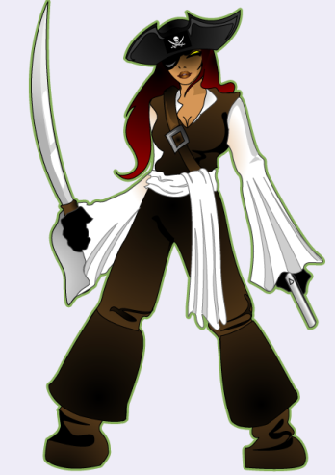
What colour are your scissors?
Where is the dog in your picture?
Has your friend got a dog?
Have you got a pig?
Have you got black hair?
What is there in your school bag?
How are you?
What has the pirate in your picture got?
How old are you?
Are you bored?
Which school are you in?
Where is your pencil case?
Good morning.
Good bye.

Answers and Replies
What colour is your ring binder?
Where is your ruler?
Which school are you in?
How old are you?
Where is the dog in your picture?
Have you got a hamster?
How are you?
Good morning.
Are you happy?
Have you got blue eyes?
Has your friend got a cat?
What has the pirate in your picture got?
What is there in your school bag?
What’s your name?
Good bye.
Answers and Replies
Good morning. | 
Have you got a hamster?
Has your friend got a dog?
What has the pirate in your picture got?
How old are you?
Are you angry?
What’s your name?
What colour is the dog in your picture?
How are you?
Have you got long hair?
What is there in your school bag?
Where is the dog in your picture?
Which class are you in?
Where is your rubber?
Good bye.

Answers and Replies
Are you happy?
Have you got blue eyes?
Good morning.
What’s your name?
Where is the dog in your picture?
Where is your ruler?
What has the pirate in your picture got?
Have you got a hamster?
What colour is the floor?
How old are you?
What is there in your school bag?
Which class are you in?
Has your friend got a cat?
How are you?
Good bye.

Answers and Replies
What’s your name? | 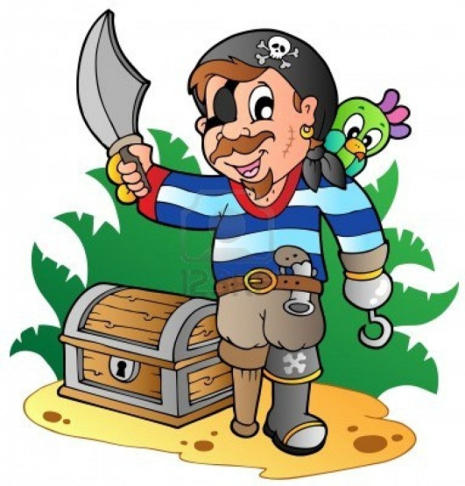
Which school are you in?
Good morning.
Are you excited?
Where is your pen?
Where is the dog in your picture?
How old are you?
What colour is the board?
What is there in your school bag?
What has the pirate in your picture got?
Have you got a cat?
Have you got red hair?
How are you?
Has your friend got a dog?
Good bye.

Answers and Replies
Good morning.
What has the pirate in your picture got?
Where is the dog in your picture?
Which school are you in?
What’s your name?
Where is your pencil sharpener?
How are you?
How old are you?
Are you happy?
Have you got blue eyes?
What colour is the door?
Has your friend got a cat?
Have you got a hamster?
What is there in your school bag?
Good bye.
Answers and Replies
Which class are you in? | 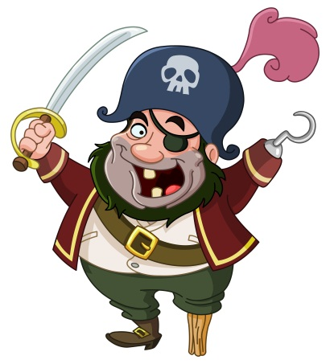  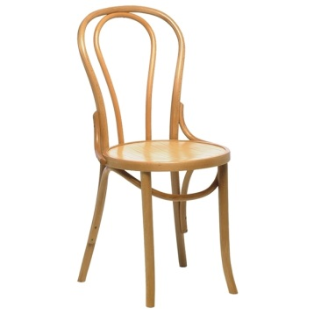
What has the pirate in your picture got?
What colour is are the curtains?
Has your friend got a dog?
Have you got a cat?
What’s your name?
How old are you?
What is there in your school bag?
Where is the dog in your picture?
Are you excited?
Have you got brown hair?
Where is your felt pen?
Good morning.
How are you?
Good bye.

Answers and Replies
What colour is the computer? | 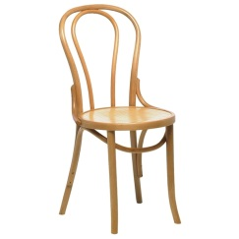
Has your friend got a cat?
Have you got a hamster?
What’s your name?
Where is the dog in your picture?
Where is your glue stick?
What has the pirate in your picture got?
What is there in your school bag?
Are you tired?
How are you?
Good morning.
Which class are you in?
How old are you?
Have you got blue eyes?
Good bye.

Answers and Replies
What’s your name? | 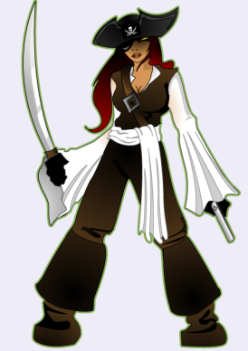  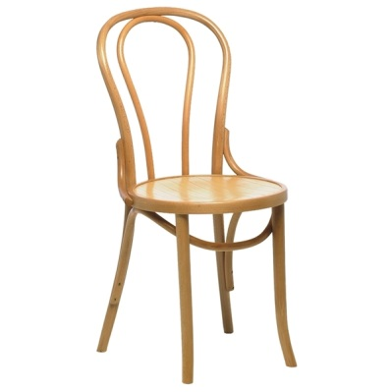
What colour is your desk?
Where is the dog in your picture?
Has your friend got a dog?
Have you got a cat?
Have you got long hair?
What is there in your school bag?
How are you?
What has the pirate in your picture got?
How old are you?
Are you bored?
Which school are you in?
Where is your pen?
Good morning.
Good bye.

Answers and Replies
What colour is your t-shirt?
Where is your pencil?
Which school are you in?
How old are you?
Where is the dog in your picture?
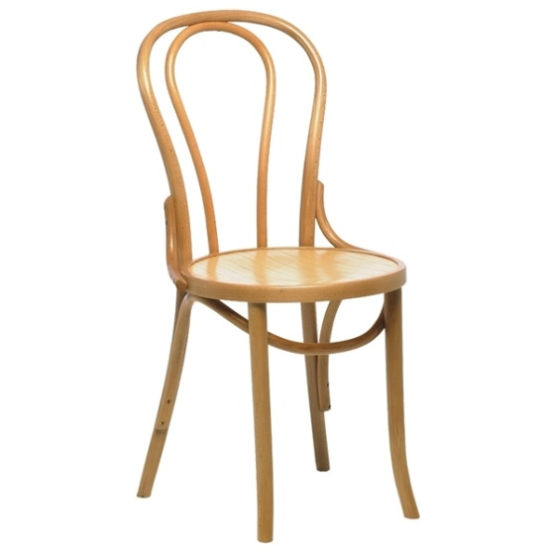
Have you got a hamster?
Have you got blue eyes?
Good morning.
Are you happy?
Good bye.
Has your friend got a cat?
What has the pirate in your picture got?
What is there in your school bag?
What’s your name?
How are you?
Answers and Replies
Which class are you in? | 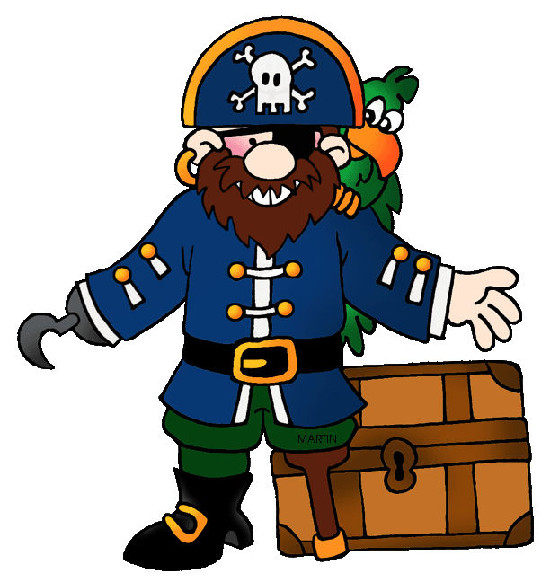
Where is your felt pen?
What’s your name?
How old are you?
Have you got a cat?
Are you excited?
Good morning.
What is there in your school bag?
Where is the dog in your picture?
Have you got brown hair?
Has your friend got a dog?
What colour is are the curtains?
What has the pirate in your picture got?
How are you?
Good bye.

Answers and Replies
What colour is the computer? | 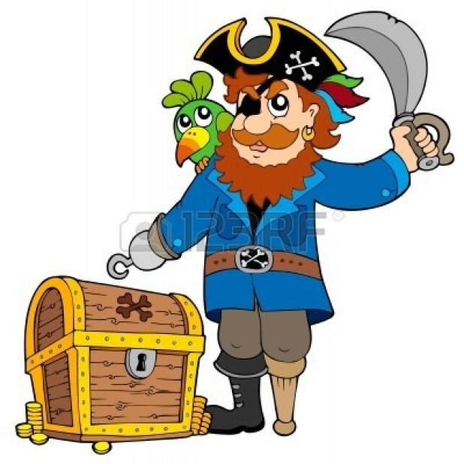
How old are you?
Have you got blue eyes?
What’s your name?
Where is the dog in your picture?
Where is your glue stick?
Has your friend got a cat?
Have you got a hamster?
Are you tired?
Good morning.
What has the pirate in your picture got?
What is there in your school bag?
How are you?
Which class are you in?
Good bye.

Answers and Replies
Good morning. | 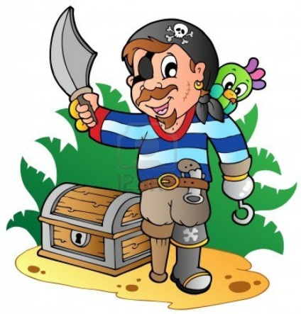
Where is your pen?
What’s your name?
What colour is your desk?
Where is the dog in your picture?
Which school are you in?
Has your friend got a dog?
How are you?
What has the pirate in your picture got?
How old are you?
Are you bored?
Have you got a mouse?
Have you got long hair?
What is there in your school bag?
Good bye.

Answers and Replies
Are you happy? | 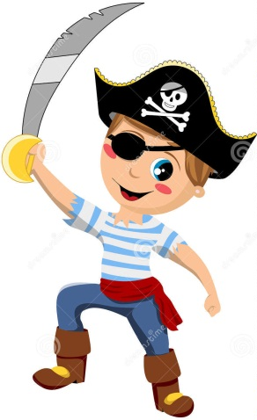
Have you got a hamster?
Which school are you in?
How old are you?
Where is the dog in your picture?
How are you?
Have you got blue eyes?
Good morning.
What’s your name?
What has the pirate in your picture got?
Has your friend got a cat?
What is there in your school bag?
What colour is your t-shirt?
Where is your pencil?
Good bye.

