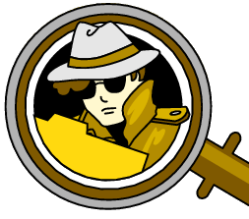
Detectives at work
Date: Time: Place: Praxis-NMS

Detectives at work
Date: Time: Place: Praxis-NMS

