What is Ruff doing?
6B


Watch the video and answer the questions.
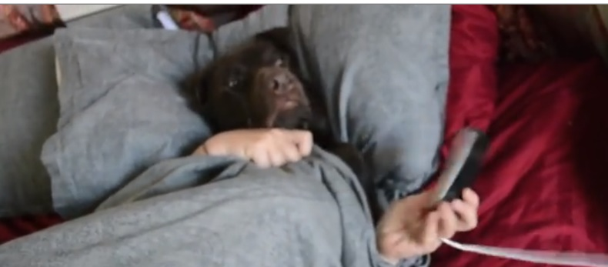

https://learningapps.org/view2169928

1 | In which room is Ruff?
 | What is he doing?
2 | In which room is Ruff?
 | What is he doing?
3 | In which room is Ruff?
 | What is he doing?
4 | In which room is Ruff?
 | What is he doing?
5 | In which room is Ruff?
 | What is he doing?
6 | In which room is Ruff?
 | What is he doing?
7 | In which room is Ruff?
 | What is he doing?
8 | In which room is Ruff?
 | What is he doing?

