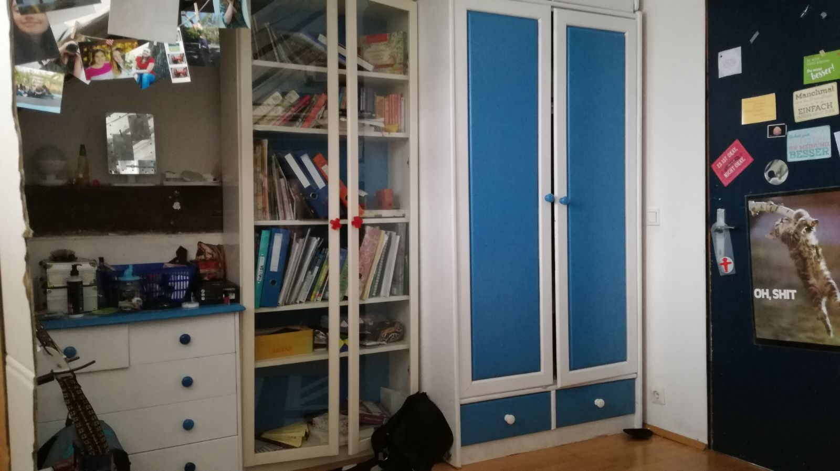
Messy Room for M5, FoF2

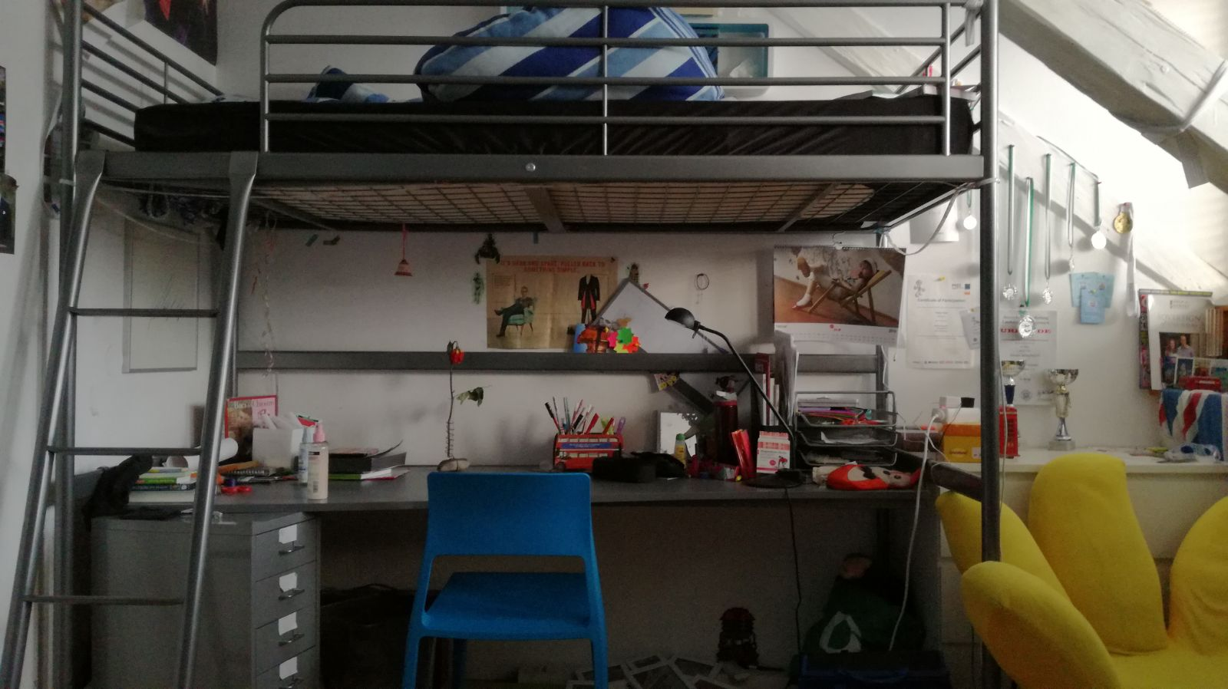
Martina’s room: for M5 FoF1

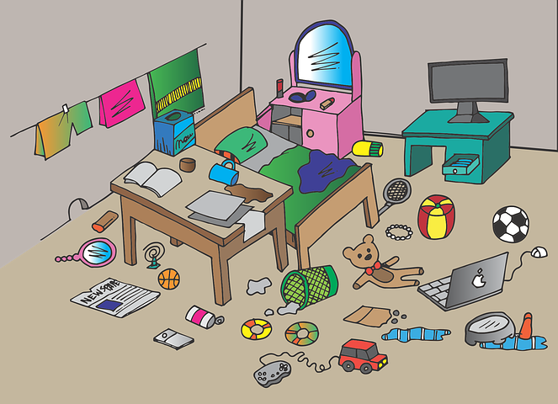
Messy oom: for M5 FoF3

