MODULE 5 Personal Time Planner
Week 1 |  | Week 2 |  | Week 3 |  | Week 4 |  | Week5
Date: ________ |  | Date: ________ |  | Date: ________ |  | Date: ____ |  | Date: ___
Date: ________ |  | Date: ________ |  | Date: ________ |  | Date: ____ |  | Date: ____
Date: ________ |  | Date: ________ |  | Date: ________ |  | Date: ____ |  | Date: ____
Week 6 |  | Week 7 |  | Week 8 |  | Week 9
Date: ________ |  | Date: ________ |  | Date: ____ |  | Date: ____
Date: ________ |  | Date: ________ |  | Date: ____ |  | Date: ____
Date: ________ |  | Date: ________ |  | Date: ____ |  |  |  | 
normaler Zeitplan (2 Jahre) Zeitplan für 3 Jahre:
Start: Mitte April Start: Ende Juni
Abschluss: 3. Woche Mai Abschluss: Ende November

Module 5 Handout: My Home
TASK
5A

Highlight all the things that you have in your home. Then label the picture below.
Start with the rooms.
How many other things can you name? Use the laminated picture dictionary cards if you need help. 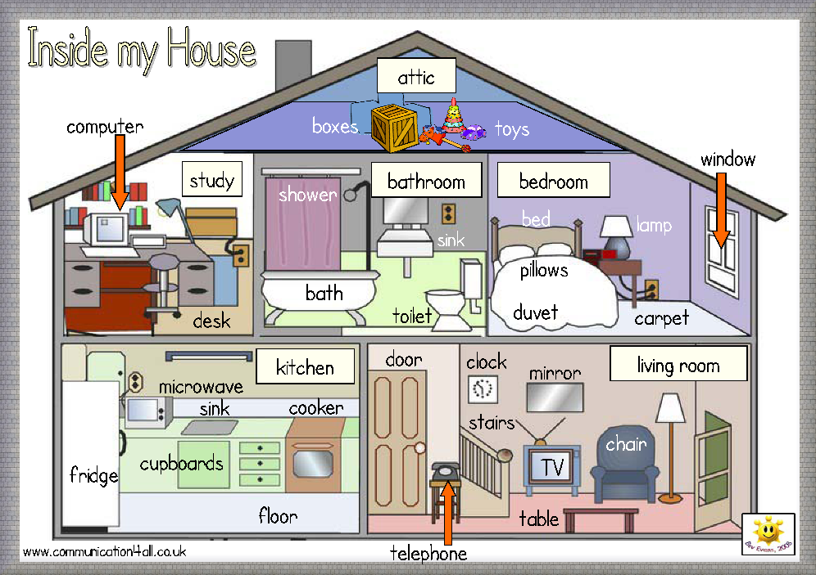
House Nr 1
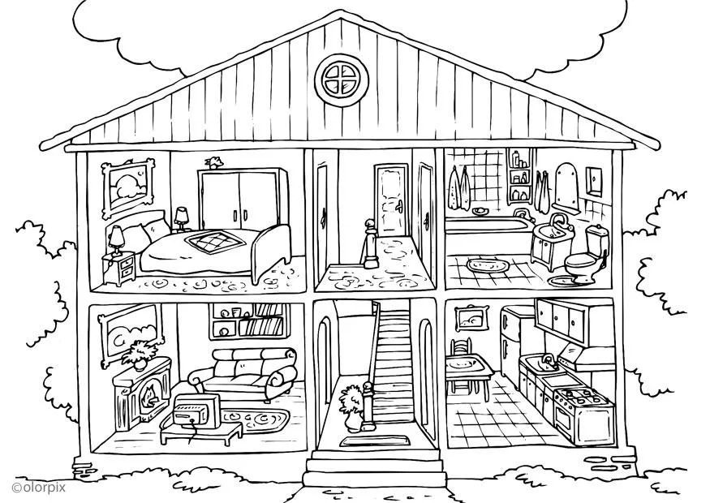
House Nr 2
https://www.schoolplaten.com/kleurplaat-huis-binnenkant-i25995.html
Read the text about house number 2 and correct the mistakes.
TASK
5B
  - If you need help, use the laminated picture dictionary cards.
living room
The house has two floors and an attic. On the first floor there are the bedroom, the hall and the kitchen.
On the second floor there are the living room, the hall and the bathroom.
In the bedroom there are two beds. Behind the bed there is a large wardrobe with two doors. On the bed there are two pillows. Above the bed there is a picture. Beside the bed there is a night-stand with a flower pot. There is a carpet on the floor.
In the bathroom there are a shower, a wash-basin and a toilet. There are two towels on the wall. There are two carpets on the floor. The mirror is above the wash-basin. The bathroom has a small window to let in fresh air.
In the living room there are two armchairs and a large sofa. There is a TV on a little table. Behind the sofa there is a bookshelf. There are many books on the bookshelf. There is a fireplace on the left side with a small lamp on it. Above the fireplace there is a large mirror.
The kitchen is very nice. There is a big fridge, a sink and a cooker. There are two chairs at the kitchen table. Above the sink and the cooker there is a cupboard with two doors.

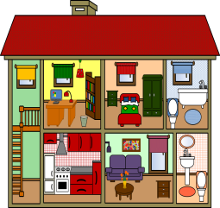
Challenge: Highlight THERE IS and THERE ARE in the text.
Find a rule: When do we say THERE IS, when do we say THERE ARE?
Explain the rule to one of your teachers.
We say THERE IS….

We say THERE ARE…

Now it’s your turn: go to your personal Grammarbook page 27

What’s wrong in this house?
TASK
5C
Some of the furniture is in the wrong room. Example:
- There’s an armchair in the kitchen. The armchair should be in the living room.
- ..................................................................................................................................
- ..................................................................................................................................
- ..................................................................................................................................
- ..................................................................................................................................
- ..................................................................................................................................
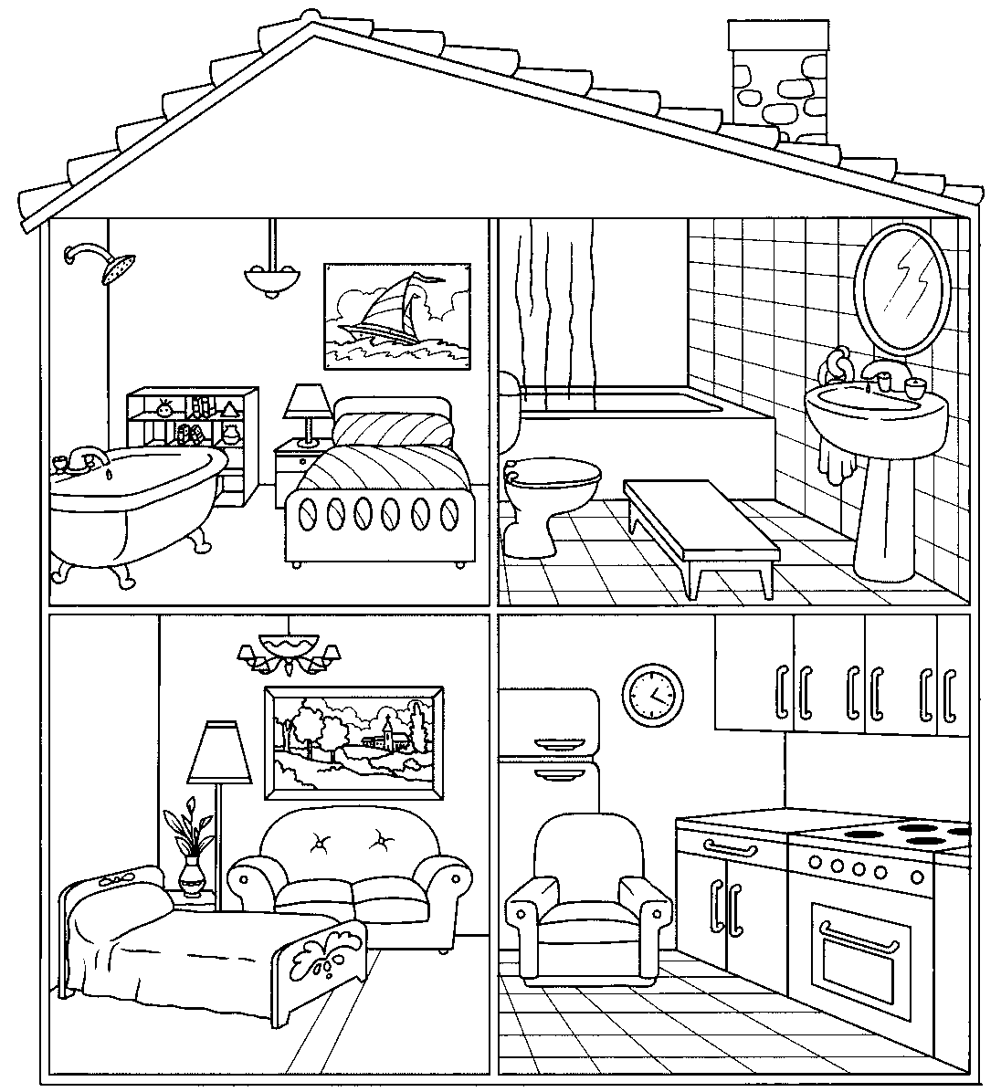
adapted from Apodo. https://en.islcollective.com
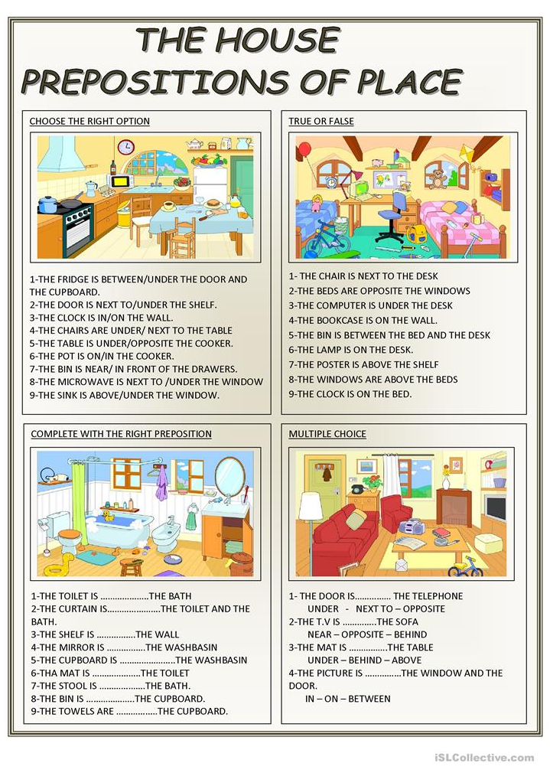
TASK
5D

TASK
5E


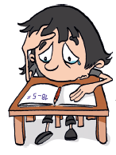
Where is Sadie?
- Read the dialogue with two friends.
Nick and Harriet
are in the living room.

2. Write a new dialogue.
You are looking for a friend at school. Change the underlined words.
(Schreibe einen eigenen Dialog. Ihr sucht eine Freundin/einen Freund in der Schule. Ändere die unterstrichenen Wörter (wenn nötig).

Useful words: classroom / workshop / hall / little study / yard / cafeteria / teachers’ office / library / radio studio / English cinema
reading / doing maths, German, English / eating lunch / playing football / writing a text / studying / working / watching a movie

Nick: Where’s Sadie? Is she in the house? ____________: Where is ____________? Is _____________in school today?
Harriet: Yes, she is. ____________: Yes, ________________________________________________.
Nick: Is she in the bedroom? ____________: Is _________________________________________________?
Harriet: No, she isn’t. ____________: No, ________________________________________________.
Nick: Is she in the bathroom? _____________: Is _______________________________________________________?
Harriet: I don’t know. SADIE! SADIE where are you? _____________: I don’t know. ______________________________________________?
Sadie: I’m in the kitchen. _____________: _________________________________________________________.
Nick: Are you making cookies? _____________: _________________________________________________________?
Sadie: No, I’m not. _____________: _________________________________________________________.
Harriet: Well, what are you doing? _____________: _________________________________________________________.
Sadie: I’m doing my maths homework.. _____________: _________________________________________________________.
Harriet: Oh Sadie! Come here and play with us! _____________: _________________________________________________________.
3. ACT OUT your dialogue for your teacher. (Spielt euren Dialog eurem Lehrer vor)

TASK
5F
Detectives at work
Date: Time: Place: Praxis-NMS

My Personal Grammarbook:
Show your sheet to your teacher. Then choose the five most interesting things and write the sentences into your LR book. Add the sentences to the page about “Routines versus Present activities”.
TASK
5G
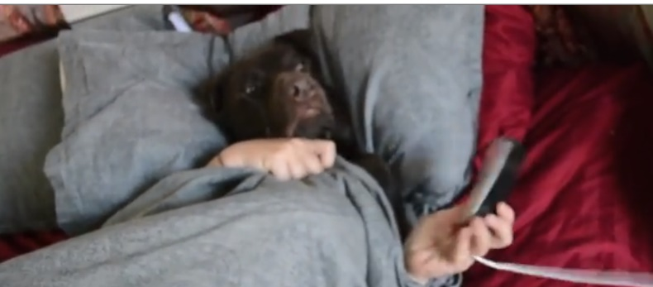
What is Ruff doing?
Watch the video and answer the questions.

https://learningapps.org/view2169928
1 | In which room is Ruff?
 | What is he doing?
2 | In which room is Ruff?
 | What is he doing?
3 | In which room is Ruff?
 | What is he doing?
4a | In which room is Ruff?
 | What is he doing?
4b | In which room is Ruff?
 | What is he doing?
5 | In which room is Ruff?
 | What is he doing?
6 | Where is Ruff?
 | What is he doing?
7 | Where is Ruff going?  What is he going to do next? Write down your ideas. | LET YOUR TEACHER CHECK YOUR ANSWERS

TASK
5H

UNBELIEVABLE ANIMALS
Watch the videos on Moodle.
Then check if you agree with the following text.
Correct the mistakes.

For my last English homework I have watched some really cool videos about unbelievable animals.You should watch them as well.

- In one of the videos you see an octopus smoking a cigarette.
- In another one you see a frog racing through the corridors of an apartment.
- A third video shows a cat that is carrying a coconut.
- One clip shows some salamanders and caterpillars flying over the ice on the North Pole.
- In one video you see a crocodile rolling down a hill and
- in another one you see some penguins skateboarding in a park.
- In one of the clips you see an orange jumping out of the water and

Unbelievable, don’t you agree? Actually, all the videos are real, except for one. Which one is fake? Can you guess?

I think….________________________________________________________________________
TASK 5I

