
Module 5 Handout: My Home
TASK
5A

Highlight all the things that you have in your home. Then label the picture below.
Start with the rooms.
How many other things can you name? Use the laminated picture dictionary cards if you need help. 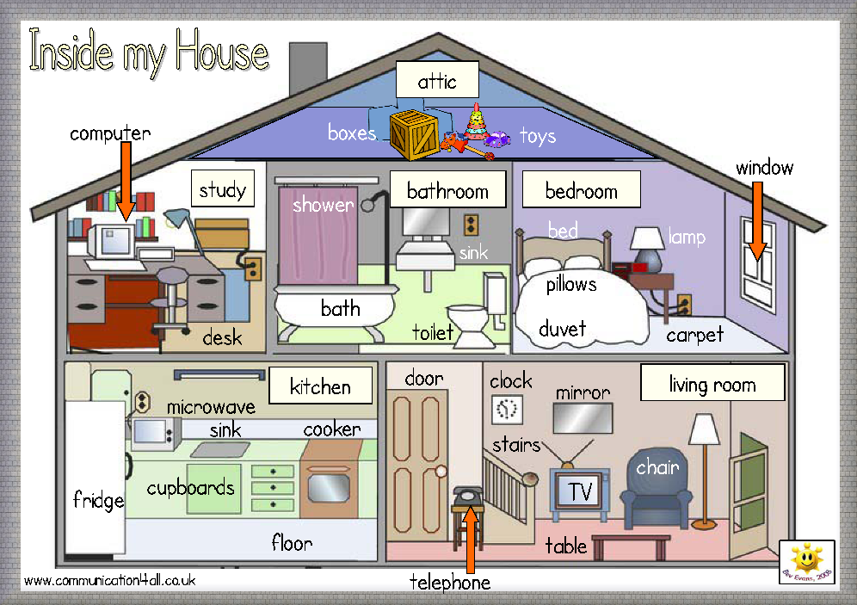
House Nr 1
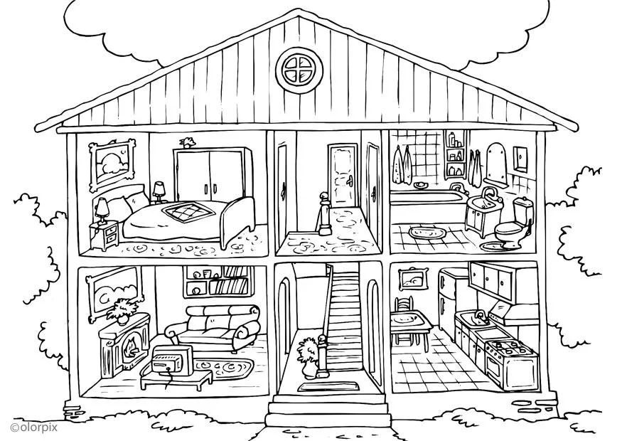
carpet
table
TV
sofa
bookshelf
fireplace
duvet
bed
bedside table
lamp
pillow
picture
chair
picture
fridge
cupboard
toilet
bath(tub)
towel
window
mirror
shelf
attic
plant
wardrobe
stairs
table
cooker
carpet
sink / washbasin
House Nr 2
https://www.schoolplaten.com/kleurplaat-huis-binnenkant-i25995.html
door
carpet
plant
Read the text about house number 2 and correct the mistakes.
TASK
5B
  - If you need help, use the laminated picture dictionary cards.
living room
The house has two floors and an attic. On the first floor there is the bedroom, the hall and the kitchen.
bed
bed
On the second floor there is the living room, the hall and the bathroom.
is one bed
In the bedroom there are two beds. Behind the bed there is a large wardrobe with doors. Above the bed there is a picture. Beside the bed there is a night-stand with a flower pot. There is a carpet on the floor.
bathtub / bath
lamp
In the bathroom there is a shower, a wash-basin and a toilet. There are two towels on the wall. The mirror is above the washbasin. The bathroom has a small window to let in fresh air.
In the living room there is a large sofa and two armchairs. There is a TV on a little table. Behind the sofa there is a bookshelf with lots of books. There is a fireplace on the left side with a small lamp on it. Above the fireplace there is a large mirror.
There is one chair
picture
flower pot
above
The kitchen is very nice. There is a big fridge, a sink and a cooker. There are two chairs at the kitchen table. Above the sink and the cooker there is a cupboard with two doors.
three

Challenge: Highlight THERE IS and THERE ARE in the text.
Find a rule: When do we say THERE IS, when do we say THERE ARE?
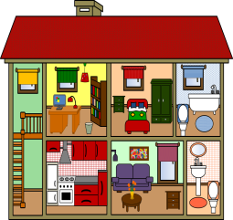
Write 4 sentences about our classroom. Use THERE IS and THERE ARE.
Explain the rule to one of your teachers.
Then write an entry in your LR book.

KEY: We use “there is” to talk about ONE thing, and “there are” to talk about more than one thing.
If we describe a room, we say what “THERE IS” in the room.
What’s wrong in this house?
TASK
5C
Some of the furniture is in the wrong room. Example:
- There’s an armchair in the kitchen. The armchair should be in the living room.
- There is a shower in the bedroom. The shower should be in the bathroom.
- There is a bathtub in the bedroom. The bathtub should be in the bathroom.
- There is a small table in the bathroom. The small table should be in the living room.
- There is a bed in the living room. The bed should be in the bedroom.
- (There is a shelf in the bedroom. The shelf should be in the living room.)

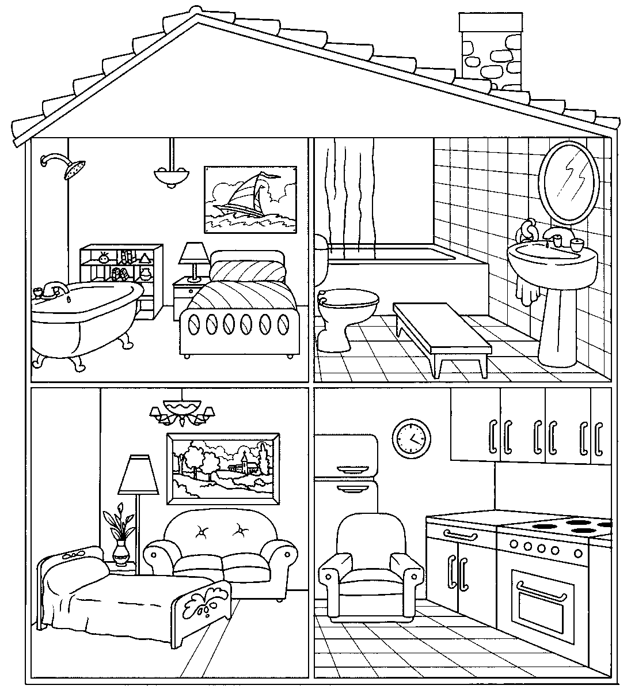
adapted from Apodo. https://en.islcollective.com
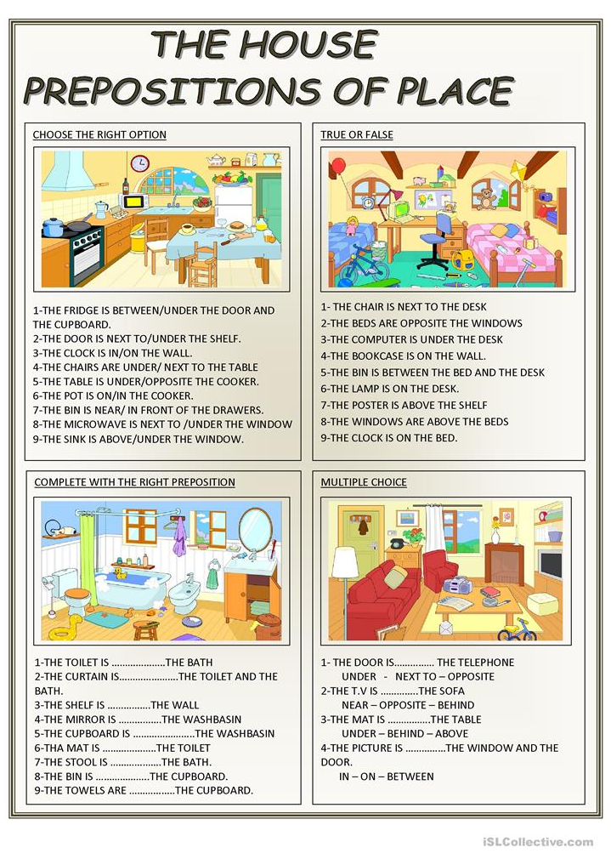
FALSE
FALSE
TRUE
TRUE
TRUE
FALSE
TRUE
FALSE
FALSE
in
in front of
near
in front of
under
above
on
between
next to
TASK
5D

TASK
5E
Where is Sadie?
- Read the dialogue with two friends.
Nick and Harriet
are in the living room.




2. Write a new dialogue.
You are looking for a friend at school. Change the underlined words.
(Schreibe einen eigenen Dialog. Ihr sucht eine Freundin/einen Freund in der Schule. Ändere die unterstrichenen Wörter (wenn nötig).

Useful words: classroom / workshop / hall / little study / yard / cafeteria / teachers’ office / library / radio studio / English cinema
reading / doing maths, German, English / eating lunch / playing football / writing a text / studying / working / watching a movie

Nick: Where’s Sadie? Is she in the house? ____________: Where is ____________? Is _____________in school today?
Harriet: Yes, she is. ____________: Yes, ________________________________________________.
Nick: Is she in the bedroom? ____________: Is _________________________________________________?
Harriet: No, she isn’t. ____________: No, ________________________________________________.
Nick: Is she in the bathroom? _____________: Is _______________________________________________________?
Harriet: I don’t know. SADIE! SADIE where are you? _____________: I don’t know. ______________________________________________?
Sadie: I’m in the kitchen. _____________: _________________________________________________________.
Nick: Are you making cookies? _____________: _________________________________________________________?
Sadie: No, I’m not. _____________: _________________________________________________________.
Harriet: Well, what are you doing? _____________: _________________________________________________________.
Sadie: I’m doing my maths homework.. _____________: _________________________________________________________.
Harriet: Oh Sadie! Come here and play with us! _____________: _________________________________________________________.
3. ACT OUT your dialogue for your teacher. (Spielt euren Dialog eurem Lehrer vor)

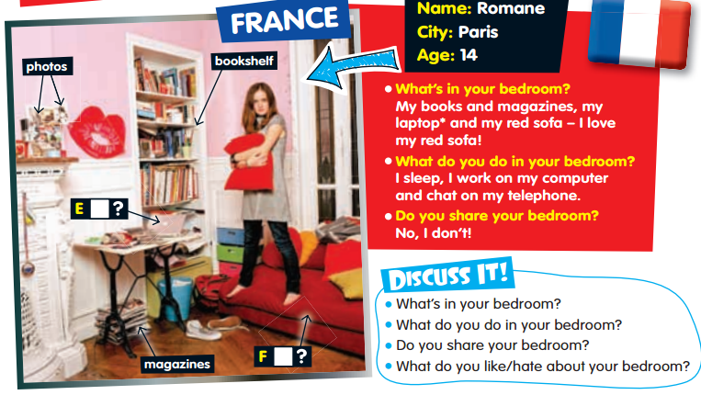
Romana’s room and Edson’s room
TASK
5F

- What does Romane do in her bedroom? She sleeps, works on her computer and chats on her phone.
- What’s in Romane’s bedroom? Her books and magazines, her laptop and her red sofa
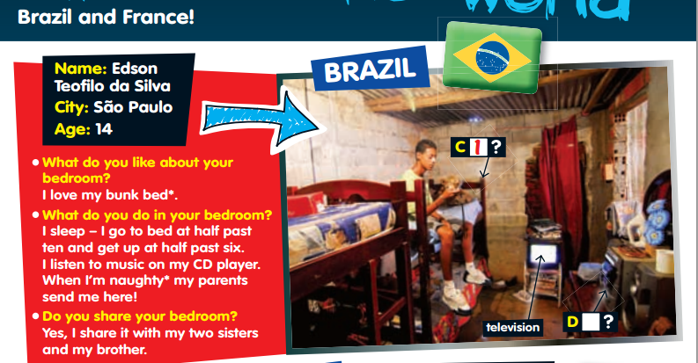
- What’s Romane’s favourite thing? Her red sofa.

- What’s Edson’s favourite thing? His bunk bed.
- What is the same for Edson and Romane?
They sleep in their rooms.
- What is different?
Edson shares his room, Romane doesn’t share her room. Romane has books and magazines in ther room, Edson has a TV in his room. Romane chats, Edson listens to music. Romane has a normal bed, Edson has a bunk bed.
- What does “share” mean? “teilen”
- Which room do you like better? Edson’s or Romane’s room? Why? )

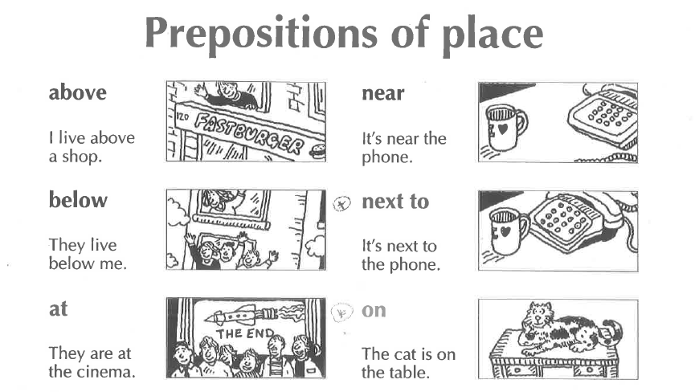
TASK
5G

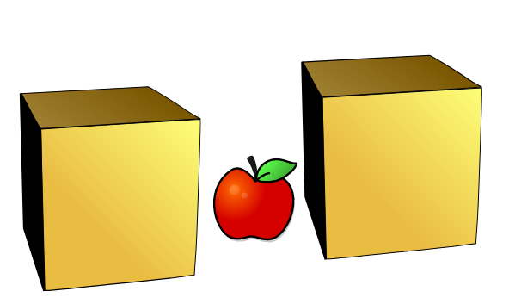


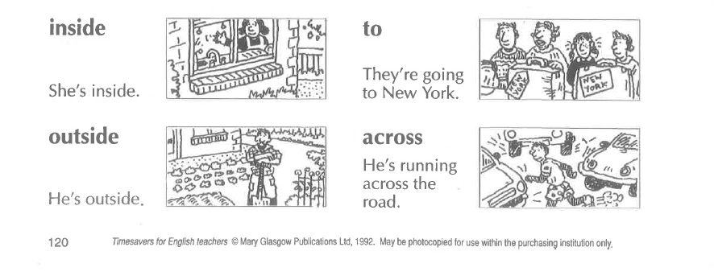
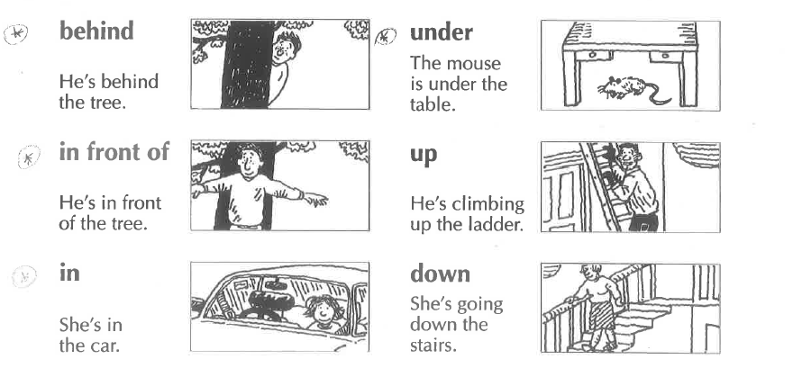
opposite
They are sitting opposite each other.
between
There is an apple between the two boxes
Is there | a | sofa | in your classroom?
Is there | an | orange | in your classroom?
Are there | any | laptops | in your classroom?

Yes, there is.  No, there isn’t. | Yes, there are.  No, there aren’t.

There is a | sofa | in/on/under/next to/in front of/behind/between…..the | …………. .
There are some | posters | in/on/under/next to/in front of/behind/between…..the | …………. .

Write 8 true sentences about your classroom / your room. Put your text into the IN-BOX.

