Module 5 Handout: My Home
TASK
5A

Highlight all the things that you have in your home. Then label the picture below.
Start with the rooms.
How many other things can you name? Use the laminated picture dictionary cards if you need help. 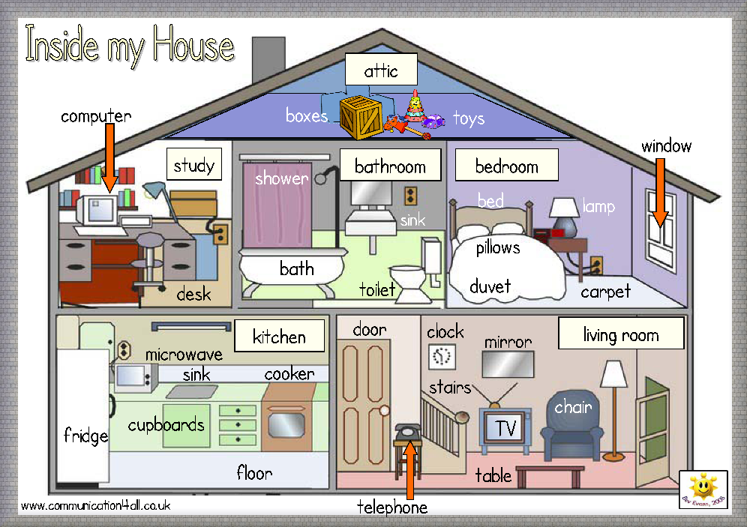
House Nr 1
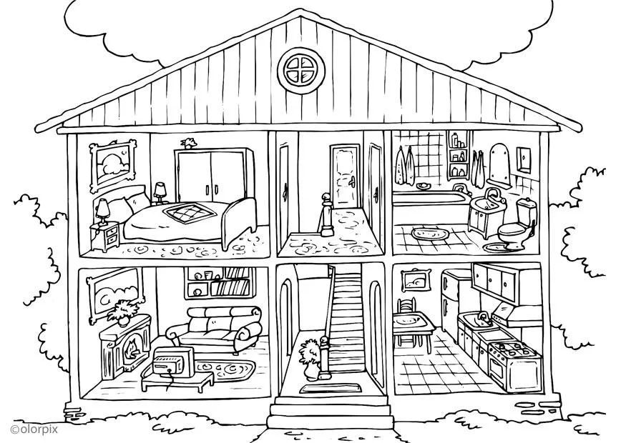
House Nr 2
https://www.schoolplaten.com/kleurplaat-huis-binnenkant-i25995.html
Read the text about house number 2 and correct the mistakes.
TASK
5B
  - If you need help, use the laminated picture dictionary cards.
living room
The house has two floors and an attic. On the first floor there is the bedroom, the hall and the kitchen.
On the second floor there is the living room, the hall and the bathroom.
In the bedroom there are two beds. Behind the bed there is a large wardrobe with two doors. Above the bed there is a picture. Beside the bed there is a night-stand with a flower pot. There is a carpet on the floor.
In the bathroom there is a shower, a wash-basin and a toilet. There are two towels on the wall. The mirror is above the wash-basin. The bathroom has a small window to let in fresh air.
In the living room there is a large sofa and two armchairs. There is a TV on a little table. Behind the sofa there is a bookshelf with lots of books. There is a fireplace on the left side with a small lamp on it. Above the fireplace there is a large mirror.
The kitchen is very nice. There is a big fridge, a sink and a cooker. There are two chairs at the kitchen table. Above the sink and the cooker there is a cupboard with two doors.

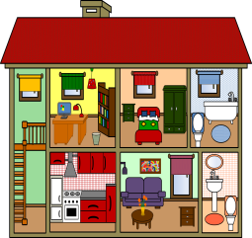
Challenge: Highlight THERE IS and THERE ARE in the text.
Find a rule: When do we say THERE IS, when do we say THERE ARE?
Explain the rule to one of your teachers.
We say THERE IS….

We say THERE ARE…

Now it’s your turn: Write five sentences about your room. Use there is and there are
Write your sentences on a sheet of paper. Show them to your teacher. Then put your sheet into your LR book, together with the blue LR book sheet for the topic “there is – there are”.

What’s wrong in this house?
TASK
5C
Some of the furniture is in the wrong room. Example:
- There’s an armchair in the kitchen. The armchair should be in the living room.
- ..................................................................................................................................
- ..................................................................................................................................
- ..................................................................................................................................
- ..................................................................................................................................
- ..................................................................................................................................
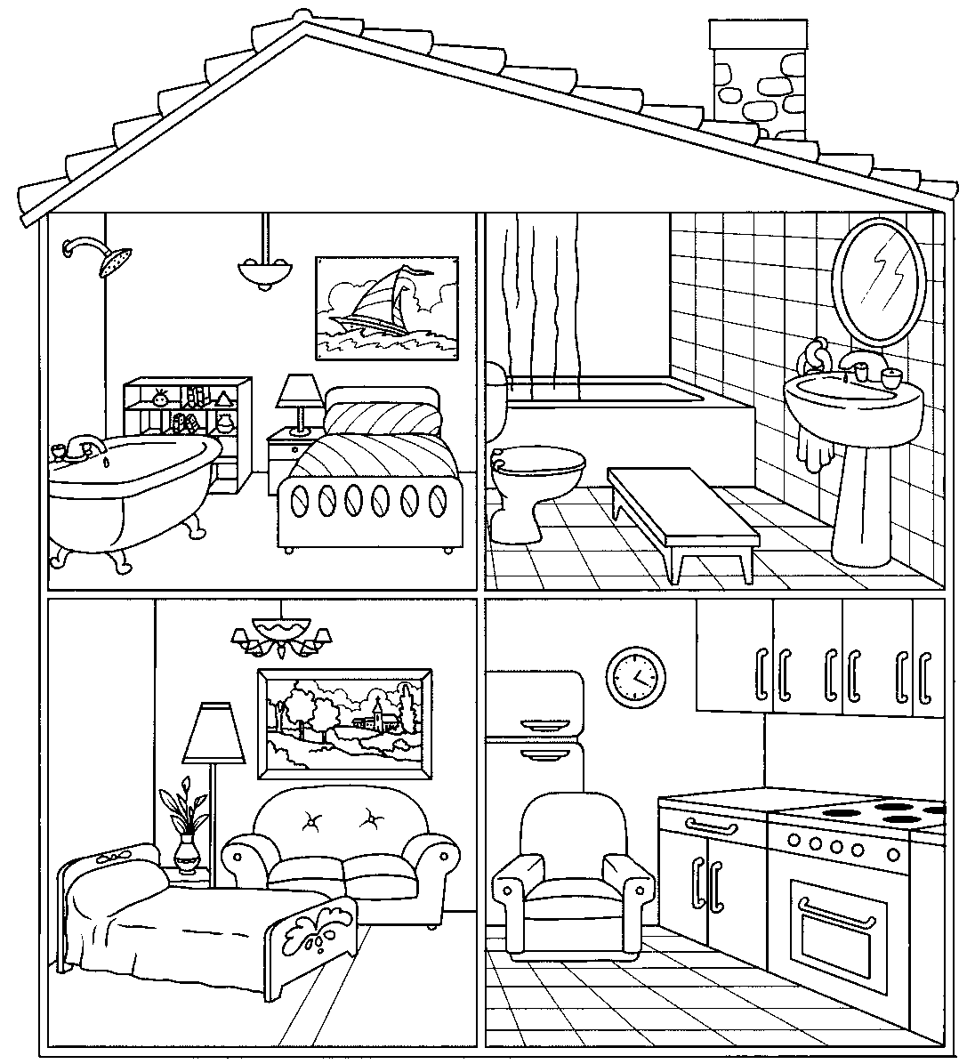
adapted from Apodo. https://en.islcollective.com
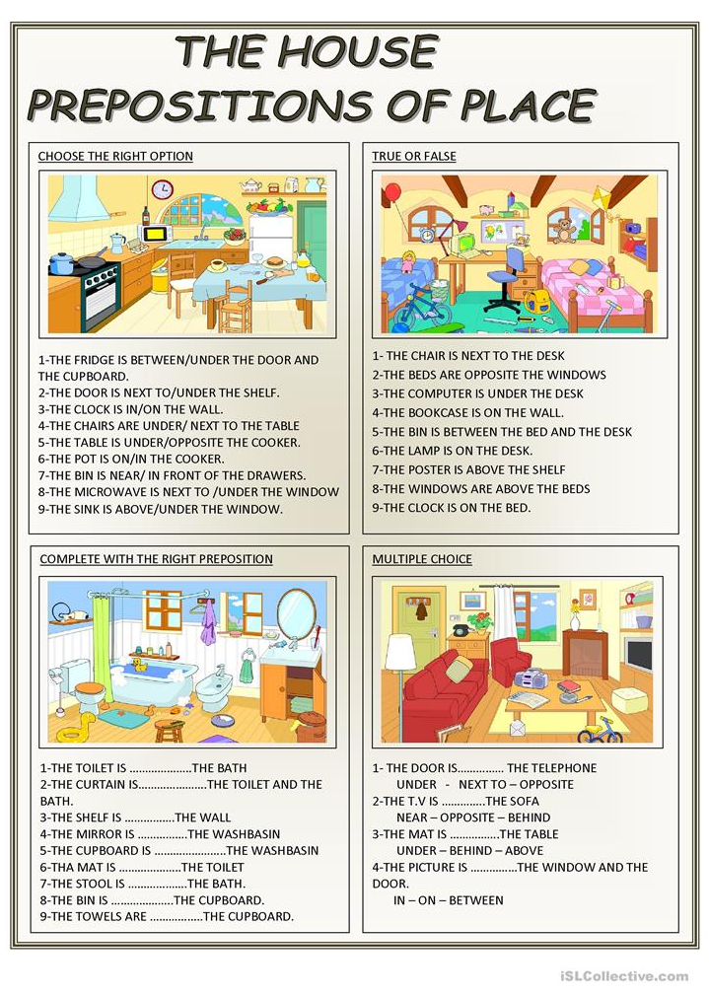
TASK
5D

TASK
5E
Where is Sadie?
- Read the dialogue with two friends.
Nick and Harriet
are in the living room.



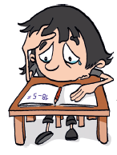
2. Write a new dialogue.
You are looking for a friend at school. Change the underlined words.
(Schreibe einen eigenen Dialog. Ihr sucht eine Freundin/einen Freund in der Schule. Ändere die unterstrichenen Wörter (wenn nötig).

Useful words: classroom / workshop / hall / little study / yard / cafeteria / teachers’ office / library / radio studio / English cinema
reading / doing maths, German, English / eating lunch / playing football / writing a text / studying / working / watching a movie

Nick: Where’s Sadie? Is she in the house? ____________: Where is ____________? Is _____________in school today?
Harriet: Yes, she is. ____________: Yes, ________________________________________________.
Nick: Is she in the bedroom? ____________: Is _________________________________________________?
Harriet: No, she isn’t. ____________: No, ________________________________________________.
Nick: Is she in the bathroom? _____________: Is _______________________________________________________?
Harriet: I don’t know. SADIE! SADIE where are you? _____________: I don’t know. ______________________________________________?
Sadie: I’m in the kitchen. _____________: _________________________________________________________.
Nick: Are you making cookies? _____________: _________________________________________________________?
Sadie: No, I’m not. _____________: _________________________________________________________.
Harriet: Well, what are you doing? _____________: _________________________________________________________.
Sadie: I’m doing my maths homework.. _____________: _________________________________________________________.
Harriet: Oh Sadie! Come here and play with us! _____________: _________________________________________________________.
3. ACT OUT your dialogue for your teacher. (Spielt euren Dialog eurem Lehrer vor)

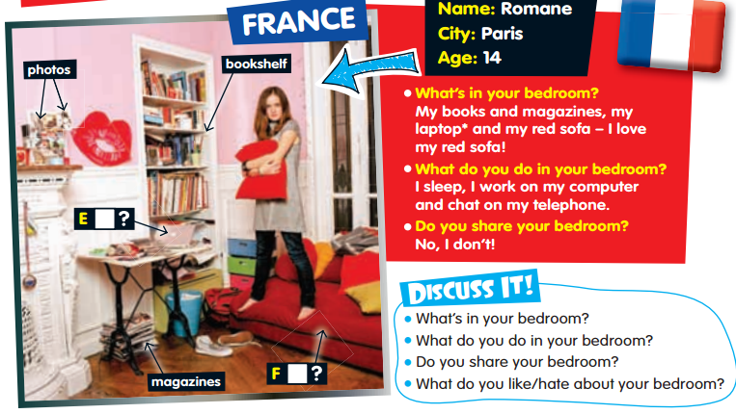
Romana’s room and Edson’s room
TASK
5F

- What does Romane do in her bedroom? _____________________________
- What’s in Romane’s bedroom?_____________________________________
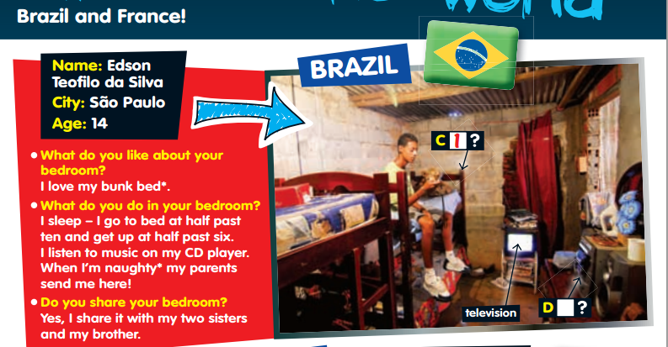
- What’s Romane’s favourite thing? __________________________________

- What’s Edson’s favourite thing? __________________________________________
- What is the same for Edson and Romane?
- ____________________________________________________________________
- What is different?
- ____________________________________________________________________
- What does “share” mean? ______________________________________________
- Which room do you like better? Edson’s or Romane’s room? Why? )
___________________________________________________________________________

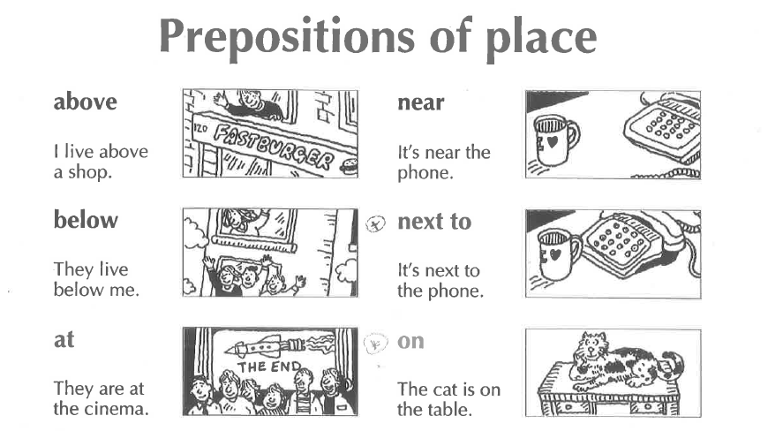
TASK
5G

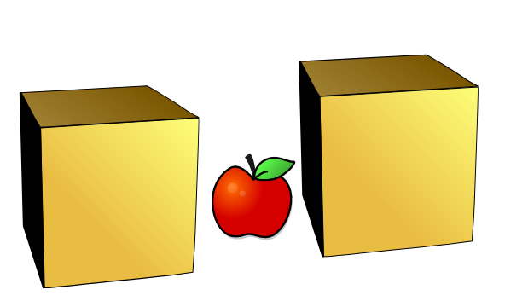

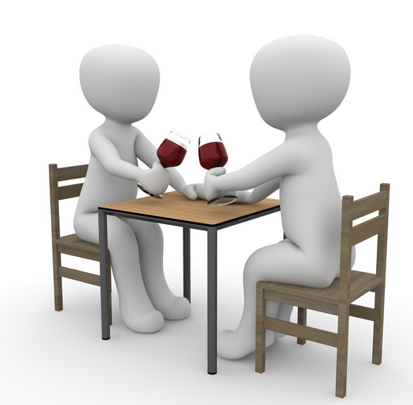
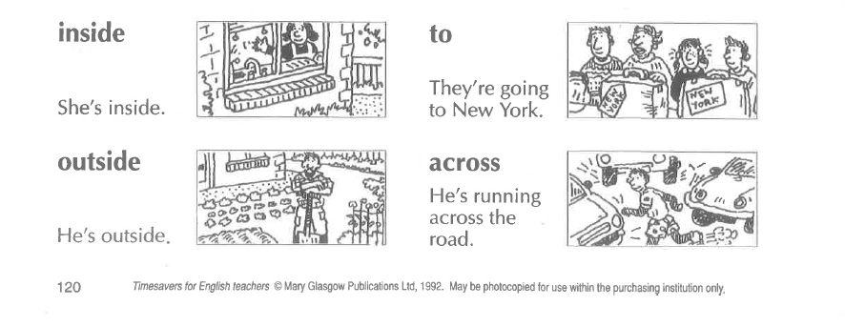
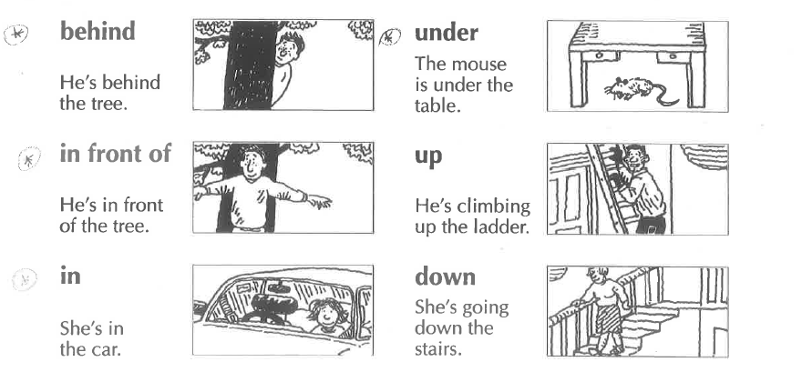
opposite
They are sitting opposite each other.
between
There is an apple between the two boxes
Is there | a | sofa | in your classroom?
Is there | an | orange | in your classroom?
Are there | any | laptops | in your classroom?

Yes, there is.  No, there isn’t. | Yes, there are.  No, there aren’t.

There is a | sofa | in/on/under/next to/in front of/behind/between…..the | …………. .
There are some | posters | in/on/under/next to/in front of/behind/between…..the | …………. .

Now it’s your turn: Write 8 true sentences about your classroom or your room. Show your sentences to your teacher. Correct your sentences and put the sheet into your LR book, opposite the blue LR book sheet for this topic.

