Happy Families
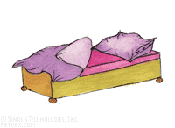  wardrobe  alarm clock  chest of drawers | 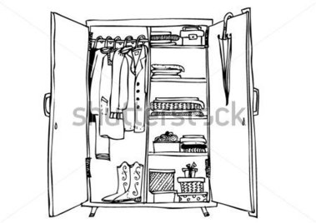  bed  alarm clock  chest of drawers | 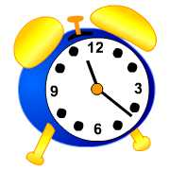  bed  chest of drawers  wardrobe | 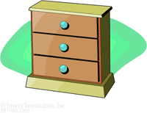  bed  wardrobe  alarm clock
  bath  towels  mirror | 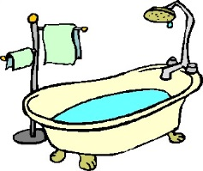  shower  towels  mirror |   shower  towels  bath |   shower  bath  mirror
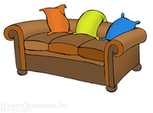  armchair  television set  coffee table |   sofa  television set  coffee table |   sofa  armchair  coffee table |   sofa  armchair  television set
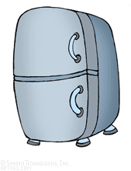  cooker  microwave  dishwasher | 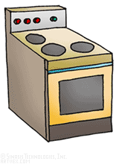  microwave  fridge  dishwasher | 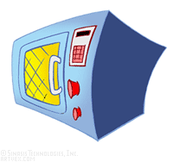  fridge  cooker  dishwasher |   fridge  cooker  microwave
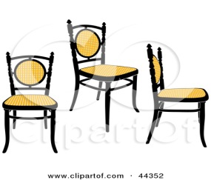  table  cupboard  lamp | 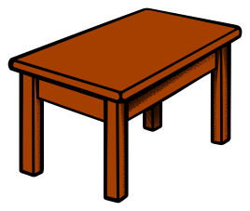  chairs  cupboard  lamp | 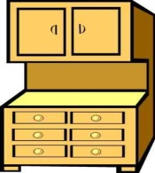  chairs  table  lamp |   chairs  table  cupboard
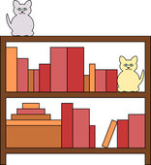  computer  desk  phone |   desk  bookcase  phone |   desk  bookcase  computer | 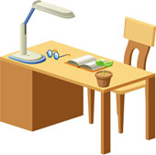  bookcase  computer  phone

Happy Families (Rules) (German: Quartet)
- Play in groups of 3 or 4.
- Hand out all the cards.
- The player with the smallest shoe-size starts.
Ask: What size of shoes do you wear?
Answer: I wear size ….. shoes.
- Collect four cards to complete a “family”. (Sammle die vier Dinge auf deinen Karten für ein Quartet.)
Ask: Do you have the bed?
Answer: Yes, I do. Here it is.
or No, I don’t have the bed.
- Keep asking for more cards until a player says: No, I don’t have the ….

adapted from: http://busyteacher.org/23848-furniture-card-game-happy-families.html

