Happy Families
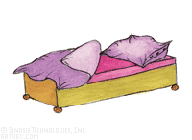  bed  Do you have the..  …wardrobe  …alarm clock  …chest of drawers | 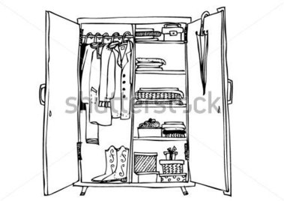  wardrobe  Do you have the..  bed  alarm clock  chest of drawers | 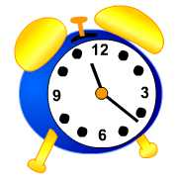  alarm clock  Do you have the..  bed  chest of drawers  wardrobe | 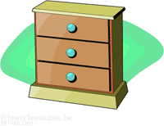  chest of drawers  alarm clock  Do you have the..  bed  wardrobe  alarm clock
  shower  Do you have the..  bath  towels  mirror | 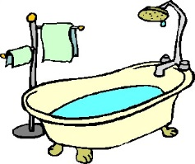  bath  Do you have the..  shower  towels  mirror | shower    mirror  Do you have the..  shower  towels  bath |   towels  Do you have the..  shower  bath  mirror
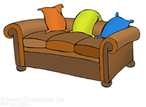  sofa  Do you have the..  armchair  television set  coffee table |   armchair  Do you have the..  sofa  television set  coffee table |   television set  Do you have the..  sofa  armchair  coffee table |   coffee table  Do you have the..  sofa  armchair  television set
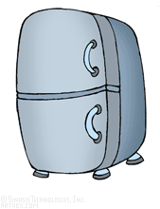  fridge  Do you have the..  cooker  microwave  dishwasher | 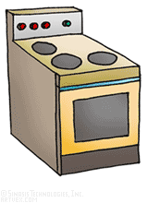  cooker  Do you have the..  microwave  fridge  dishwasher | 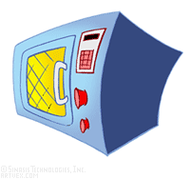  microwave  Do you have the..  fridge  cooker  dishwasher |   dishwasher  Do you have the..  fridge  cooker  microwave
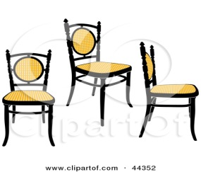  chairs  Do you have the..  table  cupboard  lamp | 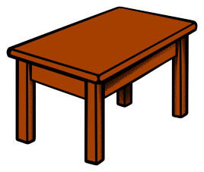  table  Do you have the..  chairs  cupboard  lamp | 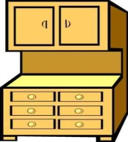  cupboard  Do you have the..  chairs  table  lamp |   lamp  Do you have the..  chairs  table  cupboard
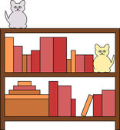  bookcase  Do you have the..  computer  desk  phone |   Do you have the..  desk  bookcase  phone |   phone  computer  Do you have the..  desk  bookcase  computer | 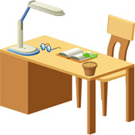  desk  Do you have the..  bookcase  computer  phone

Happy Families (Rules) (German: Quartet)
- Play in groups of 3 or 4.
- Hand out all the cards.
- The player with the smallest shoe-size starts.
Ask: What size of shoes do you wear?
Answer: I wear size ….. shoes.
- Collect four cards to complete a “family”. (Sammle die vier Dinge auf deinen Karten für ein Quartet.)
Ask: Do you have the bed?
Answer: Yes, I do. Here it is.
or No, I don’t have the bed.
- Keep asking for more cards until a player says: No, I don’t have the ….

adapted from: http://busyteacher.org/23848-furniture-card-game-happy-families.html

