Happy Families
Do you have the..    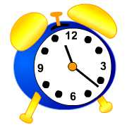  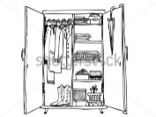 | 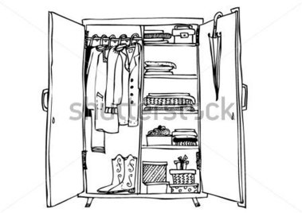  Do you have the..  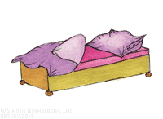 | Do you have the.. | Do you have the..
        Do you have the |     Do you have the |   Do you have the | Do you have the
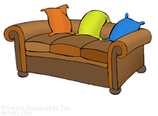  Do you have the       |   Do you have the   |   Do you have the | Do you have the
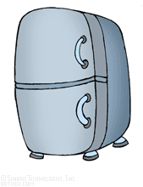  Do you have the  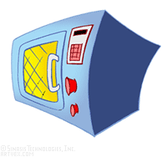  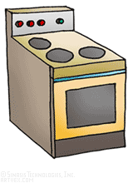   | Do you have the | Do you have the |   Do you have the
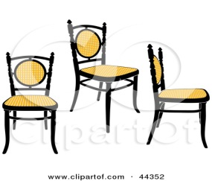  Do you have the  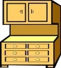    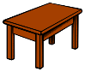 | 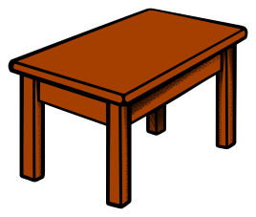  Do you have the  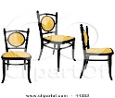 |   Do you have the |   Do you have the
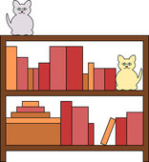  Do you have the      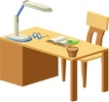 |   Do you have the  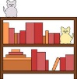 |   Do you have the | 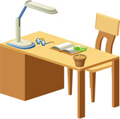  Do you have the

Happy Families (Rules) (German: Quartet)
- Play in groups of 3 or 4.
- Hand out all the cards.
- The player with the smallest shoe-size starts.
Ask: What size of shoes do you wear?
Answer: I wear size ….. shoes.
- Collect four cards to complete a “family”. (Sammle die vier Dinge auf deinen Karten für ein Quartet.)
Ask: Do you have the bed?
Answer: Yes, I do. Here it is.
or No, I don’t have the bed.
- Keep asking for more cards until a player says: No, I don’t have the ….

adapted from: http://busyteacher.org/23848-furniture-card-game-happy-families.html

