Vocabulary Threes: Our house
Where do you hang up your coat? | In the garage.
Where do you go to reach the attic? | The basement or cellar.
Where do you play with the dog? | In the living room.
How do you enter the house? | 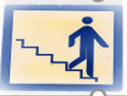  Downstairs?
Where do you do the cooking? | In the bedroom.

Where do you have dinner with guests? | In the kitchen
Where do you watch TV with your family? | In the study. // In the office.
What room is at the very bottom of the house? | The attic.
Where do you park the car? | In the bathroom.
Where do you go when you have had a lot to drink? | In the garden.

Where do you sleep? | 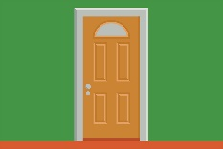  Through the front door.
Where do you work on the computer? | In the hall.
What room is at the very top of the house? | The toilet.
Where do you go to reach the basement? | 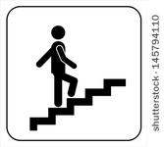  Upstairs.
Where do you have a bath or shower? | In the dining room.

