 |  | 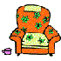 | 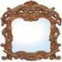 | 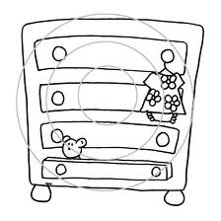
- SOFA | 2. SHELF | 3. ARMCHAIR | 4. MIRROR | 5. (CHEST OF)  DRAWERS
 |  | 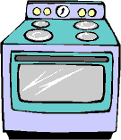 | 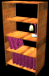 | 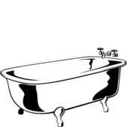
6. FIRE PLACE | 7. TABLE | 8. COOKER | 9. BOOK CASE  (BOOK SHELVES) | 10. BATH  (BATHTUB)
 | 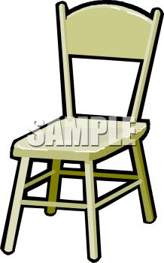 | 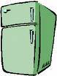
11. WARDROBE | 12. CHAIR | 13. FRIDGE | 14. BED | 15. CLOCK
 | 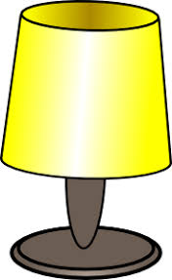 | 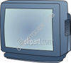 |  | 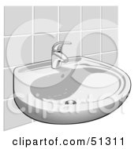
16. DESK | 17. LAMP | 18. TELEVISION | 19. T V  STAND | 20. SINK

Furniture in my House

WS
3.3
adapted from uniqpink, islcollective https://en.islcollective.com/mypage?id=184129
Bedroom
Livingroom
Kitchen
Bathroom

shelf
mirror
chest of drawer
bath(tub)
sink
sofa
shelf
armchair
table
chest of drawers
fire place
book case
chair
clock
lamp
television
TV stand
shelf
chest of drawers
chair
table
cooker
fridge
clock
sink
mirror
chest of drawers
book case
wardrobe
chair
bed
clock
lamp
television
shelf
desk

Where can you see these pieces of furniture? Write them into the correct boxes.

