 |  | 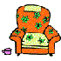 | 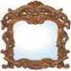 | 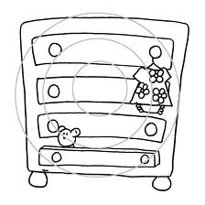
1. S _ F _ | 2. _ H _ _ F | 3. A _ M  C _ A _ R | 4. M _ _ R O _ | 5. _ R A _ E _ S
 |  | 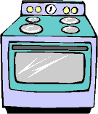 | 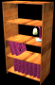 | 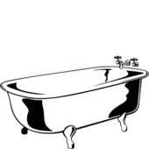
6. F _ R E _ L _ C E | 7. T _ B L _ | 8. C O _ K _ _ | 9. B O _ K  C _ S _ | 10. _ A T _
 | 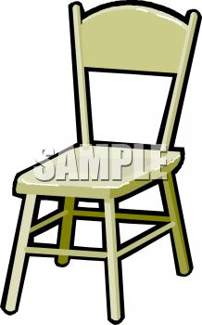 | 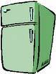
11. W _ R D _ _ B _ | 12. C _ A _ _ | 13. F _ _ D _ E | 14. _ E _ | 15. C _ O _ _
 | 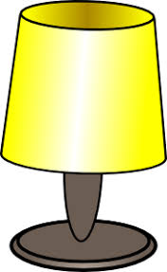 | 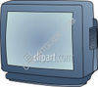 |  | 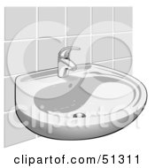
16. D _ S _ | 17. L _ _ P | 18. T _ L E _ _ S I _ N | 19. T V  S _ A _ D | 20. S _ _ K
WS
3.3
Furniture in My House
adapted from uniqpink, islcollective https://en.islcollective.com/mypage?id=184129
Bedroom
Livingroom
Kitchen
Bathroom
Where can you see these pieces of furniture? Write them into the correct boxes.

