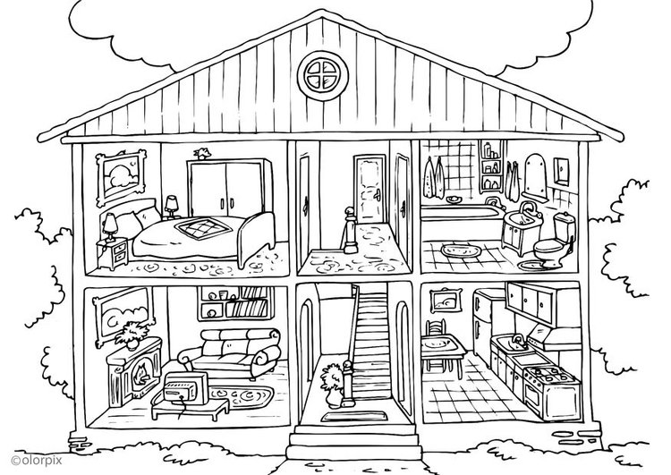
Mice Everywhere
A




Where are the mice? Ask your partner and draw them in your picture. Can you find them all?
Ask: Is there a mouse on the stairs? Yes, there is. No there isn`t.
Then add 2 more mice yourself. How many mice can you find altogether?

Mice Everywhere
B

Where are the mice? Ask your partner and draw them in your picture. Can you find them all?
Ask: Is there a mouse on the stairs? Yes, there is. No there isn`t.
Then add 2 more mice yourself. How many mice can you find altogether?

