Spot the difference A
Do NOT show your picture to your partner.
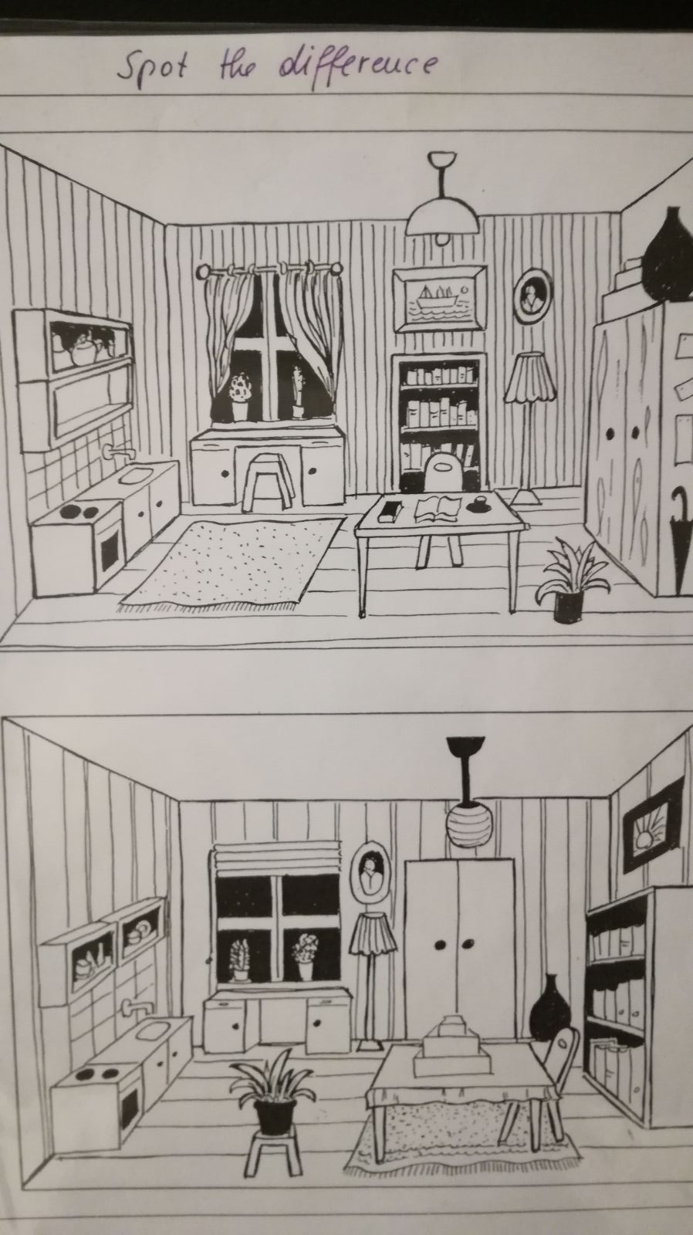
Say:
Do you have a (chair)…
Yes, I do.
No, I don’t.
Where is it?
It is…
- on
- next to
- between
- in front of
- behind
- under
- above

Spot the difference B
Do NOT show your picture to your partner.
Say:
Do you have a (chair)…
Yes, I do.
No, I don’t.
Where is it?
It is…
- on
- next to
- between
- in front of
- behind
- under
- above

