Read the text about house number 2 and correct the mistakes.
TASK
5B
  - If you need help, use the laminated picture dictionary cards.
living room
The house has two floors and an attic. On the first floor there is the bedroom, the hall and the kitchen.
bed
bed
On the second floor there is the living room, the hall and the bathroom.
is one bed
In the bedroom there are two beds. Behind the bed there is a large wardrobe with doors. On the bed there are two pillows. Above the bed there is a picture. Beside the bed there is a night-stand with a flower pot. There is a carpet on the floor.
lamp
bathtub / bath
In the bathroom there is a shower, a wash-basin and a toilet. There are two towels on the wall. The mirror is above the washbasin. The bathroom has a small window to let in fresh air.
In the living room there is a large sofa and two armchairs. There is a TV on a little table. Behind the sofa there is a bookshelf with lots of books. There are many books on the bookshelf. There is a fireplace on the left side with a small lamp on it. Above the fireplace there is a large mirror.
picture
flower pot
There is one chair
above
The kitchen is very nice. There is a big fridge, a sink and a cooker. There are two chairs at the kitchen table. Above the sink and the cooker there is a cupboard with two doors.
three

Challenge: Highlight THERE IS and THERE ARE in the text.
Find a rule: When do we say THERE IS, when do we say THERE ARE?
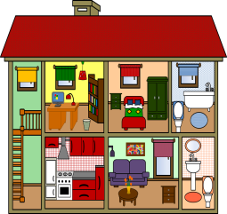
Write 4 sentences about our classroom. Use THERE IS and THERE ARE.
Explain the rule to one of your teachers.

