Describing a room
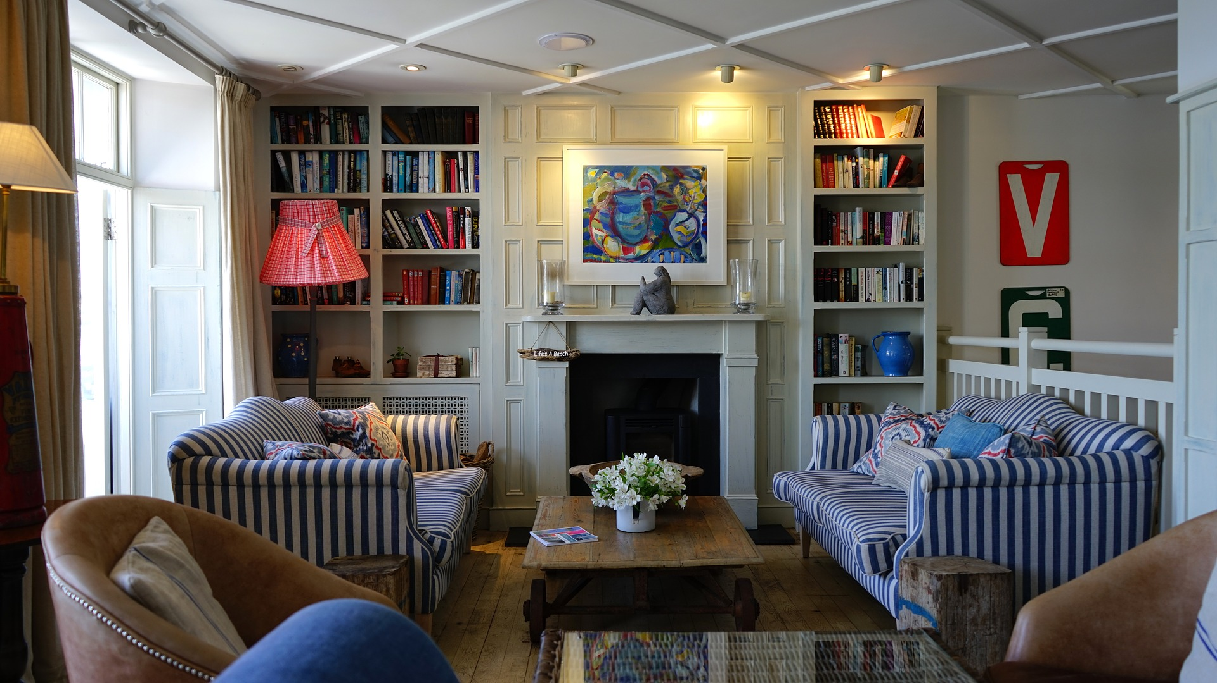
Sort the jumbled text pieces. If you need help, listen to the text.

© 1 pixabay: CC0
This is the Millers’ living room. It is not very
are striped blue and white and there are
pot of white flowers on it. The Millers love
reading books. Therefore, they have two big bookshelves
big, but it is very cozy. When you come
there is a colorful, modern painting. In front of the bookshelf, in the left corner of the
on the back wall. They are white and full of colorful
books. Between the bookshelves there is a fireplace and above the fireplace
big windows with long curtains. In the front of the room, there is
a dining table with two leather chairs. The table is made of
many soft cushions on them. Between the two sofas
in, you see two big sofas, one opposite the other. The sofas
room, there is a red reading lamp. On the left wall there are
there is a dark brown, wooden coffee table with a
glass. There are no carpets, but the wooden floor is very nice.

This is the Millers’ living room. It is not very
…………………………………………………………………………………
…………………………………………………………………………………
…………………………………………………………………………………
…………………………………………………………………………………
…………………………………………………………………………………
…………………………………………………………………………………
…………………………………………………………………………………
…………………………………………………………………………………
…………………………………………………………………………………
…………………………………………………………………………………
…………………………………………………………………………………..
………………………………………………………………………………….
………………………………………………………………………………….
glass. There are no carpets, but the wooden floor is very nice.

