The Parkers’ Livingroom
If you need help, listen to the text

Look at the text about the Parkers’ living room. It is quite boring. Can you make it better?

Add lots of details. Write the text on a worksheet form your spiral book.
Use these text pieces to make the text nice and long. Add extra words for each *
on the windowsills
in front of the right window
living very big
small round
soft white
Between the sofa and the table
with two pink cushions
In front of the sofa
small white
two big ones and a small one
under the table
Behind the table, at the wall
on the big shelf on the right
big round white
with four chairs
between the two windows
on the chest of drawers and above it
Between the two big shelves
because it is big and bright.
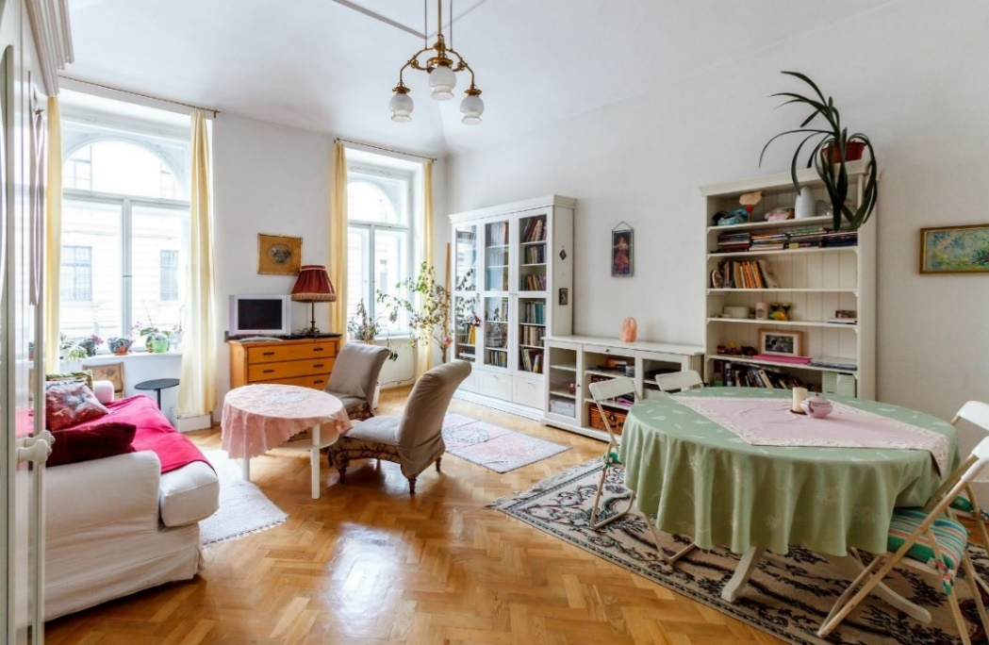
© 1 pixabay, CC0
The Parkers’ living room is very nice. There are two big windows. There are four flower pots on the windowsills and one big plant in front of the right window.
There is a soft white sofa with two pink cushions.
In front of the sofa there is a small round table.
Between the sofa and the table there is a small white carpet.
There is a chest of drawers between the two windows. There is a lamp on the chest of drawers and
above it there is a picture on the wall.
On the right side of the room there is a big round table with four chairs. There is a carpet under the table. Behind the table, at the wall, there are three white shelves, two big ones and a small one. There is a plant on the big shelf on the right.
Between the two big shelves, there is a picture on the wall. I like the room because it is big and bright.

For PROS: Look at this version. You can make the text really long

The Parkers’ living room is very nice and very big. When you come into the room, you see two big windows on the opposite wall. The windows have long, beige curtains on the side.
The Parkers love flowers and plants. There are many plants on the window sills and there is a little tree in a pot in the corner of the room. There is also a big green plant on top of a bookshelf.
Between the two, big windows, there is a chest of drawers. It is made of brown wood and has three large drawers. There is a red lamp on the chest of drawers. Next to the lamp, there is a small, white TV.
There is another lamp in the room. It is hanging from the ceiling in the middle of the room.
The Parkers like reading books. On the right wall, there are two white bookshelves. They are full of colorful books. There are also some pictures and other little things in the shelves. One of the bookshelves has three glass doors. The other bookshelf is open. Between the two tall bookshelves there is a white sideboard with three shelves.
There are three round tables in the room. The dining-table is very big. There are four white chairs around it and there is a light green table-cloth and a light pink table-cloth on it.
The coffee-table is also round and white and there is a light pink table cloth on it. The coffee-table is between a big, white sofa and two light-brown armchairs. There are lots of soft cushions and a pink blanket on the sofa.
There is a 3rd round table in the room. It is black and very small, and it is in front of the left window.
Next to the big sofa, there is a big, white cupboard. It is on the left wall.
The Parkers’ living room has a wooden floor and there are three carpets on the floor. There is a big carpet under the dining-table and there is a small white carpet between the sofa and the coffee-table. There is another small carpet in front of the big bookshelf with the glass doors.
The walls in this room are white and there are three pictures on the walls. One picture is above the chest of drawers, between the two windows. It is light brown and has a golden frame. The second picture is on the wall between the two big bookshelves. It is above the sideboard. It’s the picture of a lady in a reddish dress. The third picture is on the right side of the open bookshelf. It shows a blue, green and white sky and has a golden frame.
The Parkers’ living room is really very nice and comfortable.

